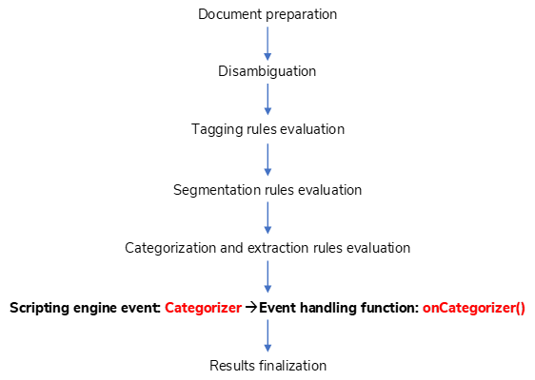

Document preparation

Scripting engine event: Categorizer 🡪Event handling function: onCategorizer()

Results finalization

Disambiguation

Tagging rules evaluation

Categorization and extraction rules evaluation

Segmentation rules evaluation