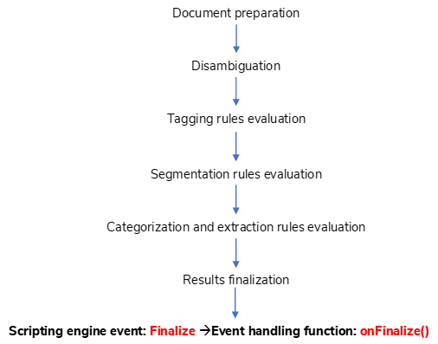

Document preparation

Segmentation rules evaluation

Categorization and extraction rules evaluation

Results finalization

Scripting engine event: Finalize 🡪Event handling function: onFinalize()

Tagging rules evaluation

Disambiguation