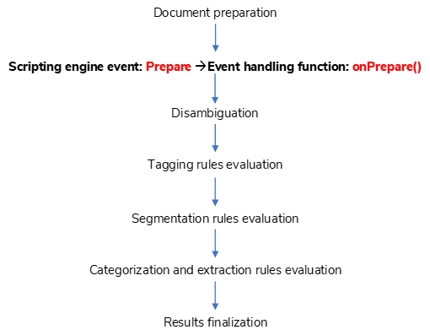

Document preparation

Scripting engine event: Prepare 🡪Event handling function: onPrepare()

Disambiguation

Tagging rules evaluation

Results finalization

Categorization and extraction rules evaluation

Segmentation rules evaluation