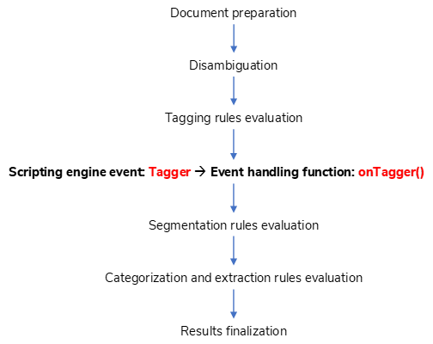

Document preparation

Results finalization

Categorization and extraction rules evaluation

Segmentation rules evaluation

Scripting engine event: Tagger 🡪 Event handling function: onTagger()

Tagging rules evaluation

Disambiguation