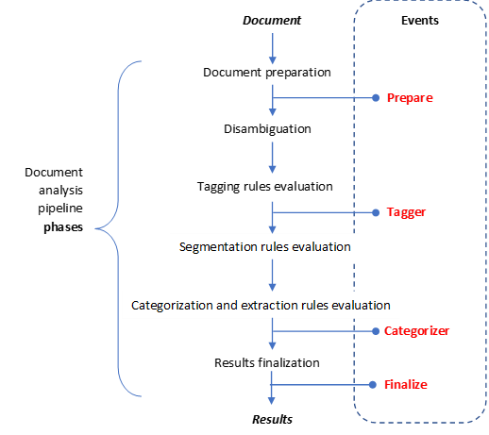

**Events**

***Document***

Document preparation

Document analysis pipeline **phases**

***Results***

**Categorizer**

**Finalize**

**Tagger**

**Prepare**

Segmentation rules evaluation

Categorization and extraction rules evaluation

Results finalization

Tagging rules evaluation

Disambiguation