To: Professor Krasso

From: James Brown

Date: 14 June 2020

Subject: From Legacy to SOA

The purpose of this memo is to give an overview of how we plan to improve the legacy software architecture of our systems. We will be covering an overview of what our setup is today, why we need to move away from it, the solution, benefits with the new solution, an overview of the migration plan, the disadvantages of moving, and a summary of what the potential end user impact will be.

Today, our applications are siloed. What does that mean? This means that none of our applications are able to communicate with each other. Some issues with the current setup include redundancy, scalability, reliability, and monitoring. To-date, we are observing various sys, such as the training sys having 10+ versions of itself. This is unacceptable as redundancy exists and is not a stable approach for managing our applications. As our systems are all fragmented, we also do not have the best visibility into how it is performing. Our logging techniques today are very limited and we often do not have the necessary data to make business decisions.

How do we go about fixing these issues? The answer is Service-Oriented Architecture. What is SOA? SOA is an architecture that is designed around wrapping your applications inside services. These services are all connected through what is called an enterprise service bus.

We have reviewed several other architectures, and this is the best option for scalability and sustainability. SOA was first introduced by Garter Inc, in the early 90’s (Wu). As it has been around for 20+ years, we know it is reliable. What benefits will we see with implementing SOA? The biggest benefits to implementing this architecture include making applications easier to implement, it allows us to re-use applications throughout our system, it is far more reliable, we are provided far better monitoring (OpenGroup), and we can integrate our existing applications into it.

I know this all sounds great, but what is the catch? There are a few things that we should consider before proceeding. The initial investment to get our existing applications merged into services would be fairly expensive. There are third parties such as IBM that will off up the enterprise service bus, but that is also not free. (IBM) SOA also has a lot of overhead on hardware as each request has to be filtered to validate the business rules are being met. This can be taxing on our hardware and we would potentially need to upgrade our servers for optimal performance. While we will be reducing redundancies, it is important to note that if a failure were to occur on the ESB, our entire system would go down as our services are access through a single ESB. It is crucial that we have a copy of the ESB, in the event we see a catastrophic failure.

To migrate our existing applications, we will first need to duplicate our existing production environment for testing purposes. We will then work to implement this test version into SOA. This starts with creating services, mapping them with our existing infrastructure, integrating the service, and testing. Once we are confident in our tests, we will merge the changes with 5% of consumer traffic. Our ramp plan to 100% is 90 days. We will tentatively plan to ramp 10% once every week, until the 50% has been reached. Once 50% has been reached, we will sync back up to review how everything has been going to decide if we are still on track to release at 100% on day 90. If everything goes smoothly, we can then ramp to 100% during a slower traffic time.

The impact to service providers and consumers will be significant at first, as the applications will need to be moved through the migration process described previously. This initial migration may be a bit rocky, but the reward for moving to SOA outweighs the negatives.

In order for us to scale our business, we need to improve our systems architecture. We cannot continue to operate in the manner that we have to-date. If we do not make the change, we will only hurt ourselves more as we continue to grow. It is my professional opinion that SOA will solve the issues we see with our current setup. Please take some time to consider this proposal.

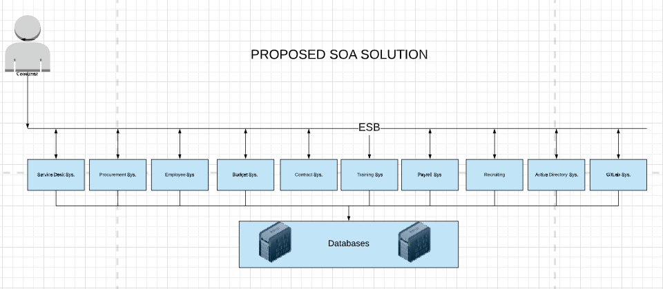 Proposed Diagram:

References

Enterprise Service Bus (ESB). (n.d.). Retrieved June 15, 2020, from https://www.ibm.com/cloud/learn/esb

O. (n.d.). The SOA Source Book. Retrieved June 15, 2020, from https://www.opengroup.org/soa/source-book/soa/p4.htm

Wu, J. (n.d.). Service-Oriented Architecture. Retrieved June 15, 2020, from https://www.sciencedirect.com/topics/computer-science/service-oriented-architecture