# CoLLection

# To collect the data the following architecture is used.

# 

# Auto-Mode

This documentation will describe the architecture of the auto mode on Android

## State

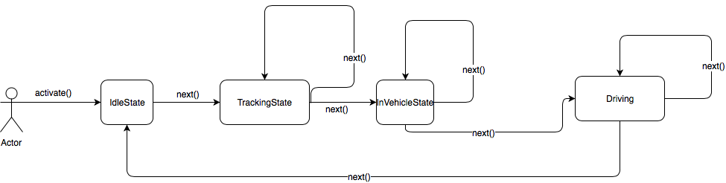

We have four states. Each state implements the scan method which will decide to state or to go to another state.

1. From **IdleState** we go to the **TrackingState** if the automode is enabled.
2. From **TrackingState** we listen to the user activity until we get IN_VEHICLE activity with a certain confidence and go to the **InVehicleState**.
3. When we are in vehicle we wait until we reach a certain speed in order to go to driving state.
4. The **Driving** state just scan the speed using location to stay in the same state or go back to idle state.

## Architecture

Ci-dessous le diagramme UML de de l’automode.

