Date: 05/September/2026
Sub: Smart India Hackathon 2026 Nomlnntjon
I am pleased to nominate the below team from our college to participate in Smart India Hackathon 2026. NCTE Application No/ UGC Registration No for our collcgc is 
Team:
 | Name | Gender | Email id | Mobile No. | Stream | Academic  Year
Team  Leader | S,k'AVlN  MUTHUVEL |  | cb.en.u4eee26033@cb.studcnts.amrita.cdu | 636911157 | EEE
Team  Member | DHARUN S |  | cb.en.u4eee26008@cb.students.amrita.edu | 6369281312 | EEE
Team  Member | KOVARTHAN SIVARAJ |  | cb.en.u4eee26014@cb.students.amrita.edu | 9150909678 | EEE
Team  Member | SAAMRITHAA |  | cb.en.u4eee26232@cb.students.amrita.edu | 9384565668 | EEE
Team  Member | YOGASHREE  THALAPATHI  SHANMUGAM |  | cb.en.u4eee26046@cb.students.amrita.edu | 6382899464 | EEE
Team  Member | DHARSHINI T |  | cb.en.u4eee26041@cb.students.amrita.edu | 9182518729 | EEE
Sincerely,
Team Members
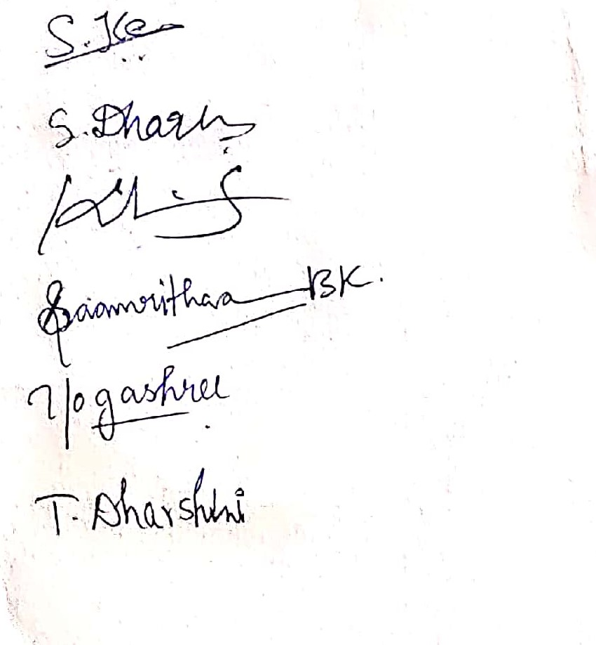
: Scanned with OKEN Scanner

