**Generation of sine wave in MATLAB**

**Steps:**

1. Open MATLAB

2. Navigate to *new* and from the dropdown select *Simulink model*

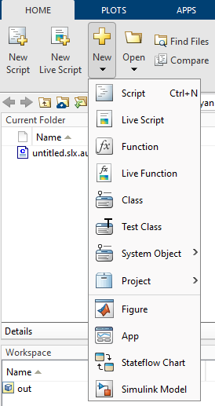

3. From the *simulation* section select *Library Browser*, this will open the list of library models that you can import in the model’s window to run the simulation.

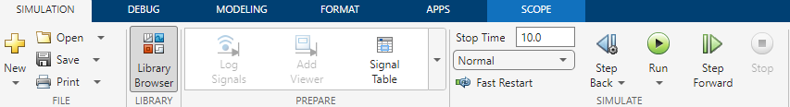

4. You will be presented with a list of functions which you can import (drag and drop) into the simulation window. Search for the required one (here sine wave) and drop it into the window

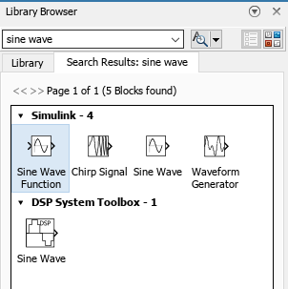

5. Now, we can see the sine wave in graph view by using the *scope function*, for short cut, we can double click on the window and search the required function there.

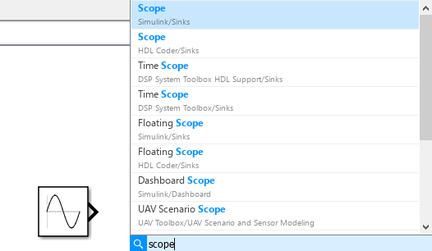

6. Connect the sine wave to the scope function using arrows as shown below:

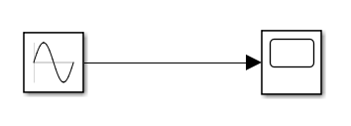

7. Press the *run* button located on the top of the screen.

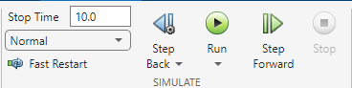

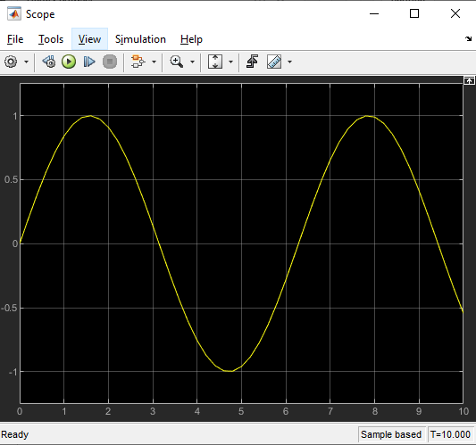8. Double click the scope function to view the graph of sine wave.

9. We can change the properties of the sine wave to generate its variant respective to properties.

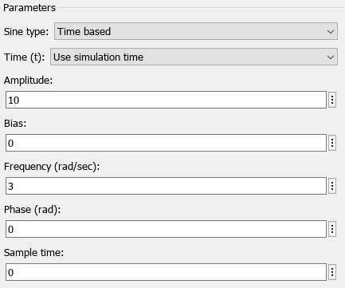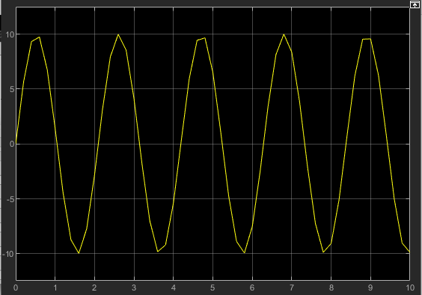

Changes:  
**Amplitude:** 10  
**Frequency:** 3