**Simulation of Suspension of car in MATLAB**

**Model of the system:**

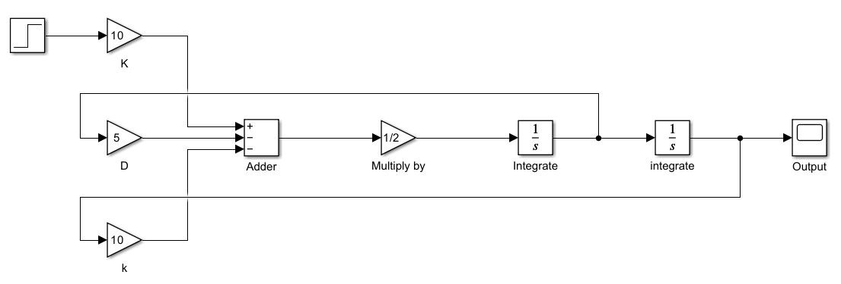

**Graph show gradual decrease in springs strength:**

