VERIFICATION AND VALIDATION OF SIGNUP &LOGIN FORM USING FORMIK AND YUP

Formik takes care of the repetitive and annoying stuff—keeping track of values/errors/visited fields, orchestrating validation, and handling submission—so you don't have to. This means you spend less time wiring up state and change handlers and more time focusing on your business logic

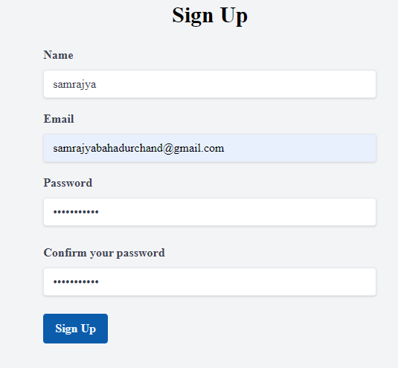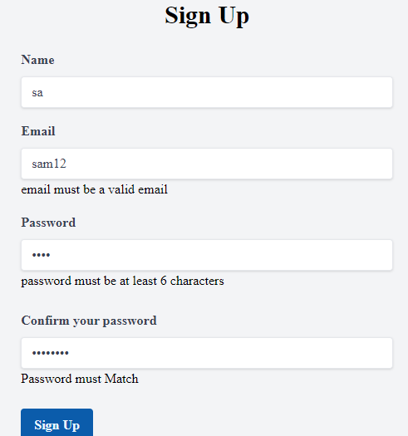Yup is a schema builder for runtime value parsing and validation. Define a schema, transform a value to match, assert the shape of an existing value, or both. Yup schema is extremely expressive and allows modeling complex, interdependent validations, or value transformation.

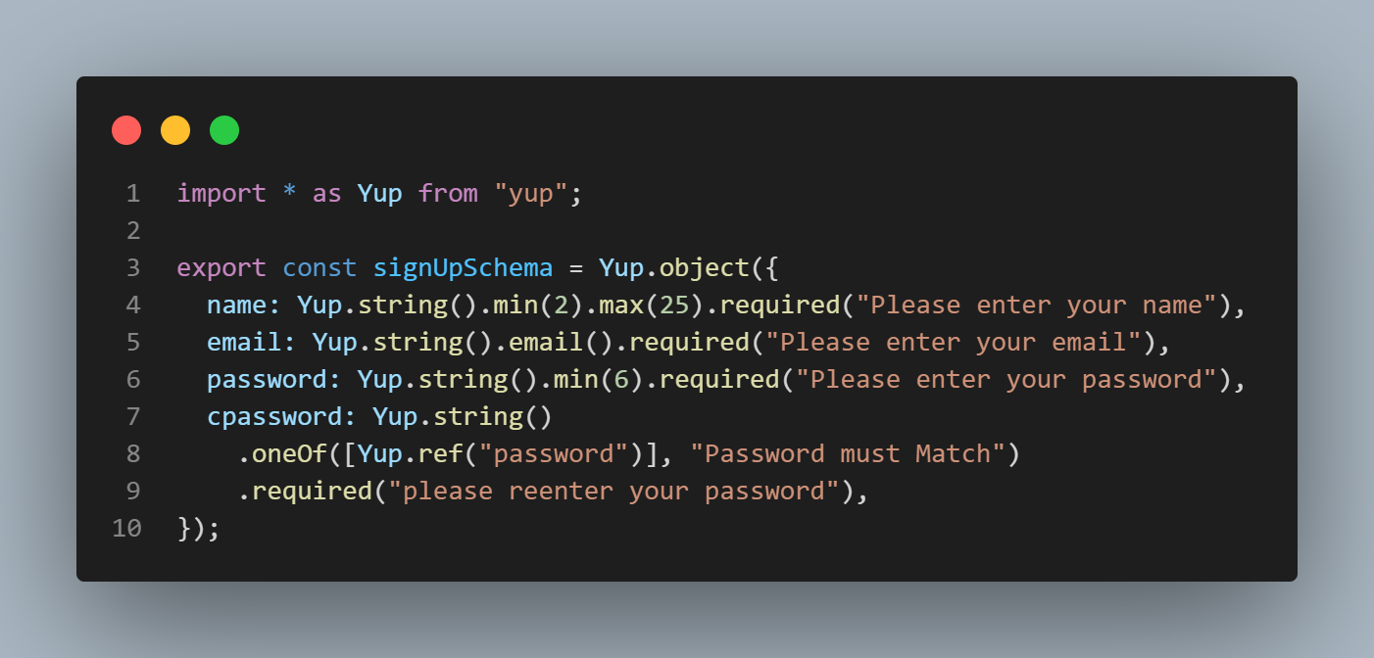SCHEMA OBJECT OUTPUT

