LAB 3: DATA VISUALIZATION AND MODELING IN POWER BI

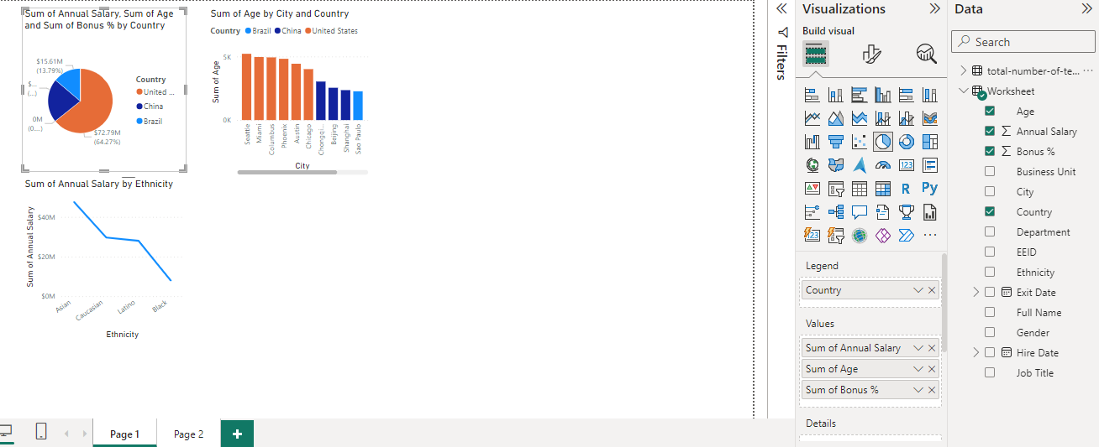DATA VISUALIZATION OF WORSHEET TABLE

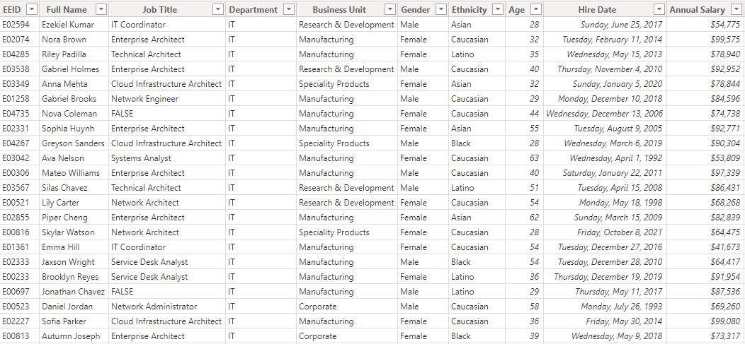EMPLOYEES TABLE

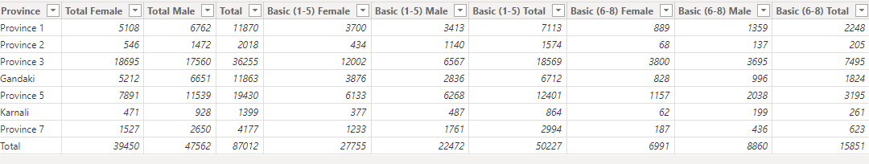

EMPLOYEES IN PROVINCE OF NEPAL

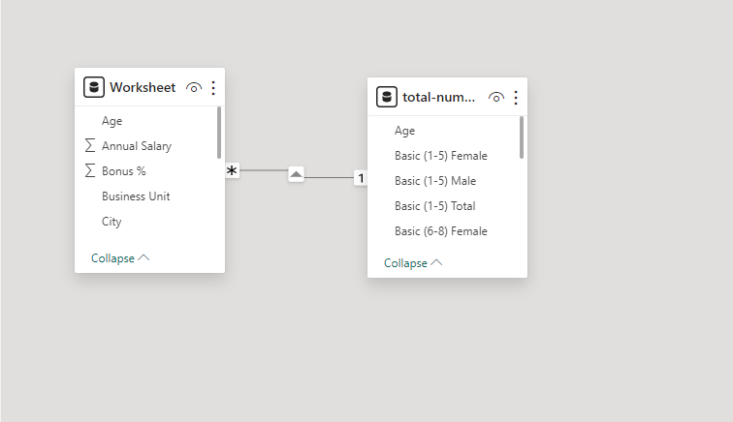DATA MODELING OF THE TWO DATASETS

DATA VISUALIZATIONS OF DATA SET AS AGE AS FOREIGN KEY AND COMMON ATTRIBUTE

