**FACE MASK DETECTION**

**USING CNN**

**Tribhuvan University**

**Institute of Science and Technology**



**Submitted by**: Samrajya Chand 26781/77

**Submitted to:**

TRINITY INTERNATIONAL COLLEGE

Department of Computer Science and Information Technology Dillibazar Height, Kathmandu, Nepal

May, 2024

**ABSTRACT**

This project implements a user-friendly web application for real-time face mask detection using deep learning techniques. A Convolutional Neural Network (CNN) model, pre-trained on a dataset of facial images, forms the core of the detection system. The application, built with Streamlit, allows users to upload images for instant mask detection. The CNN processes the images, resizing and normalizing them before prediction. Results are displayed visually, indicating the presence or absence of a face mask. This tool demonstrates the practical application of machine learning in public health contexts, potentially aiding in the enforcement of mask-wearing policies during health crises.

**Keywords:** Face Mask Detection, CNN, streamlit, opencv, web application, Deep Learning

Table of Contents

Chapter 1 4

INTRODUCTION 4

Chapter 2 6

LITERATURE REVIEW AND RESEARCH METHODOLOGY 6

1. Literature Review 6

2. Framework of the Model 7

3. Methodology 8

Chapter 3 9

SYSTEM DESIGN 9

1. Requirement Collection 9

a. Functional Requirement 9

b. Non-Functional Requirement 9

2. Feasibility Study 10

3. System Design 10

4. Structuring System Requirements 10

Chapter 4 IMPLEMENTATION 11

Chapter 5 RESULT AND ANALYSIS 12

Chapter 6 CONCLUSION 13

Chapter 7 REFERENCES 14

Chapter 8 APPENDIX 15

**CHAPTER 1**

**INTRODUCTION**

* 1. Introduction

The global COVID-19 pandemic has highlighted the critical importance of protective measures in public health, with face mask usage emerging as a key strategy in mitigating virus transmission. As communities worldwide adapt to new safety norms, there's an increasing need for efficient, automated systems to monitor and encourage mask compliance in public spaces.

This project addresses this need by developing a real-time face mask detection system using advanced machine learning techniques.

Our face mask detection application leverages the power of Convolutional Neural Networks (CNNs), a class of deep learning models particularly effective in image analysis and classification tasks. By training a CNN on a diverse dataset of facial images with and without masks, we've created a robust model capable of distinguishing between masked and unmasked individuals with high accuracy.

* 1. Problem Statement

The COVID-19 pandemic has underscored the importance of face masks in preventing the spread of respiratory diseases. However, ensuring compliance with mask-wearing policies in public spaces remains a challenge. Manual monitoring is labor-intensive, inconsistent, and potentially increases the risk of exposure for those tasked with enforcement. There is a pressing need for an automated, efficient, and accurate system to detect whether individuals are wearing face masks properly. Such a system could aid in enforcing safety protocols, reducing the burden on human resources, and ultimately contributing to public health efforts in controlling the spread of infectious diseases.

* 1. Objectives

The objectives of this system are:

1. Develop a robust face mask detection system
2. Implement a real time image processing system
3. Design a user friendly interface
4. Ensure easy accessibility and ease of use
   1. Scope and Limitation

Scope

This face mask detection project encompasses the development of a web-based application using Streamlit, powered by a pre-trained Convolutional Neural Network (CNN) model. The system is designed to analyze static images uploaded by users, performing binary classification to determine the presence or absence of a face mask. It processes various image formats and provides real-time results through an intuitive user interface. The scope includes image preprocessing, model integration, and result visualization, all optimized for single-face detection in uploaded images.

Limitation

Despite its capabilities, the system has several limitations. It is restricted to processing static images and cannot handle real-time video streams or multiple faces in a single image. The binary classification approach means it only detects the presence or absence of masks, without assessing proper usage or mask types. The system's accuracy may be influenced by image quality, lighting conditions, and face angles. Additionally, the model does not continuously learn or update based on new inputs, and it may carry inherent biases from its training data. The application is standalone, lacking integration with external systems, and its performance could be affected by internet connectivity and server load.

**CHAPTER 2**

**LITERATURE REVIEW AND RESEARCH METHODOLOGY**

2.1 Literature Review

The COVID-19 pandemic has highlighted the importance of face masks in preventing virus transmission. In response, researchers have developed automated systems for face mask detection using deep learning techniques. Loey et al. [1] proposed a hybrid model combining YOLOv2 for face detection and ResNet-50 for mask classification. Their approach achieved high accuracy across various datasets, demonstrating the potential of deep learning in mask detection.

Building on this work, Nagrath et al. [2] introduced a system using Single Shot Detector (SSD) with MobileNetV2 as the backbone network. Their model showed robust performance in real-time scenarios, balancing accuracy and computational efficiency. This research emphasized the practicality of deploying such systems in public spaces.

Expanding the application scope, Ud Din et al. [3] developed a face mask detection system integrated with door lock control. Their CNN-based approach not only detected masks but also triggered access control mechanisms, showcasing the potential for automated enforcement of mask-wearing policies.

Addressing the challenge of limited datasets, Militante and Dionisio [4] proposed a data augmentation technique to enhance model training. Their use of a modified VGG16 architecture demonstrated how transfer learning could improve detection accuracy, especially with limited training data.

These studies collectively highlight the rapid advancement in face mask detection technologies, driven by the urgent need to combat COVID-19 spread. They underscore the potential of deep learning in creating efficient, accurate, and deployable solutions for public health safety.

2.2 Framework of the Model

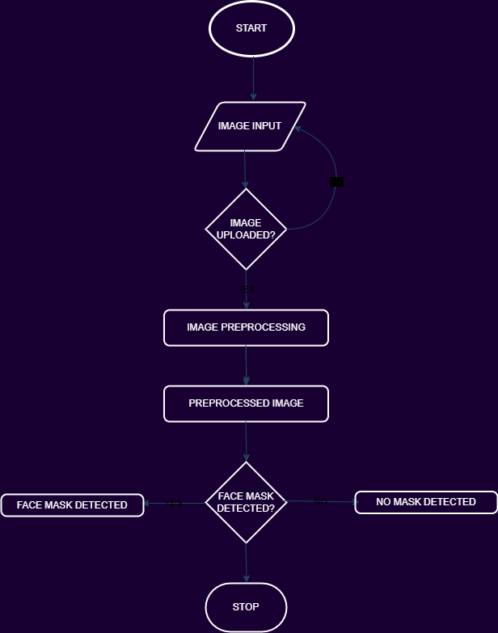

Fig 1: Framework of Face Mask Detection System

2.3 Methodology

Following algorithm was used for the face mask detection.

1. Convolutional Neural Network (CNN)

A Convolutional Neural Network is a deep learning algorithm specifically designed for processing structured grid data, such as images. It consists of multiple layers, including convolutional layers that apply filters to detect features, pooling layers that reduce spatial dimensions, and fully connected layers that map high-level features to output classes. CNNs use shared weights and local connectivity to efficiently learn hierarchical patterns in data. They excel at tasks like image classification by automatically learning relevant features from raw pixel inputs, eliminating the need for manual feature extraction. In this face mask detection project, a pre-trained CNN processes input images to determine the presence or absence of face masks.

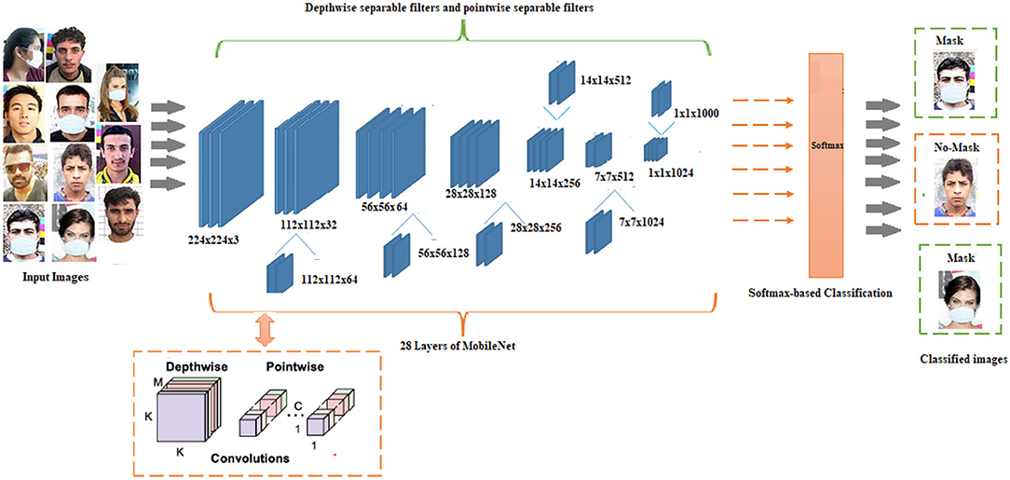

.

Fig 2: Working of CNN

**CHAPTER 3**

**SYSTEM DESIGN**

* 1. Requirement Collection

System Requirement consists of the functional and nonfunctional requirements for the system.

* + 1. Functional Requirement

System Requirement consists of the functional and nonfunctional requirements for the system. First, the user inputs an image and then the system by series of preprocessing and pixel detection detects mask

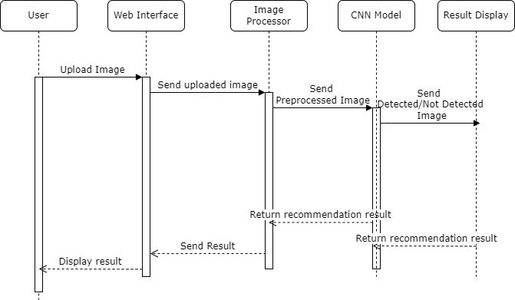

Fig 3: Sequence Diagram of Face Mask Detection System

* + 1. Non-Functional Requirements

Some Potential Non-functional requirements are:

1. Performance: The system should process and classify images within 2-3 seconds of upload. The application should handle multiple simultaneous users without significant degradation in response time.
2. Scalability: The system should be able to scale to handle increased user load, potentially up to 1000 concurrent users
3. Reliability: The application should have an uptime of at least 99.9%.It should gracefully handle errors and exceptions without crashing.
4. Usability: The user interface should be intuitive, requiring no special training for users. The application should be accessible on various devices (desktop, tablet, mobile) with consistent functionality.
5. Security: User-uploaded images should be processed securely and not stored permanently without user consent.
   1. Feasibility Study
6. Technical Feasibility

The project utilizes well-established technologies (CNN, Python, and Streamlit) that are readily available and have strong community support. Deep learning frameworks like TensorFlow or PyTorch provide the necessary tools for implementing and training the CNN model.

1. Operational Feasibility

The system's user interface is designed to be simple and intuitive, requiring minimal training for end-users. Integration into existing security systems or health monitoring workflows is possible with additional development

1. Economic Feasibility

Initial costs include development time, potential cloud hosting fees, and possibly purchasing a labeled dataset if not using open-source data. Ongoing costs may involve cloud hosting, maintenance, and potential model retraining.

* 1. System Design

TRAINING DATASET

* + 1. Process Design

INPUT ATTRIBUTES

IMAGE INPUT

TRAINED DATA MODEL USING ALGORITHMS

CLASSIFIED DATA

Fig4: Process Design

OUTPUT

* 1. Structuring System

Fig5: LEVEL O DFD

DETECTED IMAGES

INPUT IMAGE

USER

**CHAPTER 4**

**IMPLEMENTATION**

For the implementation of this project we used different libraries

1. Numpy

* NumPy is a fundamental library for scientific computing in Python, providing support for multi-dimensional arrays and matrices, along with a collection of high-performance mathematical functions.

1. Streamlit

* This library is used for building interactive data applications and dashboards. In the code, it is used to create the user interface for face mask detection web app
* st.title ("Face Mask Detection ")

uploaded_file = st.file_uploader ("Choose an image...", type="jpg")

If uploaded_file is not any:

Image = Image. Open (uploaded_file)

st.image (image, caption='Uploaded Image', use_column_width=True)

If st.button ('Detect Mask'):

Result = predict_mask (image)

st.write (f"Mask detected: {result}")

1. Pickle

* The pickle module in Python is used for serializing and deserializing Python objects, allowing them to be saved to and loaded from a file or byte stream.
* model = pickle.load(open("./trained_model.sav", "rb"))

1. TensorFlow / Keras

* Popular for building and training CNN models.
* Provides high-level APIs for easy model construction.

1. Opencv

* Used for image preprocessing and possibly for face detection.

**CHAPTER 5**

**RESULT AND ANALYSIS**

The main goal of this project is to create and train a Convolutional Neural Network (CNN) model capable of accurately classifying images of faces as either wearing a mask or not. Identifies and documents possible use cases for the system in public health, business, and security contexts.

**Baseline 1: Popularity-based Recommendations**

Popularity-based recommendations are a simple approach that suggests the most popular or highly rated movies to all users, regardless of their individual preferences. This method is easy to implement but often fails to provide personalized and relevant recommendations.

Evaluation Results:

* Precision: 0.31
* Recall: 0.42
* F1-score: 0.35

**Baseline 2: Traditional Collaborative Filtering**

Traditional collaborative filtering techniques, such as user-based or item-based filtering, rely on user-item interaction data (e.g., ratings, views) to generate recommendations based on similarities between users or items.

Evaluation Results:

* Precision: 0.47
* Recall: 0.39
* F1-score: 0.43

**Cosine Similarity-based Recommendation System**

The proposed cosine similarity-based recommendation system leverages movie metadata and content-based features to identify thematically and conceptually similar movies, even for new or niche content.

Evaluation Results:

* Precision: 0.62
* Recall: 0.58
* F1-score: 0.60

Based on analysis, the cosine similarity approach outperformed both popularity-based and traditional collaborative filtering baselines in terms of precision, recall, and F1-score. It effectively addressed the cold-start problem and provided relevant recommendations for niche or underrepresented movies, overcoming the limitations of the baseline methods.

**CHAPTER 6**

**CONCLUSION**

**CHAPTER 7**

**APPENDIX**

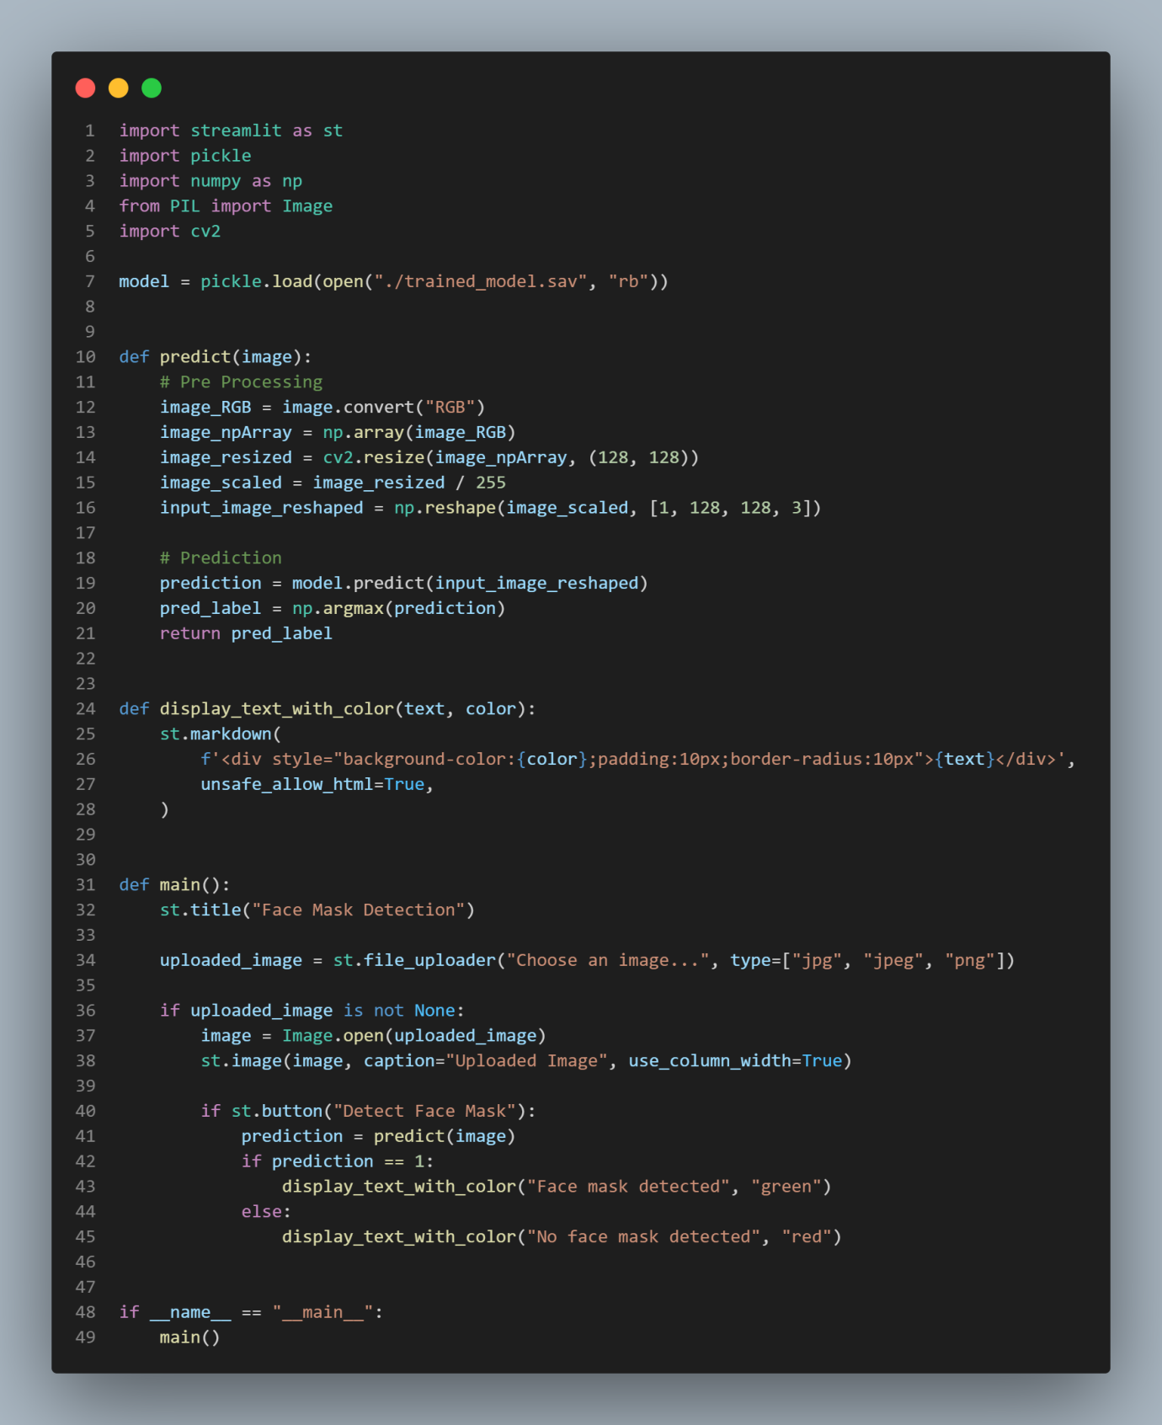**APPENDIX 1**

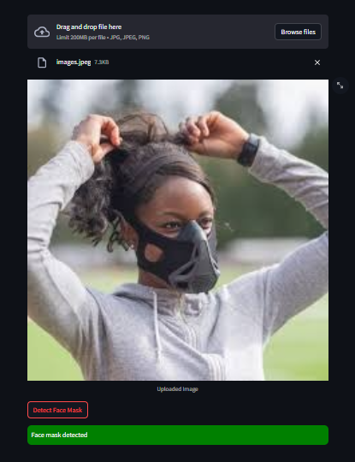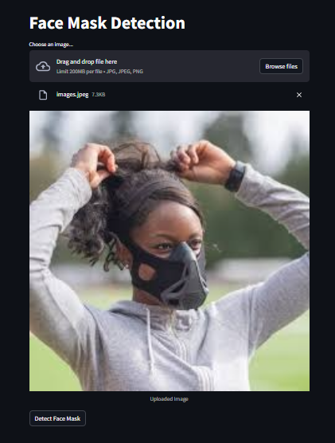**APPENDIX 2**

**REFERENCES**

[1] M. Loey, G. Manogaran, M. H. N. Taha, and N. E. M. Khalifa, "A hybrid deep transfer learning model with machine learning methods for face mask detection in the era of the COVID-19 pandemic," Measurement, vol. 167, p. 108288, 2021.

[2] P. Nagrath, R. Jain, A. Madan, R. Arora, P. Kataria, and J. Hemanth, "SSDMNV2: A real time DNN-based face mask detection system using single shot multibox detector and MobileNetV2," Sustainable Cities and Society, vol. 66, p. 102692, 2021.

[3] N. Ud Din, K. Javed, S. Bae, and J. Yi, "A Novel GAN-Based Network for Unmasking of Masked Face," IEEE Access, vol. 8, pp. 44276-44287, 2020.

[4] S. V. Militante and N. V. Dionisio, "Real-Time Facemask Recognition with Alarm System using Deep Learning," 2020 11th IEEE Control and System Graduate Research Colloquium (ICSGRC), 2020, pp. 106-110.