**Document Design & Graphics**

Samrajya Chand

Trinity International College

03/22/2024

**Document Design & Graphics**

1. This bar chart depicts the comparison of Thans miles walked during a school week to the miles she walked during her vacation. Bar chart is used here to show the comparison of her school walking miles to her in vacation.

Fig1: Bar graph

1. This pie chart is about how Gajhi spent the $1250 given by his parents for the first month of his college. We used pie chart to show his expenditure in proportion

Fig 2: Pie chart

1. We used flowchart for outlining the procedure for gaining approval for check above $300. Flowchart is suitable as it shows all the steps required.

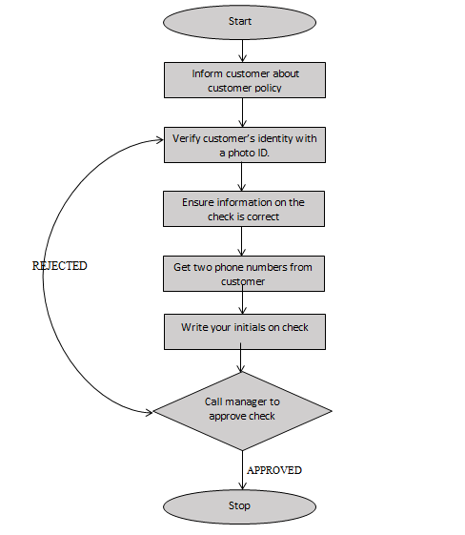

Fig 3: Flowchart

1. For showing the positions of proton, neutron within a hydrogen atom Alessendra can draw a diagrammatic representation of the hydrogen atom.

Proton

Neutron

Fig4: Diagram of structure of Nucleus

1. Since Sasha needs to show the growth of how the fish farm is increasing over the recent years. Line graph is best for her as it depicts the trend.

Fig 5: Line Graph

1. To visually represent Zach’s plan for completing the task we used Gantt chart. As Gantt chart shows the schedule of task over time. We supposed the review of literature started from 1st of July and the article submission was completed before 1st October so the article could be published. The article was published in December 1.

|  |  |  |
| --- | --- | --- |
| Task | Start Date | Duration |
| Review of literature | 1-Jul | 15 |
| Draft Written | 16-Jul | 30 |
| Draft sent to editors | 16-Aug | 15 |
| Draft sent to reviewers | 31-Aug | 15 |
| Draft revised | 16-Sep | 15 |
| Article resubmitted | 1-Oct | 10 |
| Article Published | 1-Dec | 30 |

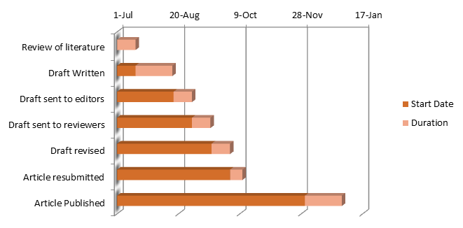

Fig 6: Gantt chart

**References**

# 