**LAB 1 : IMPLEMENTING DIFFERENT OOP CONCEPTS IN VISUAL STUDIO BY CREATING CONSOLE APP**

1. Simple Delegate Example

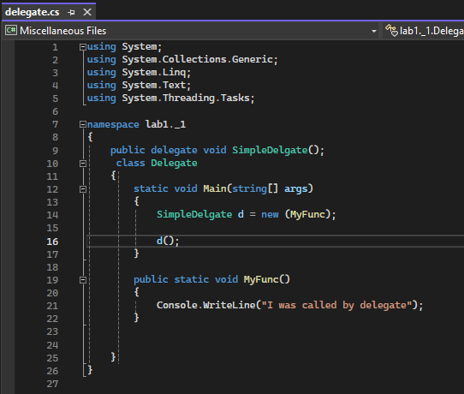

SOURCE CODE

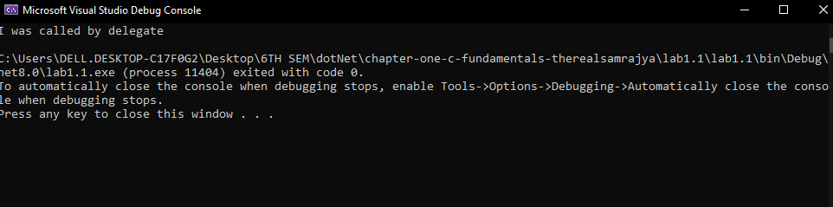OUTPUT

1. Displaying Multiple Inheritance using interface in c#

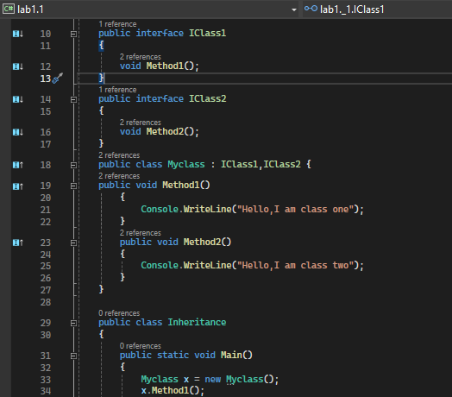SOURCE CODE

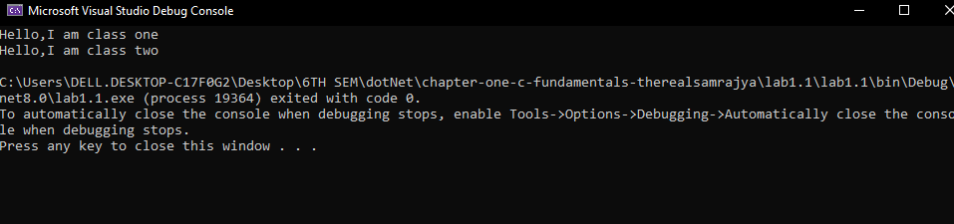OUTPUT

1. Creating record of students counting the number of students and ordering students by name (LINQ)

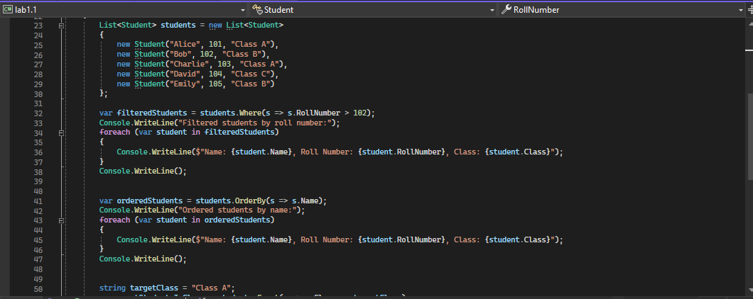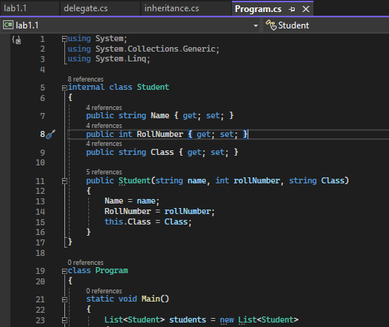

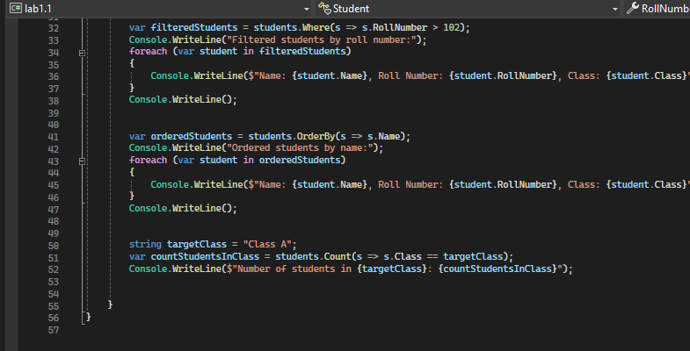

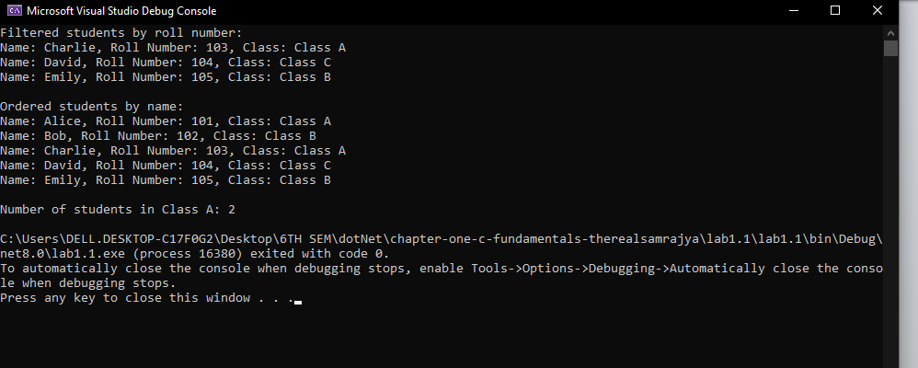OUTPUT