LAB: USING JQUERY IN OUR WEBPAGE OF ASP.NET MVC

1. Install the jquery package via nugget packages

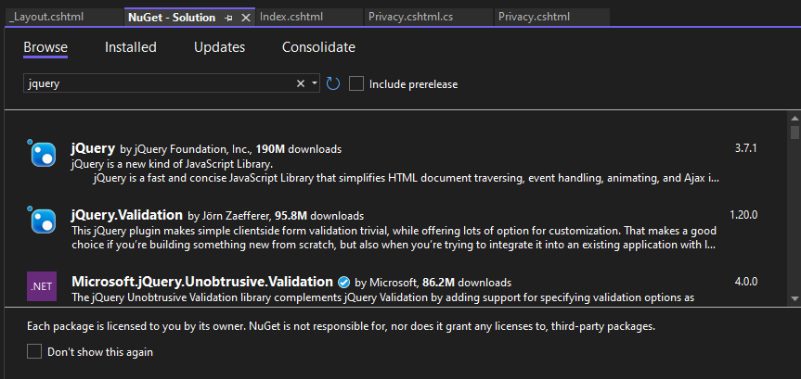

1. 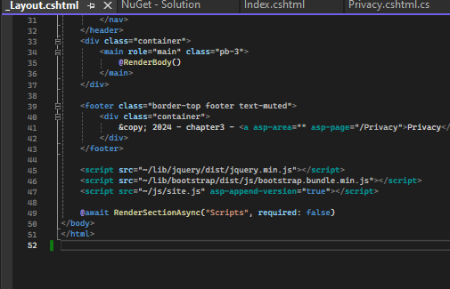Include the jquery script link in the _layout.cshtml file
2. I made a simple home page that uses several feature of jquery

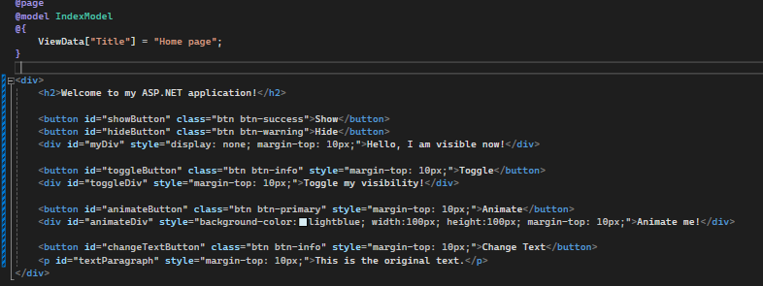

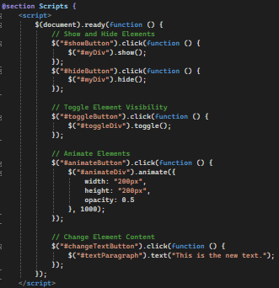

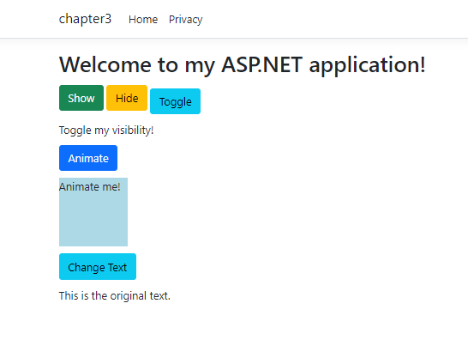

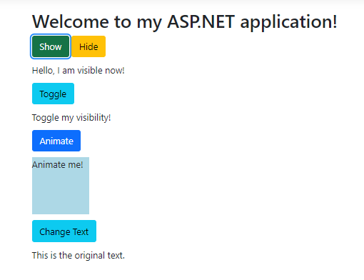Hiding elements and showing on click



Button to toggle the visibility of another div



Button to Animate size and opacity of a div

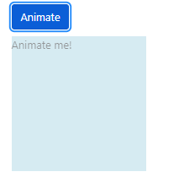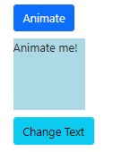

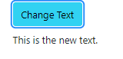A button to change the text content of a paragraph

