SHIVRAJ ROMAN

240840325056

—------------------------------------------------------------------------------------------------------------------------------ **HIVE**

Q1)

1. Find the airports that are only listed as sources but not as destinations in the routes table.

select src_airport_id from routes where src_airport_id not in (select dest_airport_id from routes) limit 5;

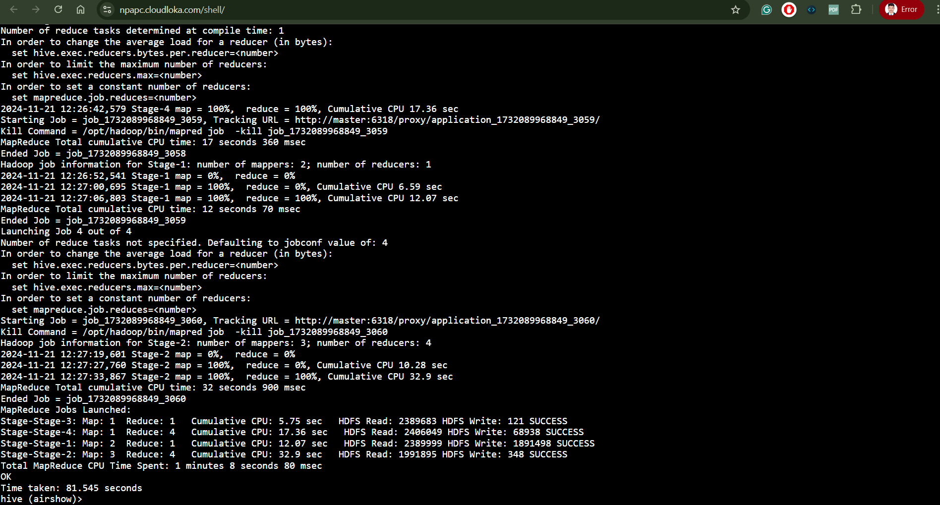

Q 2. Top 3 airlines that operates on the highest number of distinct routes.

Query - select airline_id, count(*) from routes group by airline_id order by count(*) desc limit 3;

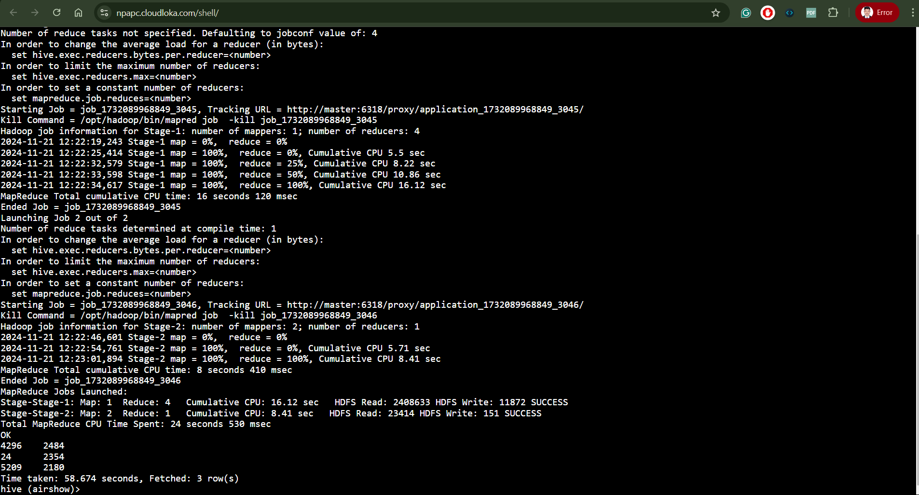

Q.3 Find the total num of distinct aircraft types used in the routes table.

Query - select count(distinct(equipment)) from routes;

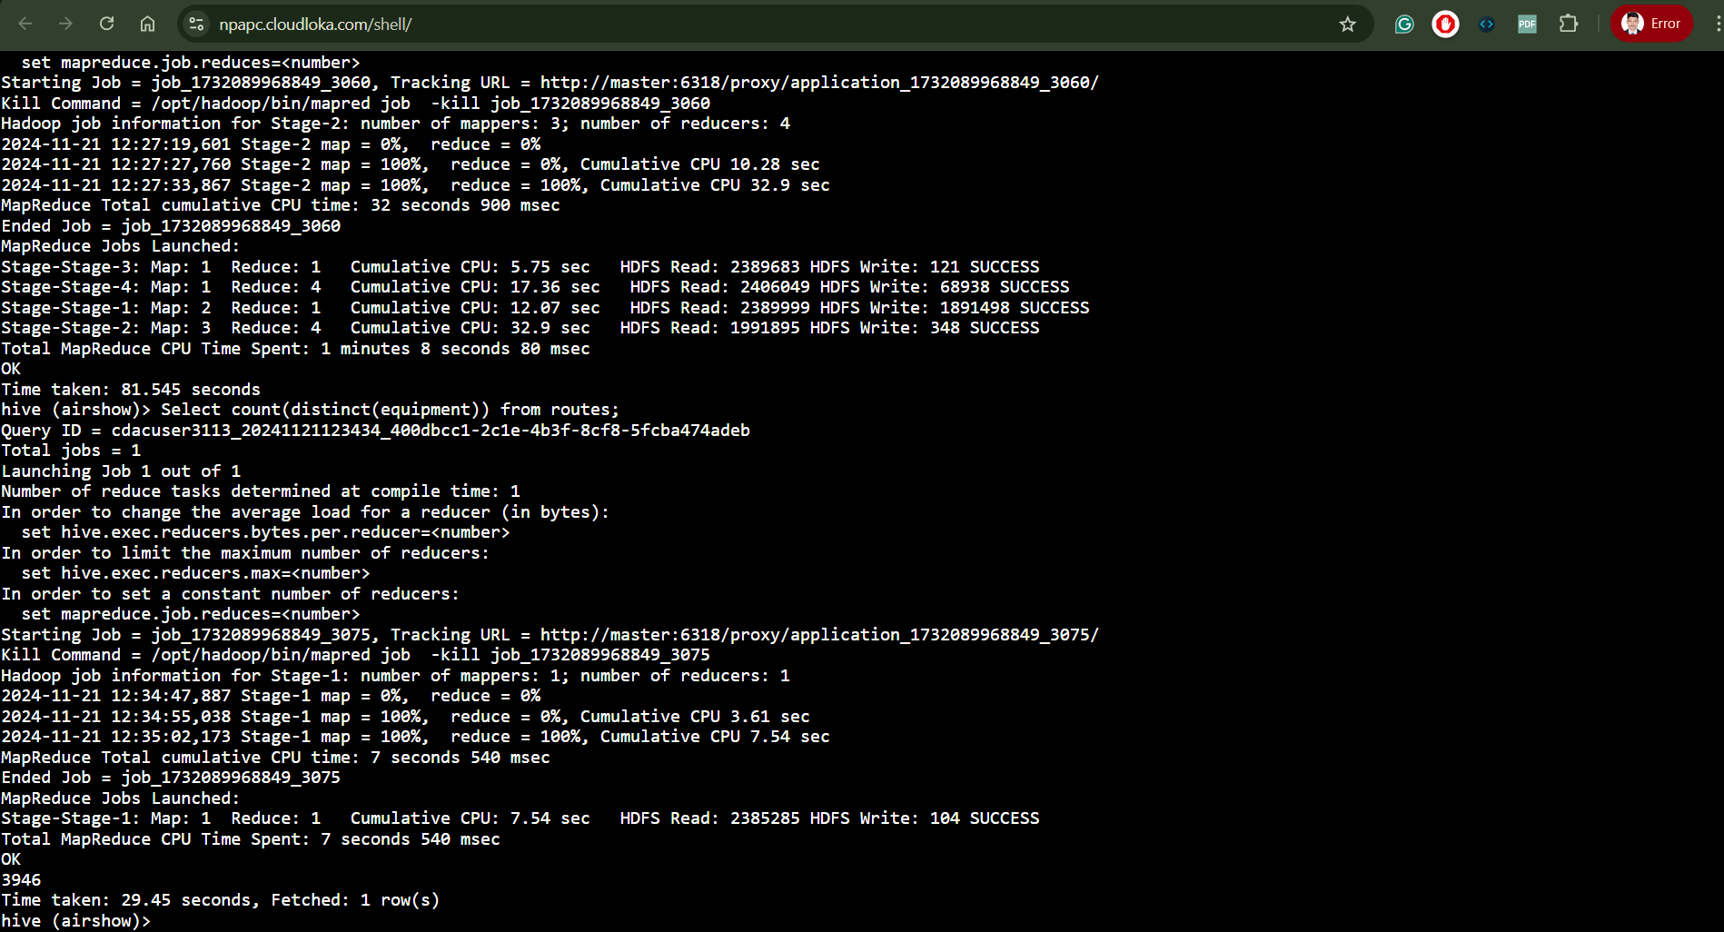

Question 2)

Query to create a partition table - (Shell not working)

create table routes_partitioned

(airline_iata string, airline_id int, src_airport_iata string,

src_airport_id int, dest_airport_iata string,

dest_airport_id int, codeshare string, stops int, equipment int)

partitioned by (dest_airport_iata) row format delimited

fields terminated by "," stored as textfile;

**—-----------------------------------------------------------------------------------------------------------------------------**

**SPARK**

**Question 1**. Solve with RDD only

1)

Code:

Step_1 Loading file

datardd = sc.textFile("user/cdacuser/training/airlines.csv")

Step_2 Checking for header

datardd.take(5)

Step_3 Eliminating the header

head = datardd.first()

eliminate = datardd.filter(lambda a: a!=head)

Comment - Spark was not working

**Question. 2**. RDD transformations

**USING RDD OR DATAFRAME: (Shell was not working properly so used Colab and Jupyter notebook for some questions)**

1)

df.agg(min(“booked_seats”), max(“booked_seats”), avg(“booked_seats”)).show()

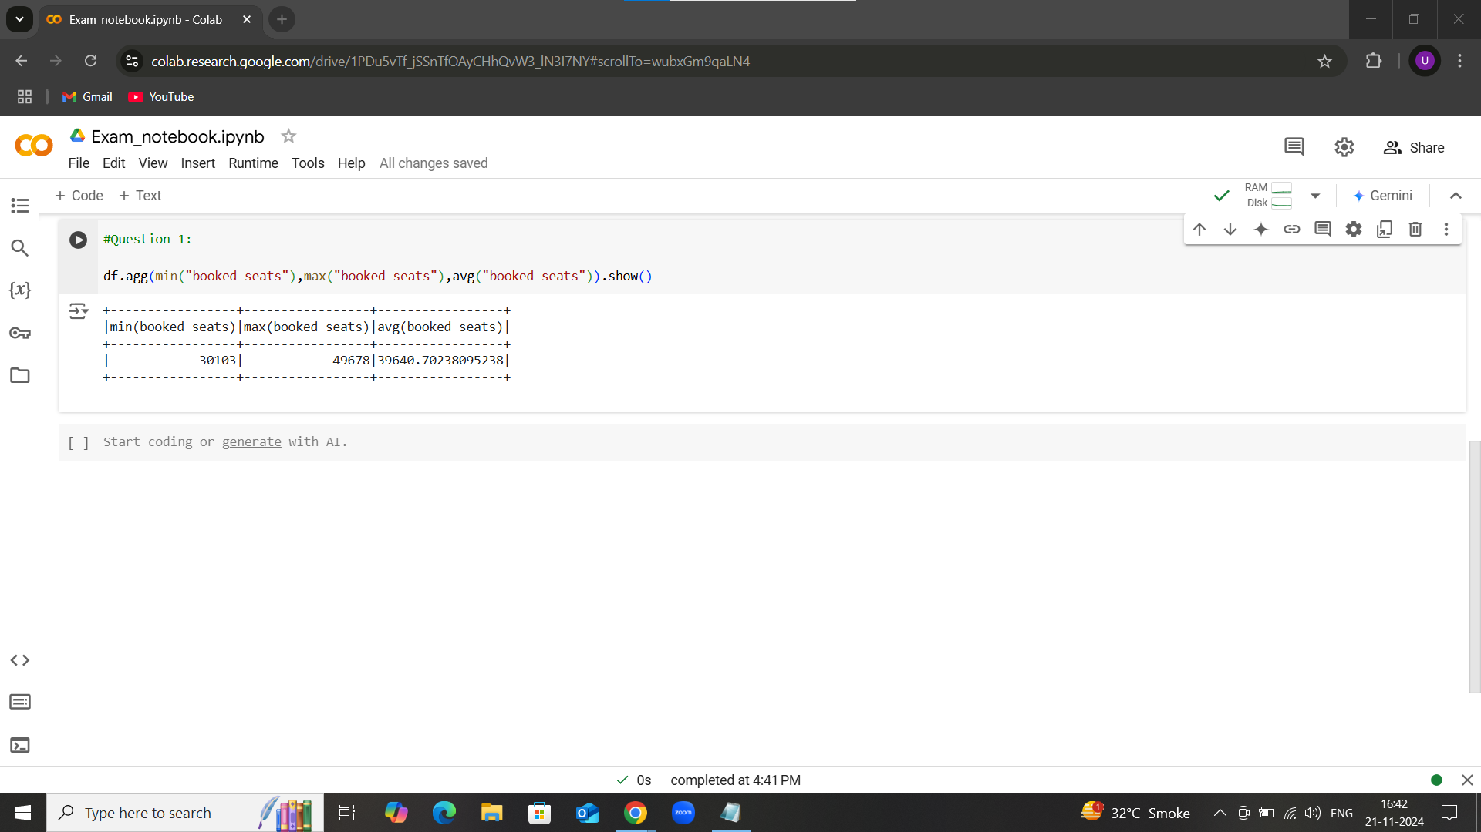

Question 2:

Query-

df.filter(col(“avg_rev”)<290.0)count()

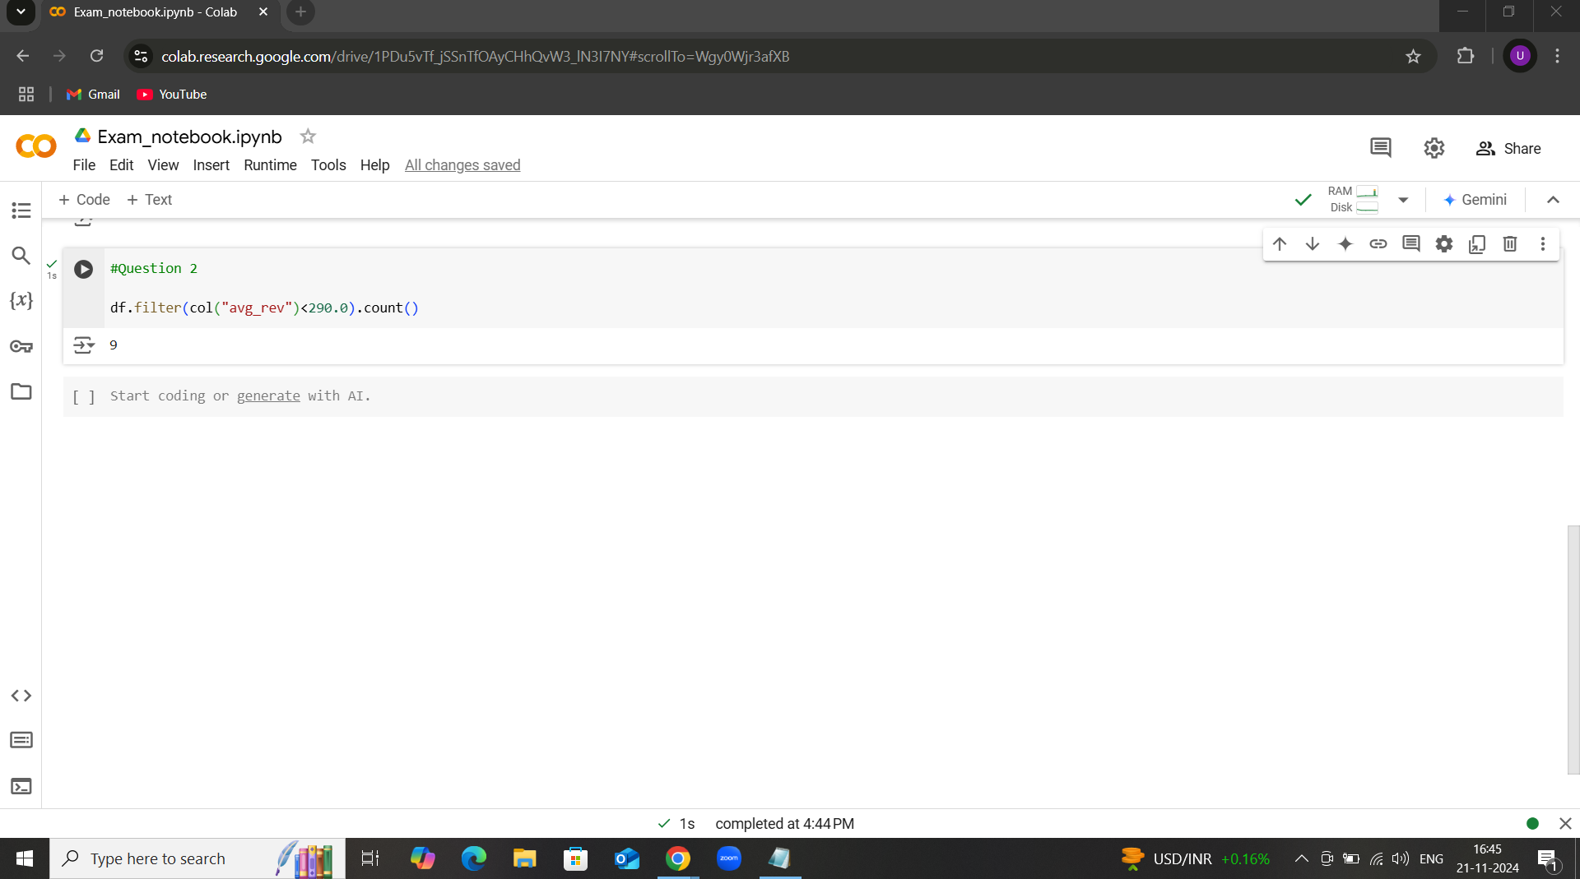

Question 3:

Query -

df.groupBy(“quert”).aff(avg(“booked_seats”).alias(“Average Booked Seats”)).show()

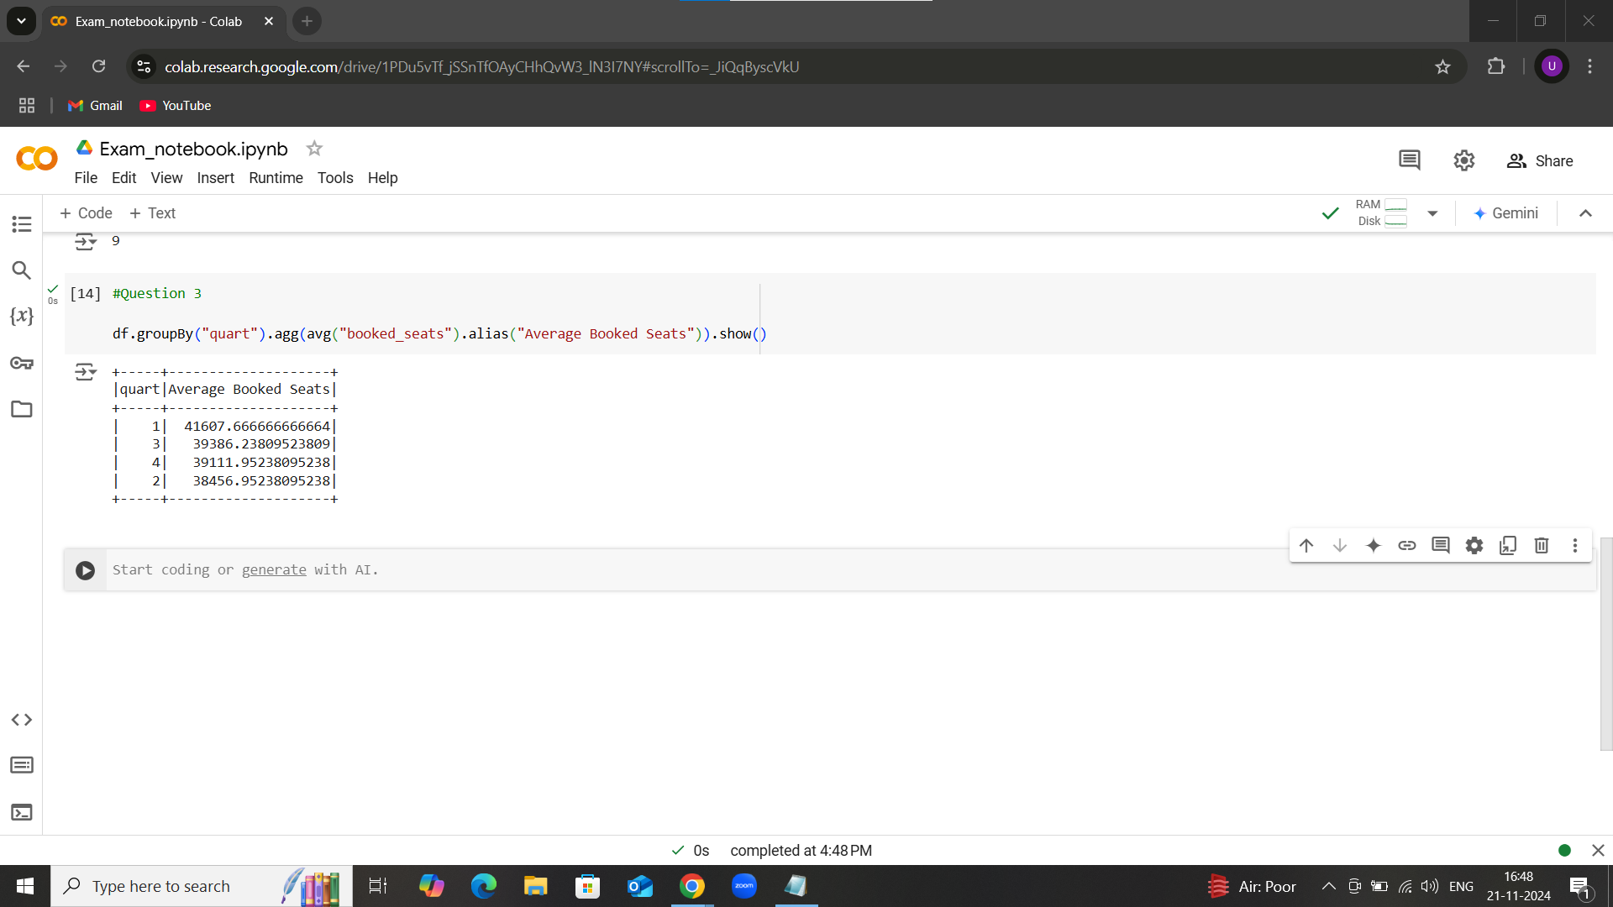

Question 4:

Query -

df.groupBy("year").agg(count("*")).show(10)

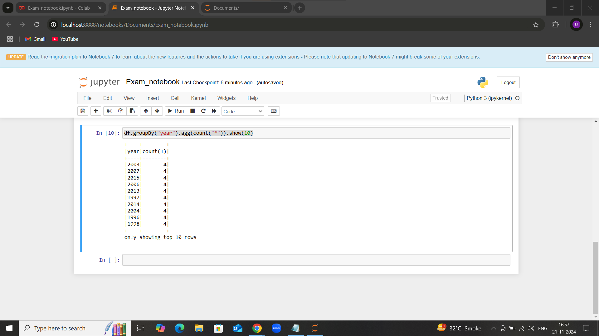

Question 5:

Query -

max_rev = df.agg(max("avg_rev")).collect()[0][0]

result = df.filter(col("avg_rev")==max_rev)

result.select("quart","avg_rev").show()

Comments- Webshell is not working