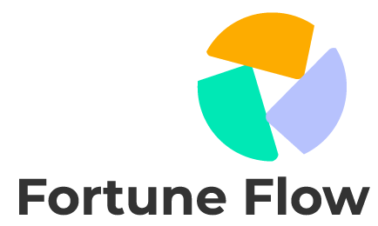

**Strategic Plan**

January 2050

**Table of Contents**

**I. Executive Summary 3**

**II. Vision and Mission 3**

**III. Goals/Objectives 3**

A. Goal 1: Market Leadership 3

# **Executive Summary**

The Fortune Flow Simple Strategic Plan outlines our vision, objectives, and strategies for the next three years. This concise roadmap will guide our company's growth trajectory and enhance our competitive edge. By prioritizing innovation, sustainability, and customer satisfaction, we are poised to achieve substantial progress in our market presence.

# **Vision and Mission**

**Vision:** Fortune Flow aspires to be a worldwide leader in sustainable technology solutions, driving progress for both society and the environment. Our aim is to revolutionize industries through advanced technologies that optimize resource utilization and reduce ecological impact.

# **Goals/Objectives**

## **Goal 1: Market Leadership**

**Objective 1.1: Increase Market Share**

* **Objective:** Achieve a 15% increase in market share within three years.

**Objective 1.2: Expand Presence in Emerging Markets**

* **Objective:** Expand our presence in emerging markets, targeting a 20% growth in revenue from new regions.