RESEARCH REPORT
CRITICAL MINERALS SUPPLY CHAINS: A WORKED EXAMPLE FOR THE PIPELINE
Prepared by: Paperforge Research
Audience: Pipeline test fixture
Completed: August 2026
Paperforge

CONTENTS
- EXECUTIVE SUMMARY
- PART I: CONTEXT
- 1.1. Global demand
- 1.2. Processing bottlenecks
- PART II: FINDINGS
- 2.1. Concentration risk
- CONCLUSION
- ANNEX: SOURCES AND METHOD
- Section 1. Source appraisal
- Section 2. Baselines

1. EXECUTIVE SUMMARY
Refining capacity, not extraction, is the binding constraint. Baseline figures and their provenance are set out in Annex Section 2.
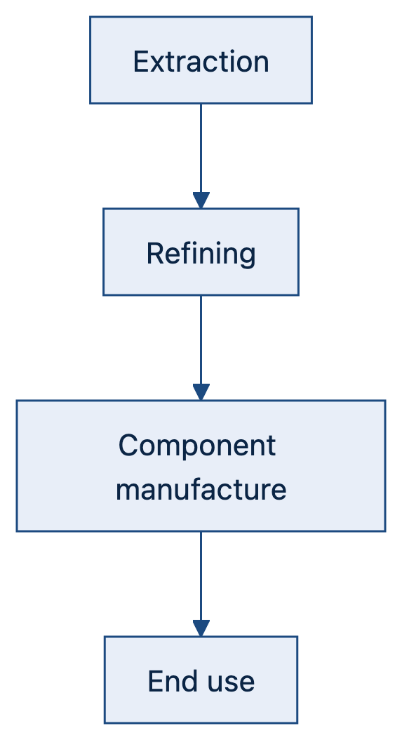
Figure 1

PART I: CONTEXT

1.1. Global demand
Demand grows with electrification. The table below is deliberately wide enough to exercise the horizontal-scroll affordance on a phone.
Mineral | Primary use | Leading producer | Refining share | Substitution risk
Lithium | Batteries | Australia | Concentrated | Low in the near term
Cobalt | Batteries | DRC | Concentrated | Moderate
Rare earths | Magnets | China | Highly concentrated | Low

1.2. Processing bottlenecks
Midstream refining is the choke point; see Annex Section 1 for how each claim was appraised.

PART II: FINDINGS

2.1. Concentration risk
A single jurisdiction refines the majority of several critical inputs.

PART III: CONCLUSION
Policy attention should follow the midstream rather than the mine./.

ANNEX: SOURCES AND METHOD

1. SOURCE APPRAISAL
Each figure is traced to a named published source and dated.

2. BASELINES
Indicator | Baseline | Source
Refining concentration | 60–90% | Industry statistics
Demand growth | 8–12%/yr | Sector outlooks

