|  |
| --- |
| Exia.Cesi |
| Projet modélisation | |
| Livrables (DD, MDF) | |

|  |
| --- |
| SAMY MEFTAHI | ECHAIB WALIM | REYHAN CHELLOUF | LAMINE OULDSLIMANE  08/04/2018 |

* Dictionnaire de données

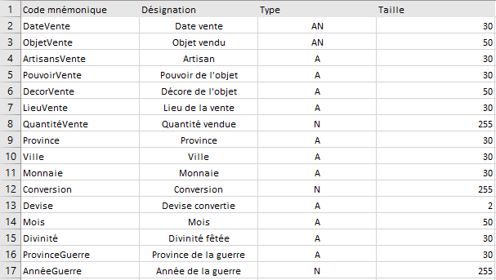

* Matrice des dépendances fonctionnelles

|  |  |  |  |  |  |  |  |  |  |  |  |  |  |  |  |  |  |
| --- | --- | --- | --- | --- | --- | --- | --- | --- | --- | --- | --- | --- | --- | --- | --- | --- | --- |
|  |  | 1 | 2 | 3 | 4 | 5 | 6 | 7 | 8 | 9 | 10 | 11 | 12 | 13 | 14 | 15 | 16 |
| 1 | DateVente | x |  |  |  |  |  |  |  |  |  |  |  |  |  |  |  |
| 2 | ObjetVente |  | x |  |  |  |  |  |  |  |  |  |  |  |  |  |  |
| 3 | ArtisansVente |  |  | x |  |  |  |  |  |  |  |  |  |  |  |  |  |
| 4 | PouvoirVente |  |  |  | x |  |  |  |  |  |  |  |  |  |  |  |  |
| 5 | DecorVente |  |  |  |  | x |  |  |  |  |  |  |  |  |  |  |  |
| 6 | LieuVente |  |  |  |  |  | x |  |  |  |  |  |  |  |  |  |  |
| 7 | QuantitéVente |  |  |  |  |  |  | x |  |  |  |  |  |  |  |  |  |
| 8 | Province |  |  |  |  |  |  |  | x |  |  |  |  |  |  |  |  |
| 9 | Ville |  |  |  |  |  |  |  | 1 | x |  |  |  |  |  |  |  |
| 10 | Monnaie |  |  |  |  |  |  |  |  |  | x |  |  |  |  |  |  |
| 11 | Conversion |  |  |  |  |  |  |  |  |  |  | x |  |  |  |  |  |
| 12 | Devise |  |  |  |  |  |  |  |  |  |  |  | x |  |  |  |  |
| 13 | Mois | 1 |  |  |  |  |  |  |  |  |  |  |  | x |  |  |  |
| 14 | Divinité |  |  |  |  |  |  |  |  |  |  |  |  | 1 | x |  |  |
| 15 | ProvinceGuerre |  |  |  |  |  |  |  |  |  |  |  |  |  |  | x |  |
| 16 | AnnéeGuerre |  |  |  |  |  |  |  |  |  |  |  |  |  |  |  | x |