|  |
| --- |
| Exia.Cesi |
| Projet modélisation | |
| Livrables (DD, MDF) | |

|  |
| --- |
| SAMY MEFTAHI | ECHAIB WALIM | REYHAN CHELLOUF | LAMINE OULDSLIMANE  08/04/2018 |

* Dictionnaire de données

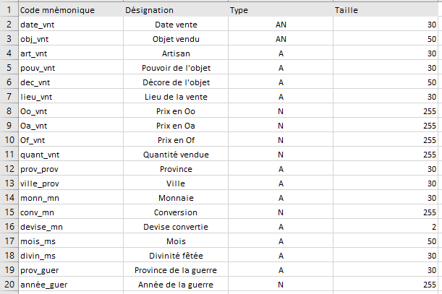

* Matrice des dépendances fonctionnelles

|  |  |  |  |  |  |  |  |  |  |  |  |  |  |  |  |  |  |  |  |  |
| --- | --- | --- | --- | --- | --- | --- | --- | --- | --- | --- | --- | --- | --- | --- | --- | --- | --- | --- | --- | --- |
|  |  | 1 | 2 | 3 | 4 | 5 | 6 | 7 | 8 | 9 | 10 | 11 | 12 | 13 | 14 | 15 | 16 | 17 | 18 | 19 |
| 1 | Date_vnt | x |  |  |  |  |  |  |  |  |  |  |  |  |  |  |  |  |  |  |
| 2 | Obj_vnt |  | x |  |  |  |  |  |  |  |  |  |  |  |  |  |  |  |  |  |
| 3 | Art_vnt |  |  | x |  |  |  |  |  |  |  |  |  |  |  |  |  |  |  |  |
| 4 | pouv_vnt |  |  |  | x |  |  |  |  |  |  |  |  |  |  |  |  |  |  |  |
| 5 | Dec_vnt |  |  |  |  | x |  |  |  |  |  |  |  |  |  |  |  | 1 |  |  |
| 6 | Lieu_vnt |  |  |  |  |  | x |  |  |  |  | 1 | 1 |  |  |  |  |  |  |  |
| 7 | Oo_vnt |  |  |  |  |  |  | x |  |  |  |  |  |  |  |  |  |  |  |  |
| 8 | Oa_vnt |  |  |  |  |  |  |  | x |  |  |  |  |  |  | 1 |  |  |  |  |
| 9 | Of_vnt |  |  |  |  |  |  |  |  | x |  |  |  |  |  | 1 |  |  |  |  |
| 10 | Quant_vnt |  |  |  |  |  |  |  |  |  | x |  |  |  |  | 1 |  |  |  |  |
| 11 | Prov_prov |  |  |  |  |  |  |  |  |  |  | x |  |  |  |  |  |  |  |  |
| 12 | Ville_prov |  |  |  |  |  |  |  |  |  |  | 1 | x |  |  |  |  |  |  |  |
| 13 | Monn_mn |  |  |  |  |  |  |  |  |  |  |  |  | x |  |  |  |  |  |  |
| 14 | Conv_mn |  |  |  |  |  |  |  |  |  |  |  |  |  | x |  |  |  |  |  |
| 15 | Devise_mn |  |  |  |  |  |  |  |  |  |  |  |  |  |  | x |  |  |  |  |
| 16 | Mois_ms |  |  |  |  |  |  |  |  |  |  |  |  |  |  |  | x | 1 |  |  |
| 17 | Divin_ms |  |  |  |  | 1 |  |  |  |  |  |  |  |  |  |  |  | x |  |  |
| 18 | Prov_guer |  |  |  |  |  |  |  |  |  |  |  |  |  |  |  |  |  | x |  |
| 19 | Année_guer |  |  |  |  |  |  |  |  |  |  |  |  |  |  |  |  |  | 1 | x |