# Introduction

This is to show that the high jitter beacon with poor detection efficiency is already enough to correct for all clock drifts including the change of the Doppler shift for high elevation angles. The methodology is the same as presented previously, with slight changes in the stretching algorithms, as explained later.

# Doppler shifts and clock drifts

As with previous data, if not otherwise stated, the data was acquired using two independent time stamp cards with a relative clock drift of 165 us/s. On top of this, we introduce a Doppler shift for each time stamp based on the pair generation time. The Doppler shift for a 500 km orbit (linear overhead pass approximation) is plotted in the below (left).

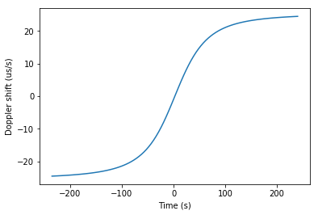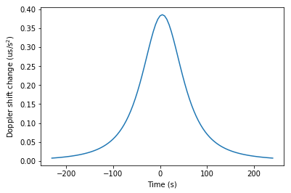

The absolute value of the Doppler shift is not relevant, since it is a constant that gets automagically corrected by the beacon correction. It is almost one order of magnitude less than the clock drift of the two time stamps. More relevant is the change in the Doppler shift over time (right) which is highest at 90 degrees elevation angle and can reach up to 400 ns/s2. This is what we need to correct for.

## Introducing doppler shift on the data

We introduce a Doppler shift of the form,

t = t + ( distance (t) )/( speed-of-light ),

where the distance is calculated for each pair generation time in orbit:

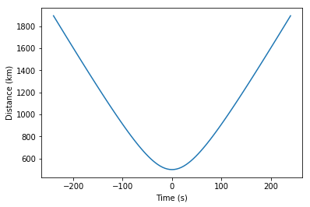

# Data

|  |  |  |  |  |  |  |
| --- | --- | --- | --- | --- | --- | --- |
| **Experiment time** | **Singles 1** | **Singles 2** | **Coincidences** | **QBER** | **Coincidence window** | **Beacon frequency** |
| 1 s | 87 k | 43 k | 5.1 k | 0.05 | 4 ns | 1-10 kHz |

The beacon has a total detected jitter of 6 ns (Alice) and 16 ns (Bob) and is detected with an efficiency between 20-60 percent (depending on resolution, does not seem to matter, the algorithm works for any reasonable detection efficiency).

# Correction

Without accounting for the clock drift, the cross correlation becomes stretched due to the change in relative clock drift over time. This stretch is of the order of microseconds per second (23 us/s for Doppler, 165 us/s for clock drifts) and it causes the cross correlation to be spread out thousands of time bins. This means that the strong correlation gets smeared out, and we cannot distinguish a significant peak in the cross correlation.

For constant clock drifts, we determine the arrival time difference between subsequent beacon pulses on Alice and Bob and determine the average clock drift. We then stretch one of the data sets accordingly and we can recover the cross correlation (see previous reports). We call this a constant correction. However, since the clock drift is not constant under changing Doppler shifts, this constant correction also yields a smeared out cross correlation here.

We generate three data sets for different points in orbit (left: 90 degrees elevation, center: 50s before, right: 150s before).

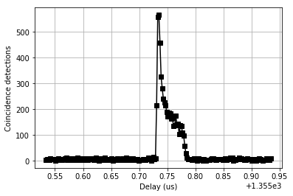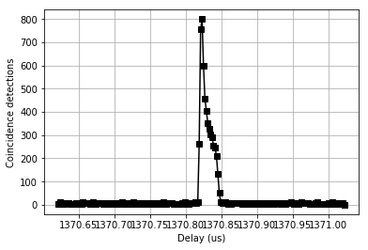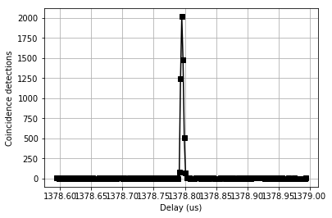

Clearly, the constant correction only works if the Doppler shift is approximately constant (right). For higher elevation, we need to correct the Doppler with a higher order correction.

The higher order correction calculates the clock drift for each point and uses a second order polynomial fit to determine the clock drift at each point. For the case of 90 degrees elevation, this is shown below:

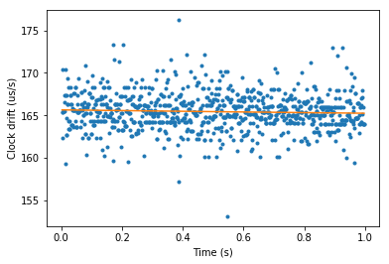

The slight changes in the clock drift are not visible due to the large total clock drift (ns/s vs. us/s). However, we can now use this information to correct each time stamp for the total accumulated clock drift at each point. This is done by stretching one time stamp by the mean of the relative clock drift until that point in time based on the polynomial fit.

The resulting cross correlation is shown below for 1 and 10 kHz (left, right):

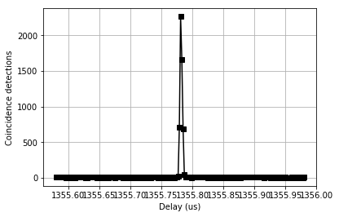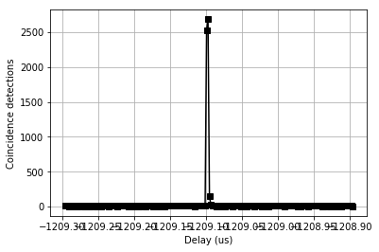

All coincidences can be recovered using a coincidence window of 4 ns and > 75 % can be recovered with a coincidence window of 2 ns. This is the same as for the data that was taken for the atomic clock assuming perfect synchronization. The seemingly sharper cross correlation is an artifact of the random binning of the histogram.

# Conclusion

We can completely reconstruct the signal despite high clock drifts and Doppler shift for all cases using a beacon with any frequency above 1 kHz. Even the poor timing jitter and detection efficiency average out over time. This suggest two things:

1. The stability of the clocks are largely irrelevant. We can choose something reasonably small and stable 🡪 TCXO
2. The beacon requirements are not so strict and even the SLED may be sufficient.

# Appendix: Comparison to the atomic clock data

Data acquired with atomic clock:

|  |  |  |  |  |  |  |
| --- | --- | --- | --- | --- | --- | --- |
| Experiment time | Singles 1 | Singles 2 | Coincidences | QBER | Tau | Comment |
| 1 s | 116 k | 69 k | 3.3 k | 0.10 | 1 |  |
| 1 s | 116 k | 69 k | 7.5 k | 0.06 | 1 | Shifted by 0.4 tau |
| 1 s | 116 k | 69 k | 10.0 k | 0.05 | 2 |  |
| 1 s | 116 k | 69 k | **10.5 k** | 0.05 | 3 | All coincidences detected |

Data acquired with beacon:

|  |  |  |  |  |  |  |
| --- | --- | --- | --- | --- | --- | --- |
| Experiment time | Singles 1 | Singles 2 | Coincidences | QBER | Tau |  |
| 1 s | 87 k | 43 k | 3.1 k | 0.05 | 1 |  |
| 1 s | 87 k | 43 k | 4.3 k | 0.05 | 1 | Shifted by 0.3 tau |
| 1 s | 87 k | 43 k | 5.1 k | 0.05 | 2 |  |
| 1 s | 87 k | 43 k | **5.2 k** | 0.05 | 3 | All coincidences detected |