DBS301

ASSIGNMENT 1

1. Display employee name, hire date as “Hire Date-Time” in a format given below, number of months employed (rounded to 2 decimal places and with an alias “# of Months” ), job and salary as “Pay” in a format given below, but only for people whose job title starts on S or on M. Exclude people hired in September and October of any year.

Here is one of the rows with its heading sample:

LName Hire Date-Time # of Months Job Pay
-----------------------------------------------------------------------------------------------------------------
JONES 02nd April 1981 00:00 366.08 MANAGER $02,975.0

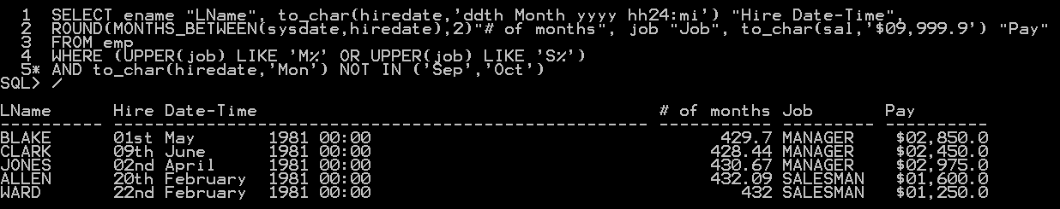

2. Select name, job title, salary and manager Id for all employees that meet all of the following conditions:
- Job title is Salesman or Clerk
- Salary is in the range of 950 to 1500
- Manager is not Clark
Sort the output by manager Id firstly and then by name.
Use a SUBQUERY here.
Here is the heading sample:

EMPLOYEE JOB TITLE SALARY MANAGER ID
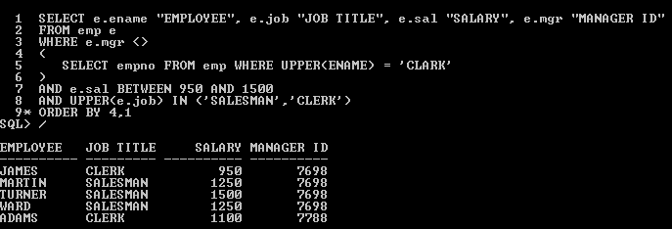

3. Display employee name (“Employee Name”), manager name (“Manager Name”), manager salary (“Manager Salary”) for all employees that have a manager making in the range of 3000 to 5000. Choose only employees that do not have an A in their names.

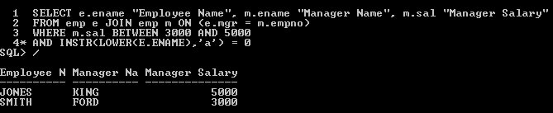

4. Display all customer IDs, customer names, and sales rep names with appropriate aliases, but only if the rep’s name does not have R as the last or before the last character. List all customers, even if they do not have a sales rep. Sort by the customer names ascending.

Here is the heading sample:

Customer ID Customer Name Sales Rep
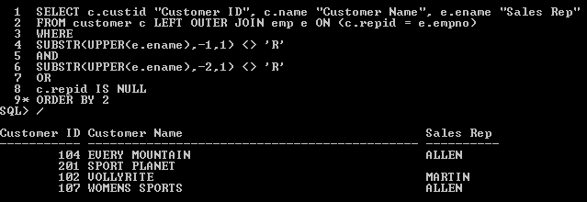

5. Display the department number, department name, the total salary and minimum salary for each department, and how many people work in the department.. Exclude any group where the total salary is less than $10,000. Supply all column aliases. Sort by top total salaries first.
Here is the heading sample:

Dept # Dept Name Total Salary Min Salary # of Employees

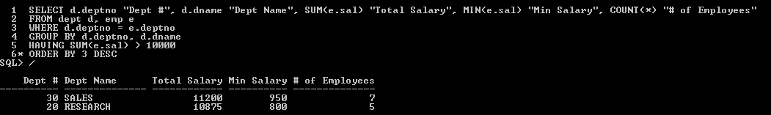

6. Display customer Name, customer city, the total money amount of that customer’s orders, total number of orders, and the sales rep name for all customers who have more than three orders. Sort with the highest total money amount of orders first.
Here is one of the rows with its heading sample:

Customer Name CITY Total Amt Total Orders Rep Name
--------------------------------------------------------------------------------------------------
EVERY MOUNTAIN CUPERTINO $7,211.0 4 ALLEN
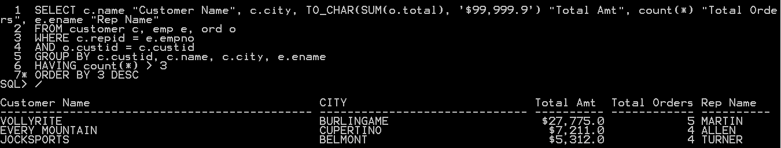

7. Show employee name, job and salary if they earn more than the amount equal to the lowest salary of all average department salaries and if they do not perform the same job as Turner or Scott. Sort by job and then by top salaries. Use a SUBQUERY here.

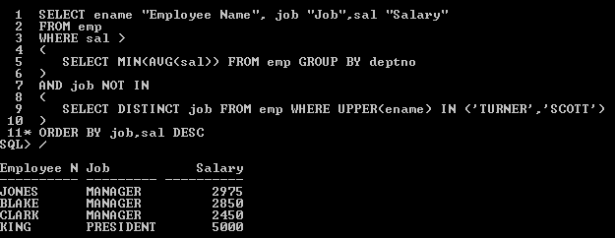

8. Display department name and name of all employees plus their manager status. Status should show message ‘is a Manager’ for those who are managers. For those who are not managers should show message ‘is NOT a Manager’. Include also empty departments as well, where the status value should be ‘NO Manager yet’. Display those people who are managers first and empty departments last. Then sort by the employee name alphabetically.
Here is the heading sample:

Department Name Employee Manager Status

