Model Archive Summary for Escherichia coli Concentration at USGS 420839080081801 Presque Isle Beach 6 Center PA

This archive summarizes the steps used to develop a multiple linear regression model that computes the probability of Escherichia coli (E. coli) concentrations exceeding 235 colony-forming units per 100 milliliters (CFU/100 mL) from May 29, 2014 through September 2, 2018. The model was based on data that do not require a water sample be collected and analyzed, and was used daily to aide in management decisions during the recreational season of 2019.

Site and Model Information
Site number: USGS 420839080081801
Site name: Presque Isle Beach 6 Center PA
Site location: Latitude (N) 42°08'39", Longitude (W) 80°08'18”, Erie County, Pennsylvania, Hydrologic Unit 04120200.
Equipment and data sources: At the same time samples for E. coli were collected, field personnel measured environmental parameters at one location at Presque Isle Beach 6 center at the swimming beach. These included air and water temperature using a hand-held instrument, wave height using a graduated rod, and counts of the numbers of bathers and birds. Turbidity was measured from discrete samples using a field portable turbidimeter.
From May 2014 to the present, Beach 2 Weather Tower, operated by the Regional Science Consortium, provides weather data, recorded every 30 minutes and available on a public website (https://www.wqdatalive.com/public/55).
Streamflow data were recorded at USGS 04213152, Walnut Creek Upstream Pool, near Erie, PA (https://waterdata.usgs.gov/pa/nwis/uv?site_no=04213152). Lake level data were available for the NOAA Erie Pennsylvania station 9063038 (https://tidesandcurrents.noaa.gov/stationhome.html?id=9063038).
Airport rainfall, wind, and barometric pressure data were available for Erie International Airport (ERI) USW00014860 (https://www.ncdc.noaa.gov/cdo-web/datasets/NORMAL_ANN/stations/GHCND:USW00014860/detail).
Date model was created: May 21, 2019
Model calibration data period: May 29, 2014 through September 2, 2018
Model application date: May 26, 2019
Computed by: Matthew Conlon, U.S. Geological Survey, Pennsylvania, mconlon@usgs.gov
Reviewed by: Amie Brady, U.S. Geological Survey, Ohio, amgbrady@usgs.gov
Approved by: Tammy Zimmerman, U.S. Geological Survey, Pennsylvania, tmzimmer@usgs.gov

Model Data
Data on E. coli concentration, the dependent variable, are stored in the National Water Information System (NWIS) database (https:// doi.org/10.5066/F7P55KJN), Station ID=420839080081801, parameter code 90902. Potential explanatory variables included weather data from Presque Isle Beach 2 weather station, USGS discharge data from the Walnut Creek Upstream Pool near Erie PA (USGS 04213152), and third-party data for locations near the sampling site. The third-party data, collected by direct download, included wind speed and direction, barometric pressure, rainfall, and lake level data. These data were checked and manipulated by the USGS for use in data analysis, as described in Francy and others (2013). A seasonal component (0 for before July 15; 1 for July 15 or later) was also evaluated as a potential explanatory variable in models. A list of all environmental and water-quality data evaluated as explanatory variables in model development are available in the file “Beach6_2019_ original_data.xlsx.”

Sampling and analysis detail
Discrete grab samples for E. coli concentration were collected by Regional Science Consortium personnel in the swimming area at the Presque Isle Beach 6 Center location and analyzed by the Regional Science Consortium Laboratory as described in Francy and others (2013). The average of two E. coli concentrations from discrete samples collected at the Presque Isle Beach 6 Center location was used in model calibration and validation. Two measurements of turbidity were done for each of the discrete samples; the average of the four turbidity measurements was used in models.

Model Calibration Dataset
The final ordinary least square (OLS) model was based on E. coli concentrations (log₁₀) from 463 water samples and field measurements/observations of turbidity (log₁₀), water temperature, and number of birds; instantaneous relative humidity from the Beach2 weather tower; change in lake level over the last 24 hours; and airport instantaneous wind speed and antecedent rainfall (square root) . Summary statistics are provided below, and the model data are provided in the file, “Beach6_2019_calibration_data.csv.” This file can be used to re-create the model, using Virtual Beach software (described below). Studentized residuals from the final model were inspected for values greater than 3 or less than negative 3. Values outside of the 3 to -3 range are considered potential outliers and require investigation. No outliers were identified in the model-calibration dataset.

Model Development
Data analysis and model development were done based on the procedures described in Francy and Darner (2006) using Virtual Beach version 3.07 (https://www.epa.gov/ceam/virtual-beach-vb). Virtual Beach is a free, easy-to-use software package for running, validating, and updating models that can be used by water-resource managers to help make management decisions.
E. coli concentrations and explanatory variables were imported into Virtual Beach and were mathematically transformed as necessary to linearize their relations. All possible combinations of up to eight explanatory variables were evaluated in models within Virtual Beach. The prediction error sum of square (PRESS) was used to rank candidate models. To avoid harmful multi-collinearity, explanatory variables were not used in the same model if the variance inflation factor (VIF) exceeded 3.
Model diagnostics and selection were done as described in Francy and Darner (2006) and included tests for (1) statistical significance of explanatory variables, (2) influence and leverage of observations, (3) normality and homoscedasticity of residuals, and (4) development of scatterplots to ensure relations between explanatory variables and the dependent variable were linear. The Anderson-Darling test was used to test for autocorrelation of residuals.
After ranking in increasing order by PRESS statistic, the best model was selected based on (1) significance of explanatory variables (p<0.05), (2) ability to reasonably explain how each explanatory variable could potentially affect the observed variation in E. coli concentrations, and (3) the ability to use the model results to estimate threshold exceedance for E.coli concentrations with good sensitivity and specificity.
Model Summary
Summary of final regression analysis for E. coli concentration at USGS 420839080081801 Presque Isle Beach 6 Center PA. The model report generated from Virtual Beach is the text file, “Beach6_2019_report.txt.” The Virtual Beach project file containing the model is “PISP_Beach6_2019.vb3p.” You will need to install Virtual Beach (described above) to open this file.
ECOLI_LOG10 = -1.013 + 0.6835*(LOG10(TURB_NTRU)) + 0.007938*(RHUM_PCT) + 0.05256*(WTEMP_CEL) + 0.001812*(BIRDS_NO) + 0.3176*(CHANGELL_FT) + 0.02481*(AirportWindSpInst_mph) + 0.198*(SQUAREROOT(AirportRain48W_in))
Where
ECOLI_LOG10 is the concentration of E. coli in log₁₀ colony-forming units per 100 milliliters (CFU/100 mL). A threshold of 2.37 log₁₀ CFU/100 mL was used for the model.
TURB_NTRU is the turbidity in nephelometric turbidity ratio units, measured by use of a field instrument at the same location and time as the E. coli sample was collected. This variable needs to be log₁₀-transformed for the model.
RHUM_PCT is the relative humidity, percent, measured at the time the E. coli sample was collected.
WTEMP_CEL is the water temperature, degrees Celsius, measured at the time the E. coli sample was collected.
BIRDS_NO is the number of birds on the sand, in the water near and in the bathing area at the time the E. coli sample was collected.
CHANGELL_FT is the lake level change over the last 24 hours (8 a.m. today-8 a.m. yesterday), in feet, NOAA Station at Erie, PA.

AirportWindSpInst_mph is wind speed instantaneous at 8 a.m., miles per hour, Erie International Airport, PA.

AirportRain48W_in is rainfall, in inches, cumulated sums for the past 48 hours, giving the most weight to the most recent value, as follows: (2 * Dm1) + Dm2. DM1 is the 24-hour total up to 8 a.m. on the day the E. coli sample was collected; DM2 is the rain 2 days ago, Erie International Airport, PA. The square root of this variable needs to be used in the model.

The output from each selected model was the probability of exceeding a threshold E. coli concentration of 2.37 log₁₀ or 235 CFU/100 mL. The probability of exceeding the threshold was calculated as described in Francy and Darner (2006).

Model Statistics, Data and Plots
A variety of models that predict E. coli concentrations were evaluated. Best Fit scores ranged from 109.9 to 110.6; the best model was selected with the 3rd lowest Best Fit score, an adjusted R² in line with all candidate models (0.48).
Basic Model Statistics
Number of samples=463
Coefficient of determination (adjusted R²) = 0.47
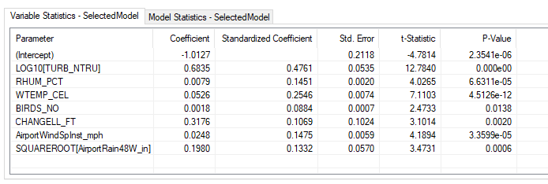
Variable summary statistics (calibration dataset)
 | E. coli, CFL/100 mL (LOG₁₀) | Turbidity, nephelometric turbidity ratio units | Relative humidity, percent | Water temperature, degrees Celsius | Birds, number observed | Change in lake level, ft, Erie PA | Wind Speed, Instantaneous, miles per hr, Erie Intl Airport |  | Rainfall, 48 hours, weighted, inches, Erie Intl Airport
Min | 0.30 | 0.60 | 42 | 9.2 | 0 | -1.04 |  | 0 | 0
Median | 1.53 | 5.5 | 73 | 22.2 | 10 | -0.003 |  | 7 | 0.04
Mean | 1.51 | 10.9 | 73 | 21.4 | 24 | -0.007 |  | 7 | 0.33
Max | 3.00 | 160 | 219 | 29.8 | 200 | 0.79 |  | 22 | 10.76

Threshold probability, specificity, sensitivity, and accuracy (calibration dataset)
Setting a threshold probability of 25%, the specificity of the model is 0.90, sensitivity 0.49, and accuracy 0.87. There are 41 false positives and 22 false negatives in the calibration dataset; 44 data points were equal to or above 2.37 log₁₀ CFU/100 mL.
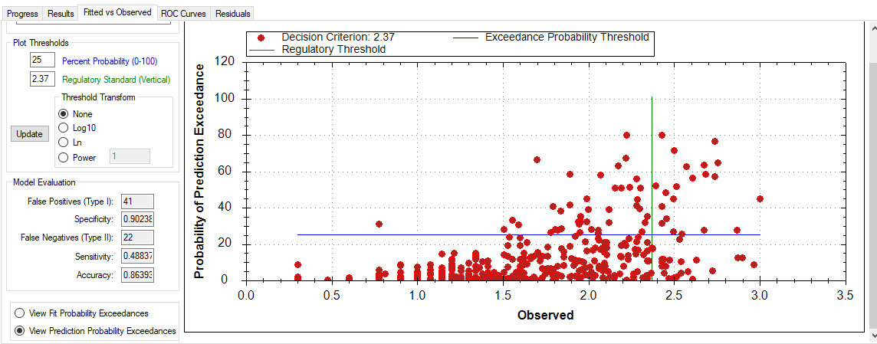

Model validation and use in 2019
The model was used in 2019 for management decisions. The daily data spreadsheets with E. coli and explanatory variable data are in the file “Beach6_validation_spreadsheet_2019.” Of the 100 observations, only one sample exceeded the E. coli threshold concentration of 235 CFU/100 mL. Using a threshold probability of 25%, the use of the model resulted in 14 false positive and 0 false negatives during 2019; model specificity was 85.9%, sensitivity was 100%, and accuracy was 86.0%. Model results can be compared with using the previous day’s E. coli concentration to estimate the current day’s E. coli concentration (persistence method). The persistence method results in only 1 false positive and 1 false negative; specificity was 99.0%, sensitivity was 0%, and accuracy was 98.0%.

References
Francy, D.S., Darner, R.A., 2006, Procedures for developing models to predict exceedances of recreational water-quality standards at coastal beaches: U.S. Geological Survey Techniques and Methods, 6‒B5, 34 p., https://pubs.usgs.gov/tm/2006/tm6b5/.
Francy, D.S., Brady, A.M.G., Carvin, R.B., Corsi, S.R., Fuller, L.M., Harrison, J.H., Hayhurst, B.A., Lant, J., Nevers, M.B., Terrio, P.J., and Zimmerman, T.M., 2013, Developing and implementing predictive models for estimating recreational water quality at Great Lakes beaches: U.S. Geological Survey Scientific Investigations Report 2013-5166, 68 p., https://doi.org/10.3133/sir20135166.

