Model Archive Summary for Escherichia coli Concentration at Huntington Reservation USGS 412928081560220 (2 Central), 412929081561100 (West), and 412928081560215 (Composite)

This archive summarizes the steps used to develop a multiple linear regression model that computes the probability of Escherichia coli (E. coli) concentrations exceeding 235 colony-forming units per 100 milliliters (CFU/100 mL) from May 25, 2005 through September 2, 2019. The model was based on real-time data and was analyzed and used daily to aid in management decisions during the recreational season of 2019.

Site and Model Information
Site number: USGS 412928081560220, USGS 412929081561100, USGS 412928081560215
Site name: Lake Erie at Huntington Reservation 2 (central), Lake Erie at Huntington Reservation West OH (west), Lake Erie 3Ft W-C Composite at Huntington Res. OH (composite)
Site location: Latitude (N) 41°29'28", Longitude (W) 81°56'02”, Cuyahoga County, Ohio, Hydrologic Unit 04120200.
Equipment and data sources: At the same time samples for E. coli were collected, field personnel measured environmental parameters at one location at Huntington Reservation 2 at the swimming beach: water temperature using a hand-held instrument and wave height using a graduated rod. Turbidity was measured from discrete samples using a field portable turbidimeter.
Lake level data were available for the NOAA Cleveland, Ohio station 9063063 (https://tidesandcurrents.noaa.gov/).
Airport rainfall, wind, and barometric pressure data were available for Cleveland-Hopkins International Airport (CLE) USW00014820 (https://www.ncdc.noaa.gov/cdo-web/datasets).
Date model was created: May 13, 2019
Model calibration data period: May 25, 2005 through September 3, 2018
Model application date: May 20, 2019
Computed by: Becky Karns, Cuyahoga County Board of Health, Ohio, bkarns@ccbh.net
Reviewed by: Samantha Smith, Cuyahoga County Board of Health, Ohio, ssmith@ccbh.net
Approved by: Amie Brady, United States Geological Survey, Ohio, amgbrady@usgs.gov

Model Data
Starting in 2008, data on E. coli concentration, the dependent variable, are stored in the National Water Information System (NWIS) database (https://doi.org/10.5066/F7P55KJN), Station ID= USGS 412928081560215, USGS 412928081560220, and USGS 412929081561100, parameter code 90902 or 50468. Potential explanatory variables included field measurements and observations and third-party data for locations near the sampling site. The third-party data, collected by direct download, included wind speed and direction, rainfall, and lake level data. These data were checked and manipulated by the USGS for use in data analysis, as described in Francy and others (2013). A list of all environmental and water-quality data evaluated as explanatory variables in model development are available in the file “Huntington_2019_ original_data.xlsx.”

Sampling and analysis detail
Discrete grab samples for E. coli concentration were collected by personnel from the Cuyahoga County Board of Health at two locations at the swimming beach from 2005 through 2015 (central and west) or from one location from 2016 through 2019 (central). Samples were analyzed by the Northeast Ohio Regional Sewer District Laboratory as described in Francy and others (2013). From 2005 through 2012, samples were analyzed by use of the modified mTEC method (parameter code 90902); from 2013 through 2019, samples were analyzed by the Colilert QuantiTray method (parameter code 50468). The average of two E. coli concentrations (west and central) was used in model calibration for data collected from 2005 through 2015; otherwise, one sample result was used for each observation. Average E. coli concentrations were stored in NWIS under the composite site for samples collected in 2008 through 2010. Measurements of turbidity were done for each of the discrete samples; the average of the two turbidity measurements were used in models when applicable.

Model Calibration Dataset
The final ordinary least square (OLS) model was based on E. coli concentrations (log₁₀) from 1,011 water samples and field measurements of turbidity (log₁₀), water temperature, and wave height (square root); change in lake level over the last 24 hours; and airport antecedent rainfall (square root). Summary statistics are provided below, and the model data are provided in the file, “Hutnginton_2019_calibration_data.csv.” This file can be used to re-create the model, using Virtual Beach software (described below). Studentized residuals from the final model were inspected for values greater than 3 or less than negative 3. Values outside of the 3 to -3 range are considered potential outliers and require investigation. No outliers were identified in the model-calibration dataset.

Model Development
Data analysis and model development were done based on the procedures described in Francy and others (2006) using Virtual Beach version 3.07 (https://www.epa.gov/ceam/virtual-beach-vb). Virtual Beach is a free, easy-to-use software package for running, validating, and updating models that can be used by water-resource managers to help make management decisions.
Escherichia coli concentrations and explanatory variables were imported into Virtual Beach and were mathematically transformed as necessary to linearize their relations. All possible combinations of up to eight explanatory variables were evaluated in models within Virtual Beach. The Corrected Akaike Information Criterion (AICC) was used to rank candidate models. To avoid harmful multi-collinearity, explanatory variables were not used in the same model if the variance inflation factor (VIF) exceeded 3.
Model diagnostics and selection were done as described in Francy and Darner (2006) and included tests for (1) statistical significance of explanatory variables, (2) influence and leverage of observations, (3) normality and homoscedasticity of residuals, and (4) development of scatterplots to ensure relations between explanatory variables and the dependent variable were linear. The Anderson-Darling test was used to test for autocorrelation of residuals.
After ranking in increasing order by AICC statistic, the best model was selected based on (1) significance of explanatory variables (p<0.05), (2) ability to reasonably explain how each explanatory variable could potentially affect the observed variation in E. coli concentrations, and (3) the ability to use the model results to estimate threshold exceedance for E. coli concentrations with good sensitivity and specificity.
Model Summary
Summary of final regression analysis for E. coli concentration at Huntington Reservation, Ohio (USGS 412928081560220, USGS 41292908156110, and 412928081560215). The model report generated from Virtual Beach is the text file, “Huntington_model_2019_report.txt.” The Virtual Beach project file containing the model is “Huntington_model_2019.vb3p.” You will need to install Virtual Beach (described above) to open this file.
LOG10(EcoliAve_CFU) = -0.03466 + 0.03596*(Lake_Temp_C) + 0.6896*(LOG10(Lake_Turb_NTRU)) + 0.1942*(SQUAREROOT(WaveHt_Ft)) + 0.3781*(LL_PreDay) + 0.4537*(SQUAREROOT(AirportRain48W_in))
Where
EcoliAve_CFU is the concentration of E. coli colony-forming units per 100 milliliters (CFU/100 mL) or most probable number per 100 milliliters (MPN/100mL). This variable needs to be log10-transformed in the model. A threshold of 2.37 log₁₀ CFU/100 mL was used for the model.
Lake_Temp_C is the water temperature, degrees Celsius, measured at the time the E. coli sample was collected.
Lake_Turb_NTRU is the turbidity in nephelometric turbidity ratio units, measured by use of a field instrument at the same location and time as the E. coli sample was collected. This variable needs to be log₁₀-transformed for the model.
WaveHt_Ft is the wave height in feet, measured by use of a measuring rod at the same location and time as the E. coli sample was collected. This variable uses a square root transformation for use in the model.
LL_PreDay is the lake level change over the last 24 hours (8 a.m. today-8 a.m. yesterday), in feet, NOAA Station at Cleveland, Ohio.

AirportRain48W_in is rainfall, in inches, cumulated sums for the past 48 hours, giving the most weight to the most recent value, as follows: (2 * AirportRain24_in) + AirportRain48_in. AirportRain24_in is the 24-hour total up to 8 a.m. on the day the E.coli samples was collected; AirportRain48_in is the rain 2 days ago, Cleveland-Hopkins International Airport, Ohio. This variable uses a square root transformation for use in the model.

The output from each selected model was the probability of exceeding a threshold E. coli concentration of 2.37 log₁₀ or 235 E. coli per 100 milliliters. The probability of exceeding the threshold was calculated as described in Francy and Darner (2006).

Model Statistics, Data and Plots
A variety of models that predict E. coli concentrations were evaluated. The model with the lowest best fit score was selected; the adjusted R² was the largest among candidate models.
Basic Model Statistics
Number of samples=1,011
Coefficient of determination (adjusted R²) = 0.55
Best Fit statistic = -628.8461

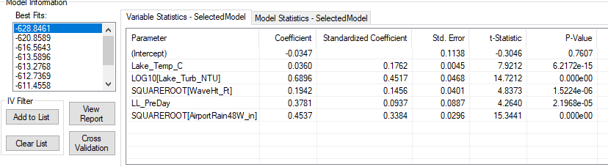
Variable summary statistics (calibration dataset)

 | EcoliAve_CFU | Lake_Temp_C | Lake_Turb_NTRU | WaveHt_Ft | LL_PreDay, feet | AirportRain48W_in
Min | 0 | 11.1 | 1.2 | 0.0 | -0.584 |  | 0
Median | 47 | 22.4 | 8.4 | 0.30 | -0.010 |  | 0055
Mean | 200 | 21.8 | 18 | 0.67 | -0.001 |  | 0.394
Max | 16,000 | 28.1 | 603 | 5.0 | 0.86 |  | 8.39
Threshold probability, specificity, sensitivity, and accuracy (calibration dataset)
Setting a threshold probability of 30%, the specificity of the model is 89.4%, sensitivity 66.5%, and accuracy 85.2%. There are 87 false positives and 63 false negatives in the calibration dataset; 188 data points were equal to or above 2.37 log₁₀ or 235 CFU/100 mL.
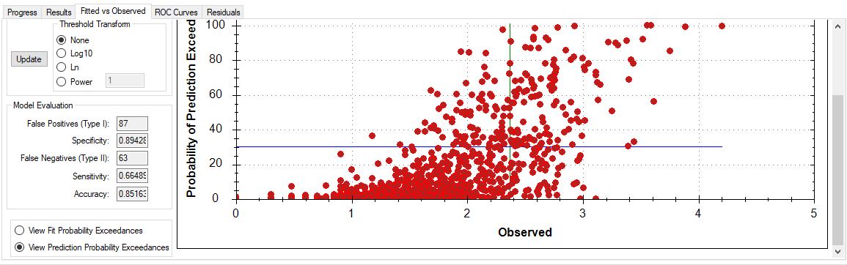

Model validation and use in 2019
The model was used in 2019 for management decisions. The nowcast probabilities, nowcast E. coli predictions, lab E. coli concentrations, and error types are in the file “Huntington_validation_spreadsheet_2019.” Of the 103 observations, 12 samples exceeded the E. coli threshold concentration of 235 CFU/100 mL. Using a threshold probability of 30%, the use of the model resulted in 16 false positive and 3 false negatives during 2019; model specificity was 82.4%, sensitivity was 75.0%, and accuracy was 81.6%. Model results can be compared with using the previous day’s E. coli concentration to estimate the current day’s E. coli concentration (persistence method). The persistence method resulted in 8 false positives and 9 false negatives; specificity was 90.8% sensitivity was 25.0%, and accuracy was 82.8%.

References
Francy, D.S., Darner, R.A., 2006, Procedures for developing models to predict exceedances of recreational water-quality standards at coastal beaches: U.S. Geological Survey Techniques and Methods, 6‒B5, 34 p., https://pubs.usgs.gov/tm/2006/tm6b5/.
Francy, D.S., Brady, A.M.G., Carvin, R.B., Corsi, S.R., Fuller, L.M., Harrison, J.H., Hayhurst, B.A., Lant, J., Nevers, M.B., Terrio, P.J., and Zimmerman, T.M., 2013, Developing and implementing predictive models for estimating recreational water quality at Great Lakes beaches: U.S. Geological Survey Scientific Investigations Report 2013-5166, 68 p., https://doi.org/10.3133/sir20135166.

