Hello Boris,

I am done. You can hand over to your engineer team asap. 🥳🙃

Code can be found here:

<https://github.com/thereforcer/absa.hire>

As an Azure specialist, I have also provisioned the testing endpoint for you. 🤓🤠

[https://absahirehavelka.azure-api.net/convert/v1/{value}/{unit}/to/{expectedUnit}](https://absahirehavelka.azure-api.net/convert/v1/%7bvalue%7d/%7bunit%7d/to/%7bexpectedUnit%7d)

*Warning:* API rate limit is 16 calls per 5 minutes from one IP address which will grant you about ~4600 max calls per day.

Testing endpoint from task definition:

<https://absahirehavelka.azure-api.net/convert/v1/1/meter/to/feet>

<https://absahirehavelka.azure-api.net/convert/v1/3/kiloinches/to/meter>

<https://absahirehavelka.azure-api.net/convert/v1/1/MiB/to/bytes>

<https://absahirehavelka.azure-api.net/convert/v1/20/fahrenheit/to/kelvin>

Solution contains 3 projects, one is API library, one is unit test project and last one is AZF (Azure Function) compatible endpoint project.

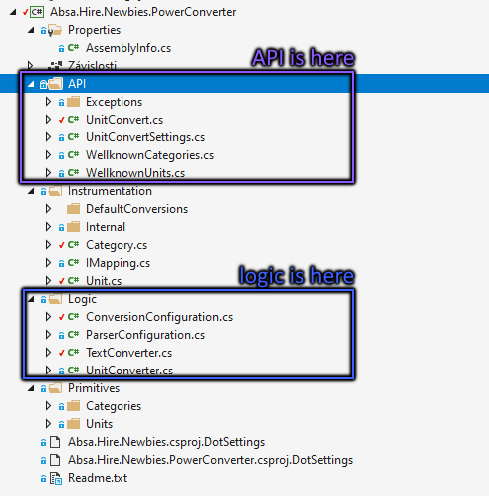

Test project contains 26 unit tests with 80% pure code coverage without test project.

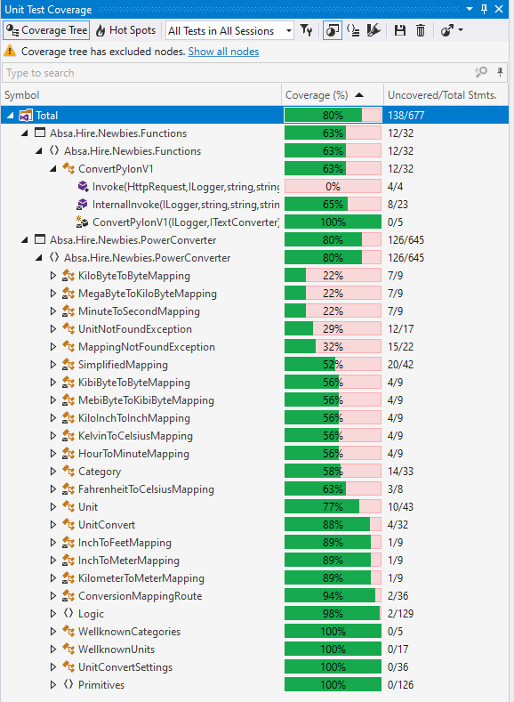

👉 Run dotnet test

