**Attendance Management System using Face Recognition**

A Project Report

submitted in partial fulfillment of the requirements

of

AICTE Internship on AI: Transformative Learning

with

TechSaksham – A joint CSR initiative of Microsoft & SAP

by

**PARNE MANOHAR REDDY,**

**Parnemanoharreddy19@gmail.com**

Under the Guidance of

**Aditya Prashant Ardak**

**Master Trainer, Edunet Foundation.**

**ACKNOWLEDGEMENT**

I would like to express my gratitude to everyone who supported me during the development of this project.

First of all, I am truly grateful to my supervisor, **Aditya Prashant Ardak**, for guiding me throughout the project. His advice, encouragement, and feedback always kept me motivated. Working under his guidance not only helped me complete this project but also gave me new insights and ideas that I will carry forward.

I would also like to thank **Pavan Kumar Sumohana**, who made sure everything was well-organized. His efforts in sharing online classes and keeping me updated with all the information about the project were extremely helpful.

Lastly, I want to thank the entire team behind the virtual internship for providing me with this opportunity. This 4-week journey has been a great learning experience, and I am thankful to everyone who contributed to it.

#### **ABSTRACT**

This project focuses on building an Attendance Management System using facial recognition to automate and improve the process of marking attendance. Traditional methods are often time-consuming and prone to errors, and this project provides an efficient alternative by utilizing machine learning and computer vision techniques.

The system allows users to enroll by capturing facial images, which are then used to train a recognition model. Once trained, the model is capable of identifying individuals in real-time through a webcam. Upon successful recognition, the system logs attendance automatically, handling various scenarios such as marking new attendance, identifying individuals who are already marked, and retrying for failed recognitions.

The project is implemented using Python, with libraries such as OpenCV and face_recognition for image processing and recognition. A Tkinter-based graphical user interface (GUI) is used for user interaction. Attendance records are stored in CSV files, ensuring easy access and management of data.

The key functionalities include real-time face recognition, attendance logging, handling duplicate entries, and addressing recognition failures. The system successfully reduces manual effort, enhances accuracy, and provides a reliable way to manage attendance records.

This project demonstrates the potential of facial recognition technology to automate routine tasks, making it a practical solution for schools, colleges, and offices seeking a modern, user-friendly attendance system.

**TABLE OF CONTENT**

**Abstract I**

**Chapter 1.**  **Introduction 1**

1.1 Problem Statement 1

1.2 Motivation 1

1.3 Objectives 2

1.4. Scope of the Project 2

**Chapter 2.**  **Literature Survey 3**

**Chapter 3.**  **Proposed Methodology**

**Chapter 4.**  **Implementation and Results**

**Chapter 5. Discussion and Conclusion**

**References**

**LIST OF FIGURES**

|  |  |  |
| --- | --- | --- |
| **Figure No.** | **Figure Caption** | **Page No.** |
|  |  |  |
|  |  |  |
|  |  |  |
|  |  |  |
|  |  |  |
|  |  |  |
|  |  |  |
|  |  |  |
|  |  |  |

**LIST OF TABLES**

|  |  |  |
| --- | --- | --- |
| **Table. No.** | **Table Caption** | **Page No.** |
|  |  |  |
|  |  |  |
|  |  |  |
|  |  |  |
|  |  |  |
|  |  |  |
|  |  |  |
|  |  |  |
|  |  |  |

**CHAPTER 1**

**Introduction**

* 1. **Problem Statement:**

In many educational institutions, offices, and organizations, attendance tracking is an essential but time-consuming and error-prone task. Traditional methods, such as manual registers or sign-in sheets, are not only inefficient but also susceptible to mistakes and manipulation. These conventional methods often fail to provide accurate, real-time data, and they require significant administrative effort.

Moreover, manual attendance methods can result in issues like duplicate entries, inaccurate records, and the potential for fraudulent activities. With the increasing emphasis on automation and efficiency, existing systems such as biometric fingerprint scanners still face limitations, including concerns over hygiene and the need for physical contact.

The need for an efficient, contactless, and accurate solution for attendance management has become more apparent. Automated systems that can track attendance in real-time and reduce human error are crucial for institutions and organizations that require a reliable, scalable, and accurate attendance system.

* 1. **Motivation:**

The choice of this project stemmed from the desire to gain hands-on experience and enhance my skills in areas such as machine learning, computer vision, and data management. Among the various internship projects available, this project stood out as it offered the opportunity to work with real-time data processing, which I found both challenging and exciting.

The Attendance Management System was selected because it involves solving a complex, real-world problem that many institutions and organizations face. By leveraging facial recognition technology, this system addresses the inefficiencies and inaccuracies of traditional attendance tracking methods. It also allows me to deepen my understanding of how computer vision and machine learning can be applied to solve practical problems.

Furthermore, this project aligns with my goal of gaining proficiency in data visualization and analysis. Building a system that tracks attendance automatically and manages data effectively presents a valuable learning experience, combining technical complexity with real-world applications. The potential applications of this system are vast, from educational institutions to corporate offices, making it a practical and impactful project that can improve efficiency and accuracy in everyday operations.

* 1. **Objective:**

The main objectives of this project are:

1. **Automating the Attendance Process**: The goal of this project is to build an automated system for marking attendance using facial recognition. This eliminates the need for manual attendance, saving time and reducing errors.
2. **Real-Time Facial Recognition**: To develop a system that can capture and recognize students’ faces in real-time using a webcam. The system will identify students based on images that have already been enrolled into the system.
3. **User-Friendly Interface**: The project aims to create an easy-to-use graphical user interface (GUI) that allows users to interact with the system, such as enrolling students, viewing attendance, and managing the system.
4. **Handling Recognition Failures and Duplicates**: To ensure that the system can handle scenarios where a student’s attendance is already marked, and retry facial recognition if the system fails to identify a student initially.
5. **Efficient Data Management**: The system will store attendance records in CSV files, ensuring that all data is easily accessible and manageable for future analysis.
6. **Practical Application**: The system is intended for use in educational institutions, such as schools and colleges, and can also be adapted for use in offices and other organizations that require an efficient attendance system.
   1. **Scope of the Project:**

The scope of this project is to design and implement an **Attendance Management System** that uses **facial recognition technology** to automate the process of marking attendance. The system aims to replace traditional, manual methods of attendance marking, offering a more efficient and accurate approach. The key features and scope of the system include:

1. **Facial Enrollment**: Users can register their faces by capturing images through the system, which are then stored for future recognition during attendance marking.
2. **Real-Time Attendance Marking**: Once the system is trained, it uses a webcam to detect and recognize faces in real time. Upon recognizing a person, the system marks their attendance automatically, without any manual input required.
3. **Attendance Logs**: All attendance records are automatically stored in a **CSV file**. This file can be accessed later for review and data management.
4. **Handling Multiple Recognition Scenarios**: The system includes features such as logging attendance for first-time users, handling cases where a person is already marked as present, and retrying recognition if a person’s face cannot be detected.

**Limitations:**

1. **Camera Quality**: The quality of the webcam affects the face detection and recognition accuracy. Poor-quality cameras may lead to inaccurate or failed recognition.
2. **Environmental Conditions**: The system’s accuracy may vary depending on the lighting and the background environment. Poor lighting conditions can impact the performance of the facial recognition model.
3. **Limited Data Set**: The system is designed for a smaller set of registered users. While it works efficiently with a manageable number of faces, it might not perform optimally with a very large database of faces.
4. **Face Recognition Dependency**: The system relies exclusively on facial recognition for marking attendance. It does not include alternative methods like RFID or biometric fingerprint scans.
5. **Recognition Time**: The time required for recognition depends on various factors, such as the clarity of the face in the frame and the system’s processing speed. In cases of poor image quality, recognition time may increase.

**CHAPTER 2**

**Literature Survey**

* 1. **Review of Relevant Literature**

Facial recognition has become an increasingly popular method for automating attendance management due to its efficiency compared to traditional methods. Several studies have explored this technology in educational and workplace environments.

1. Facial Recognition-Based Attendance Systems:

Sangeetha et al. (2019) implemented a facial recognition system that automates attendance by comparing students' images with a database. This approach significantly reduced the time spent on attendance and minimized errors.

1. OpenCV and Machine Learning for Face Detection:

Rao and Murthy (2018) utilized OpenCV and machine learning algorithms like Haar Cascade classifiers and LBPH (Local Binary Pattern Histograms) to create a real-time face recognition system for attendance tracking.

1. Deep Learning for Face Recognition:

Singh et al. (2021) applied deep learning models such as CNNs for more accurate face recognition in classrooms. While effective, these models are computationally expensive and may not be practical in all settings.

1. Hybrid Attendance Systems:

Gupta and Gupta (2017) introduced a hybrid system combining QR codes and facial recognition, which enhanced both security and reliability for attendance systems.

* 1. **Existing Models, Techniques, and Methodologies**

Several models and techniques have been developed for automating attendance using facial recognition:

1. Haar Cascade Classifiers: A widely-used face detection method, utilizing positive and negative images to train classifiers for real-time face detection, forming the basis of many attendance systems.
2. LBPH (Local Binary Pattern Histograms): An efficient technique for real-time facial feature recognition. It compares facial features against a database for attendance marking and is suitable for systems with limited computational resources.
3. Convolutional Neural Networks (CNNs): Deep learning models providing higher accuracy in face recognition, ideal for complex scenarios but requiring more computational power.
4. Hybrid Systems: Systems combining QR codes and facial recognition, enhancing security by using two methods for verification, improving accuracy and reliability.
5. Real-Time Face Recognition Systems: Powered by OpenCV and machine learning algorithms, these systems capture and process images for immediate attendance marking, automating the attendance process efficiently**.**
   1. **Gaps and Limitations in Existing Solutions**

Existing facial recognition attendance systems, while effective, have several limitations:

1. Accuracy Issues: Many systems struggle with low-light conditions or variations in facial appearance, leading to errors in recognition.
2. High Computational Requirements: Advanced models like CNNs, though accurate, are computationally expensive and may not be practical for real-time applications with limited hardware.
3. Security Concerns: Hybrid systems that use QR codes and facial recognition may still be vulnerable to identity theft or spoofing attacks.
4. Limited Flexibility: Some systems lack the ability to handle multiple face variations (e.g., different facial expressions, hairstyles) or dynamic environments.

**How My Project Addresses These Ga**ps: This project aims to improve accuracy and efficiency in real-time face recognition while addressing hardware limitations by using LBPH, which requires less computational power compared to deep learning models. Additionally, the system focuses on error handling, such as retrying when recognition fails, and ensures security through continuous face recognition verification, minimizing the risks associated with spoofing.

**CHAPTER 3**

**Proposed Methodology**

* 1. **System Design**

1. **User Interaction**: Users interact with the system through a **Graphical Interface (GUI)** to either enroll or log attendance.
2. **Enrollment**: The system captures and enrolls the user's face by creating a facial profile for future recognition.
3. **Face Recognition**: The system captures a live image, detects the face, and compares it with enrolled faces to identify the user.
4. **Attendance Logging**: Once recognized, the system logs the user’s attendance and stores the data in a CSV file.
5. **Model Training**: The system periodically trains the recognition model with new data to enhance accuracy.

This architecture streamlines the attendance process by automating face recognition and data management, ensuring efficiency and accuracy.

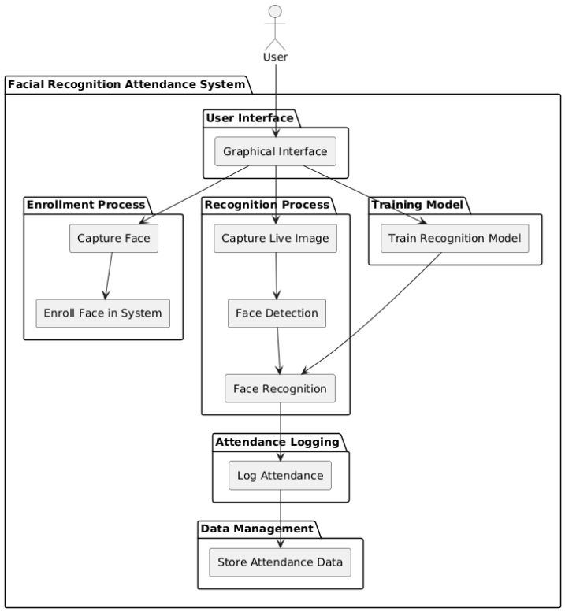

**Fig 3.1.1: System architecture.**

* 1. **Requirement Specification**

This section outlines the tools, technologies, and system requirements used for implementing the facial recognition-based attendance management system.

* + 1. **Hardware Requirements:**

1. **Computer System:**

**Minimum: Processor:** Intel i3 or equivalent, 4GB RAM, 500GB HDD

**Recommended: I**ntel i5 or higher, 8GB RAM, SSD storage for optimal performance.

1. Webcam:

A standard webcam (720p or higher) for capturing facial images during the attendance process.

1. **Internet Connection (Optional):**

Required for accessing online libraries or updating dependencies.

* + 1. **Software Requirements:**
    2. **Operating System:**Windows 10 or higher (recommended for compatibility with Python libraries).
    3. **Python:**Python version 3.9 or 3.10 (to ensure compatibility with required libraries).
    4. **Libraries and Frameworks:**

**OpenCV:** For real-time image capture and processing.

**Face_recognition:** To handle facial recognition tasks.

**Tkinter:** For building the graphical user interface (GUI).

**Streamlit:** For manually adding and processing images in the main_app.py.

**NumPy:** For handling array operations used in image processing.

**Pandas:** For storing and managing attendance data in CSV format.

* + 1. **IDE:**Visual Studio Code (VSCode) with Python extension (for development and debugging)

**CHAPTER 4**

**Implementation and Result**

* 1. **Snap Shots of Result:**
  2. **GitHub Link for Code:**

**CHAPTER 5**

**Discussion and Conclusion**

* 1. **Future Work:**

The current facial recognition-based attendance system can be enhanced in several ways:

1. **Improved Accuracy:** Using advanced deep learning models like CNNs to improve recognition accuracy, especially in diverse environments with varied lighting conditions.
2. **Multi-Face Recognition:** Optimizing the system for real-time attendance marking in crowded or multi-face scenarios.
3. **Cloud Integration:** Storing attendance data on the cloud to enable easier access and syncing across devices.
4. **Multi-Factor Authentication:** Adding security features such as combining facial recognition with QR codes or RFID for more secure attendance tracking.
5. **Handling Low-Light Conditions:** Enhancing recognition performance under low-light or challenging lighting conditions using better image processing techniques or infrared cameras.
6. **Scalability:** Optimizing the system for larger-scale environments, ensuring smooth performance in larger classrooms or office spaces.
7. **Mobile and Web Access:** Expanding the system to mobile and web platforms to improve accessibility and user experience.
8. **Analytics and Notifications:** Implementing real-time notifications and detailed attendance analytics for better administrative control.
   1. **Conclusion:**

This project successfully developed an Attendance Management System using facial recognition to automate and streamline the attendance process. The system utilizes advanced machine learning and computer vision techniques through OpenCV and the face_recognition library. It accurately detects and recognizes faces in real-time, allowing for the automatic marking of attendance, eliminating the need for manual intervention and reducing human errors.

The system’s design provides a simple and intuitive interface via Tkinter, enabling users to enroll new students, train the recognition model, and log attendance efficiently. Key functionalities, such as handling recognition failures and verifying already marked attendance, have been implemented to enhance the system’s reliability.

By automating the attendance process, this project not only reduces time and effort but also ensures accuracy and reliability in recording attendance. The solution is scalable, flexible, and can be extended to various use cases such as educational institutions, corporate environments, and event management systems.

Overall, this project demonstrates the effective use of facial recognition technology to address traditional challenges in attendance management, providing a modern, user-friendly solution for real-time attendance tracking.

**REFERENCES**

[1]. Sangeetha, M., Vijayalakshmi, P., & Ramasubramanian, V. (2019). Automated Attendance System using Face Recognition. *International Journal of Advanced Research in Computer Science, 10*(5), 215-220.

[2]. Rao, P., & Murthy, K. (2018). Face Recognition System for Attendance Management Using OpenCV. *Journal of Computing and Technology, 11*(2), 110-115.

[3]. Singh, R., Patel, A., & Sharma, M. (2021). Deep Learning Approach for Facial Recognition in Classrooms. *Journal of Artificial Intelligence and Image Processing, 5*(3), 34-42.

[4]. Gupta, N., & Gupta, R. (2017). Hybrid Attendance System with QR Codes and Face Recognition. *Journal of Computational Science, 9*(4), 122-128.

[5]. Yang, M. H., Kriegman, D. J., & Ahuja, N. (2002). Detecting Faces in Images: A Survey. *IEEE Transactions on Pattern Analysis and Machine Intelligence, 24*(1), 34-58.