Jeremy Scheuerman

Dr. Wang

Project 2

Writeup and testing

Testing-should retest all functions from project 1 and also test the sort database function from project 2

Read Compilation and initial print

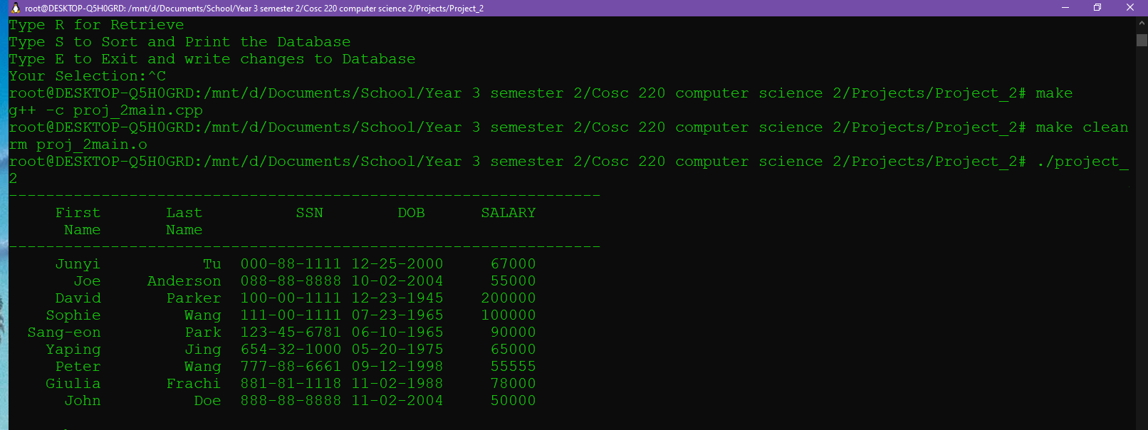

Insert

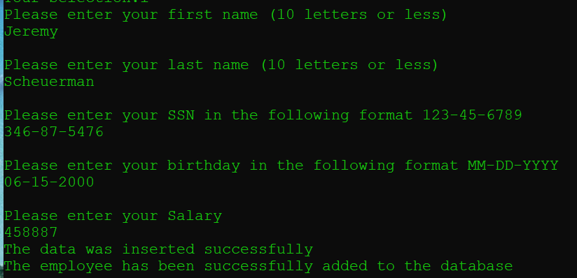

Delete function

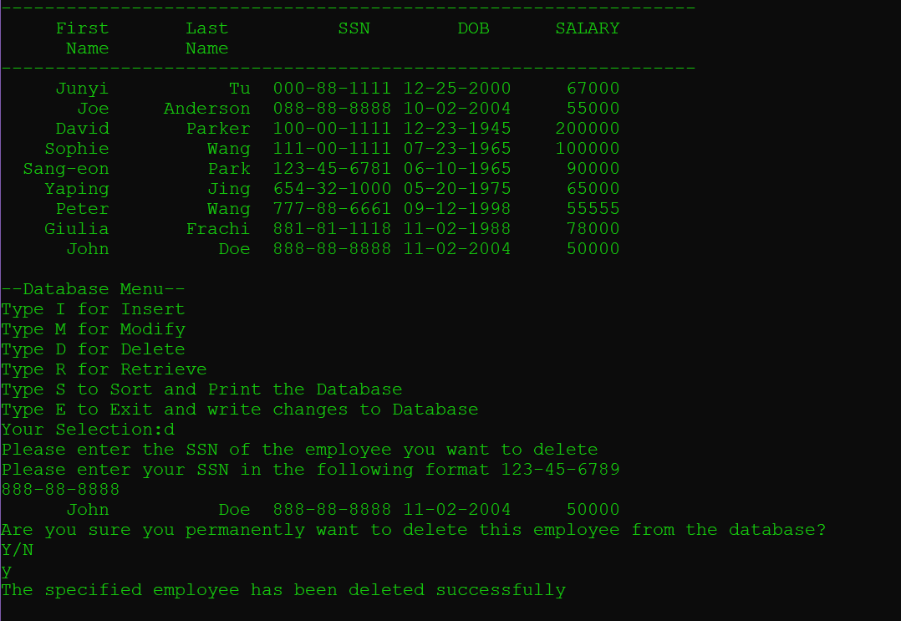

Retrieve

ssn

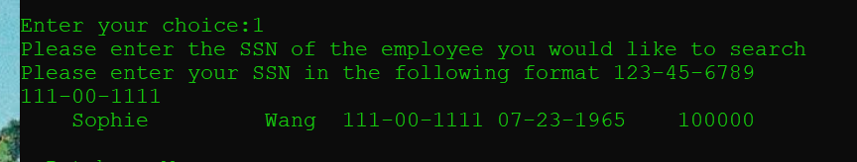

Last name

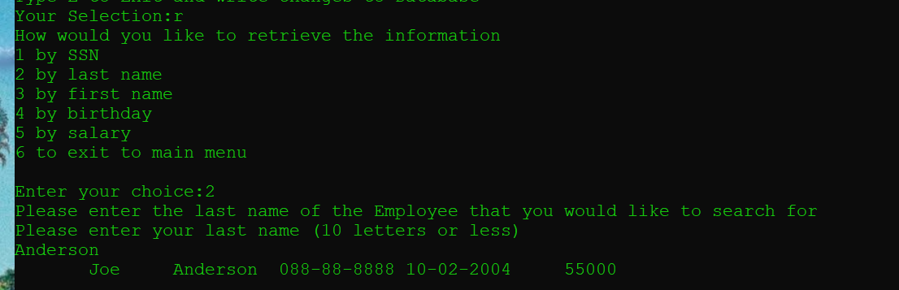

First Name



Birthday

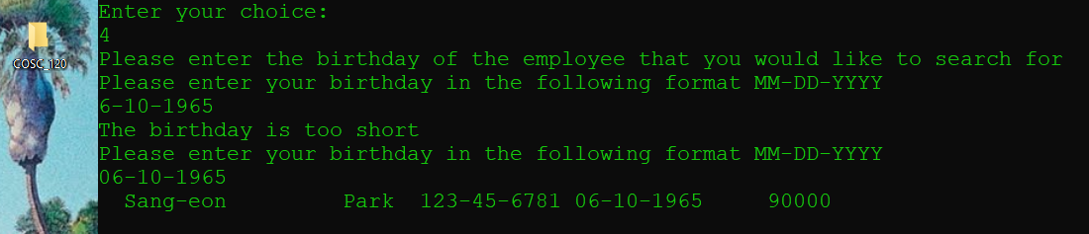

Salary



Modify

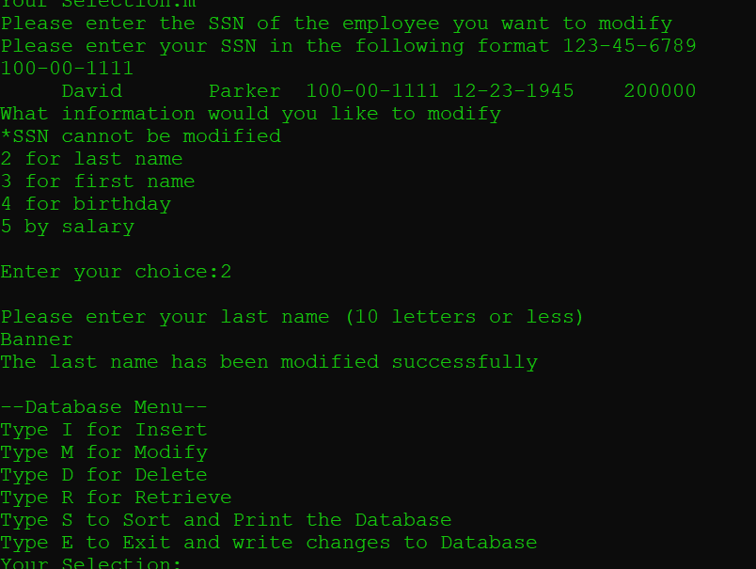

Insert

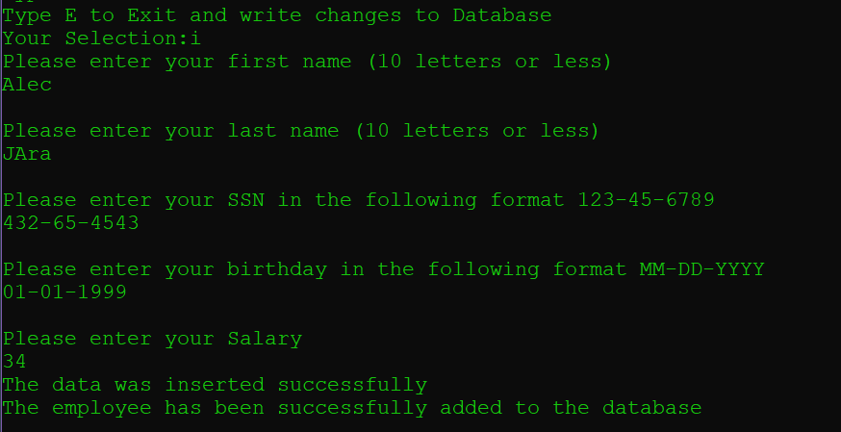

Write Database

