Jeremy Scheuerman

Dr. Sophie Wang

COSC 220

1/29/21

Project 1

Menu interface

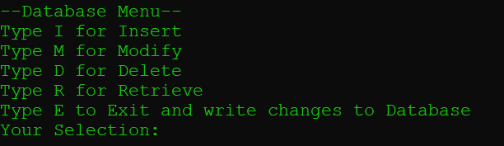

Retrieve Menu

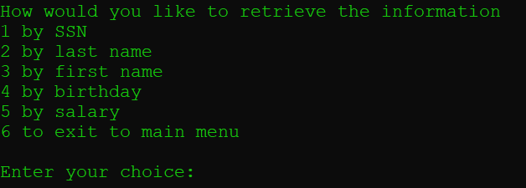

Print database function

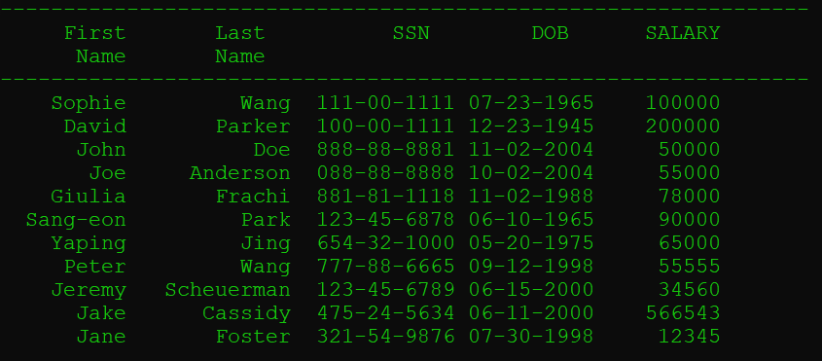

Insert Function

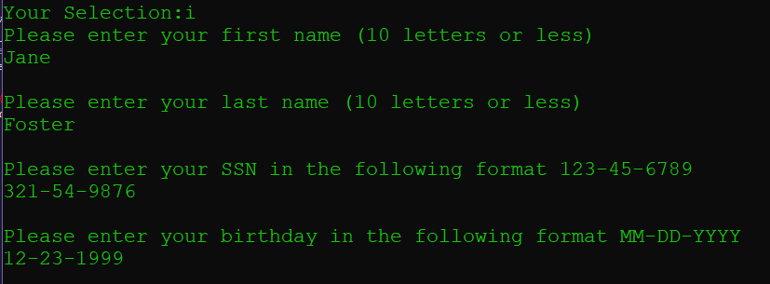

Delete function

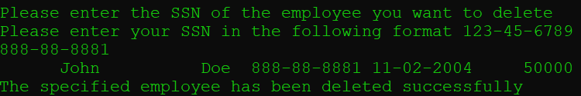

Retrieve function

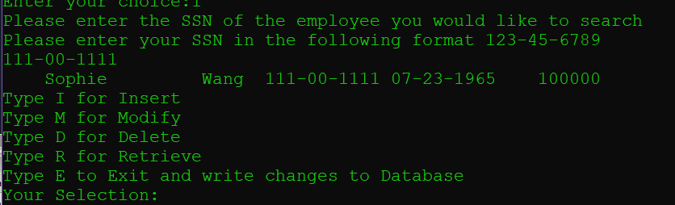

Exit to database function

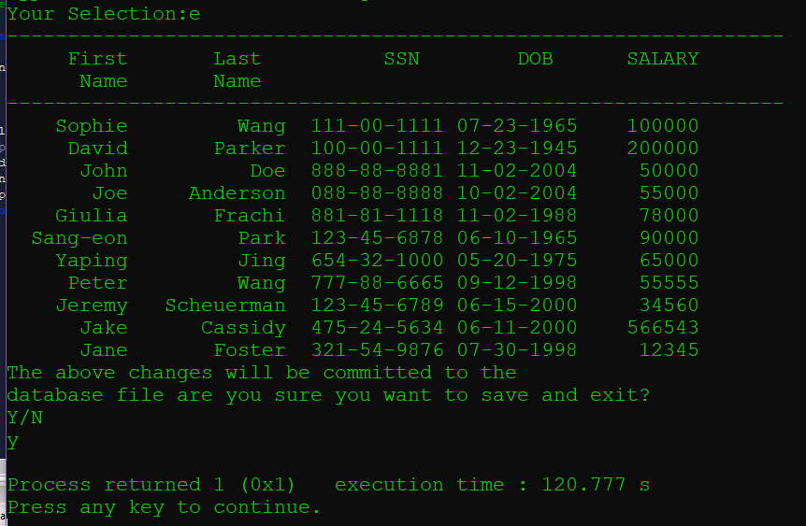

Source Code:  
All attached as .cpp files as it seemed inefficient to put it all here