Dr. Wang

Jeremy Scheuerman

COSC 220

10 April 2021

Project 2 writeup

Testing Plan (all recored in this pdf)

The plan is to make sure that I can add remove print and print top for all 4 implementations of stack and all 4 implementations of queue, I shall try to test it all in one go to make sure I do not get segfaults like I did with the last project. I shall post the output in this pdf.

Building in linux environment

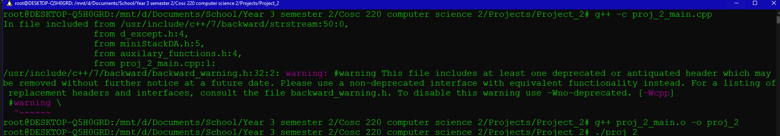

(warning about header files dosen’t affect running of program

Stack Vector

Add elements

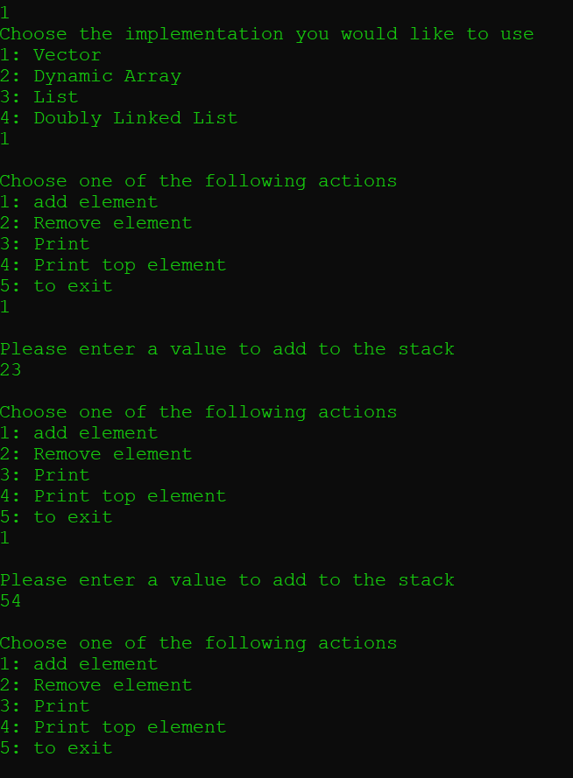

Print and Print top

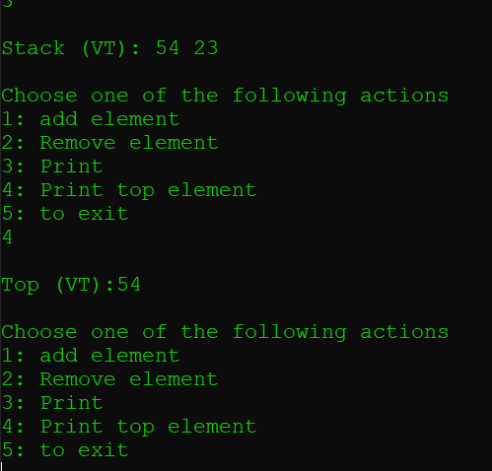

Remove elements ( and do it until exception handling kicks in

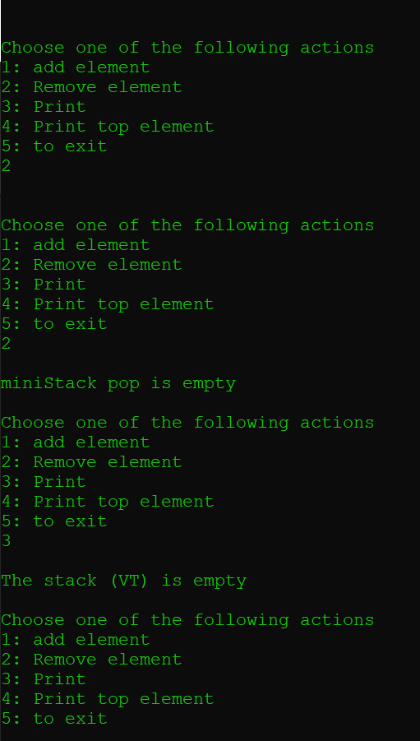

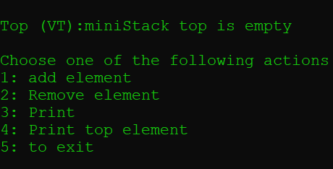

As we can see exceptions were raised and a message similar showed up when trying to print empty stack (same with printing the top)

Exit and tried again with a different implementation

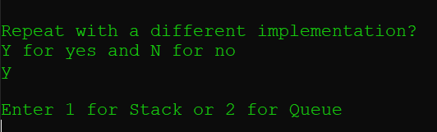

Try it again for stack dynamic array also see input validation in the menu

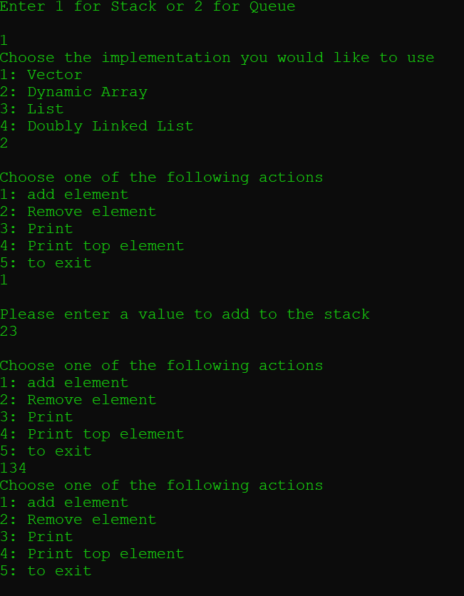

Removed Element and saw exception handling messages occur

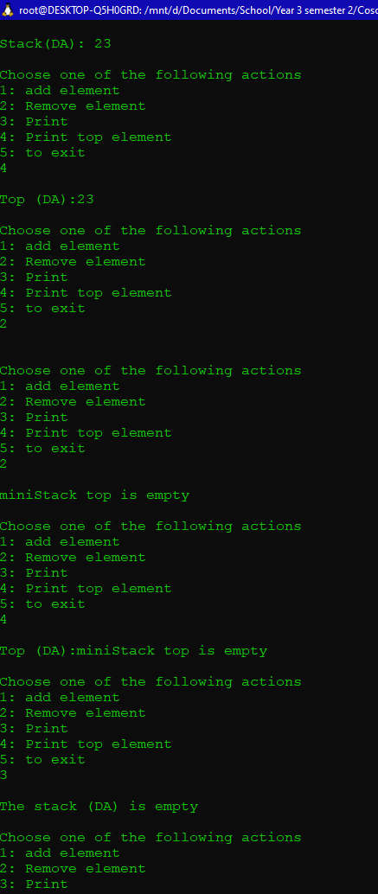

Keep going and do it again with STL list

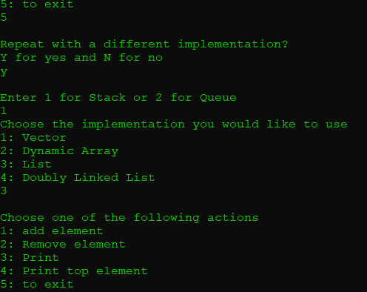

Added 3 elements to the stack and printed it out

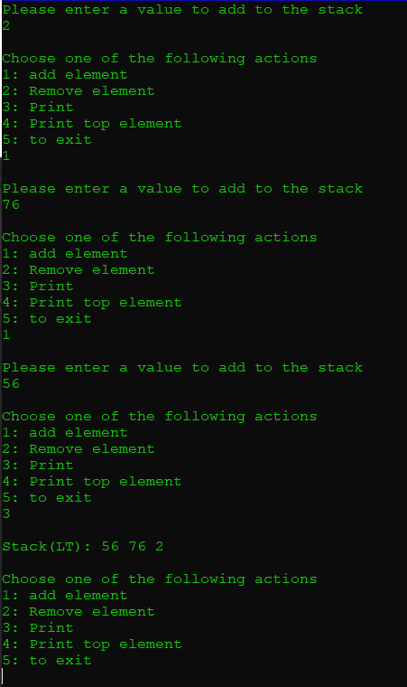

Remove them all and show exception messages happen for deleting and printing

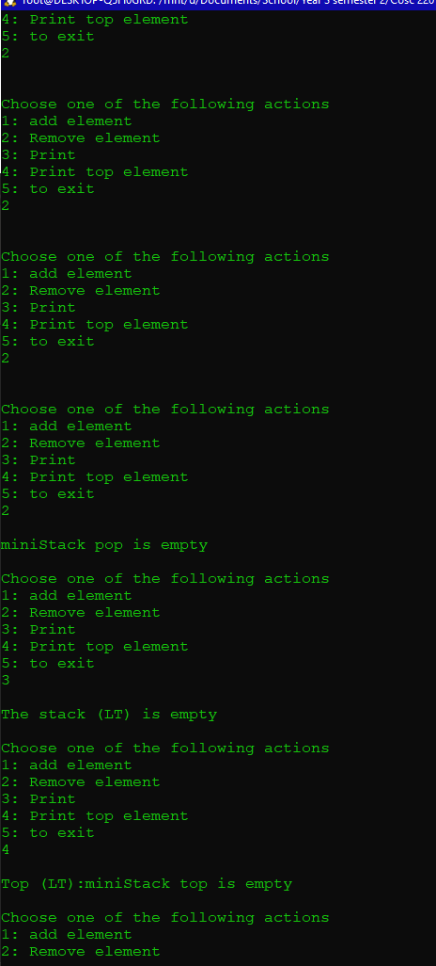

Repeat process with doubly linked list

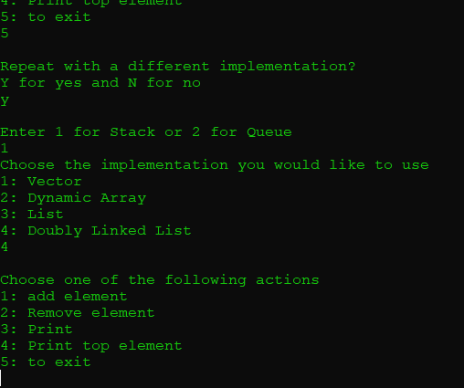

Add element remove and show error messages

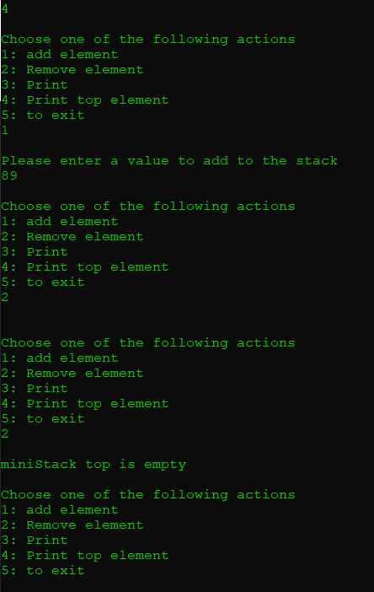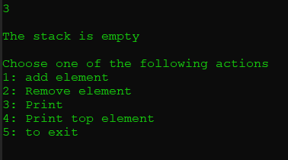

Exit now test process with Queues starting with queue vector

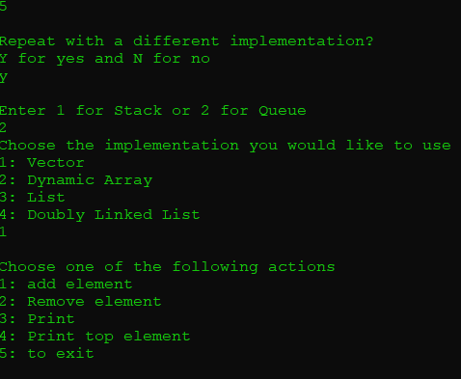

Add some elements and print the queue and the queue front

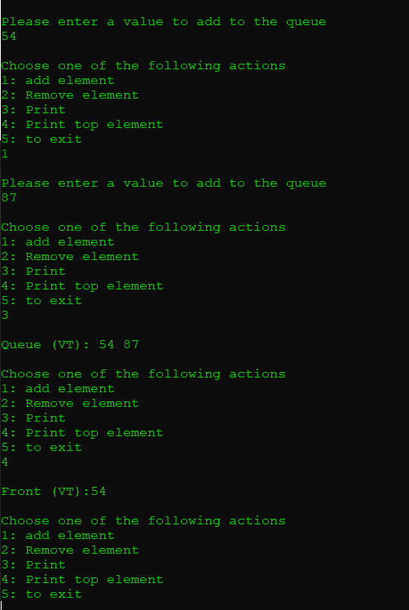

Remove elements and trigger exception for empty stack and print exception messages

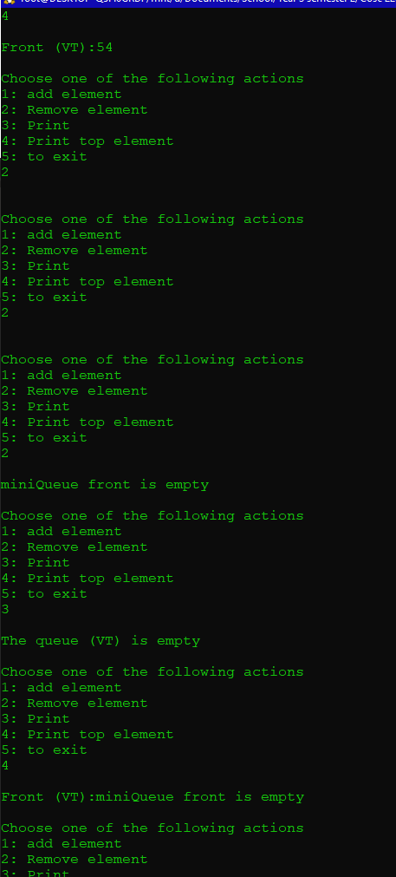

Retry with queue dynamic array

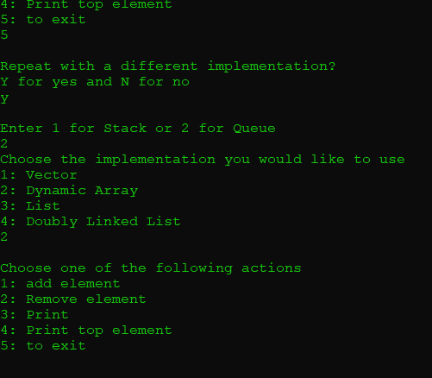

Added some elements and printed them out

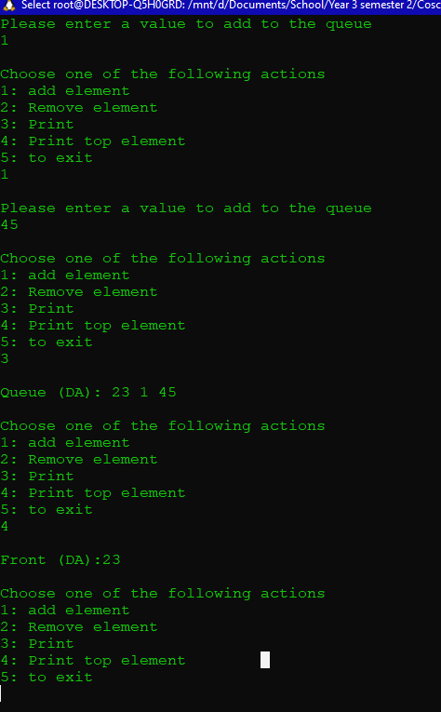

Remove elements until nothing is left and exception messages appear

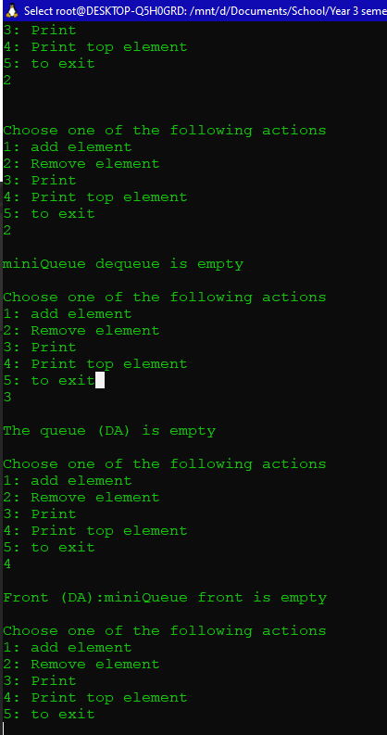

Restart with stl list

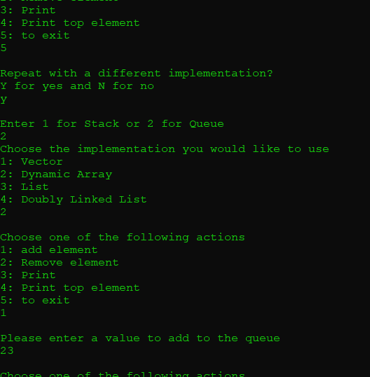

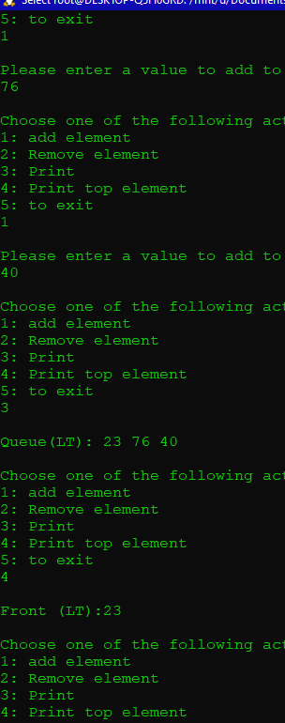

Finally test with queue doubly linked list

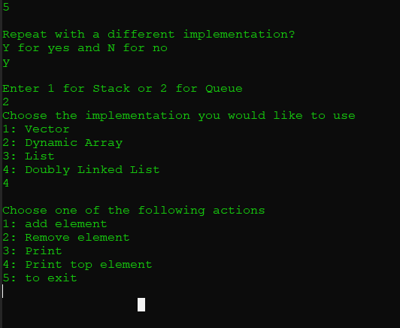

Add some elements to it

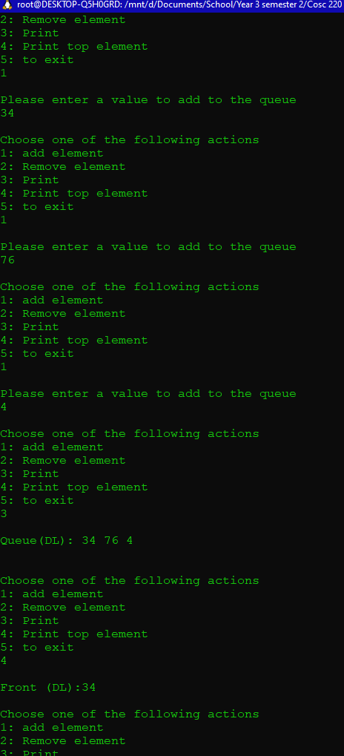

Now remove them all and make sure remove print and print front exceptions work

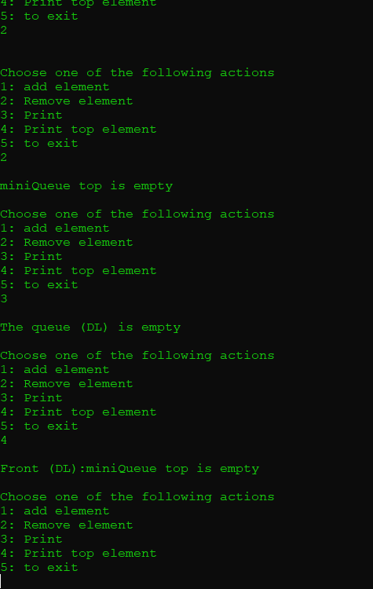

Exit and don’t repeat

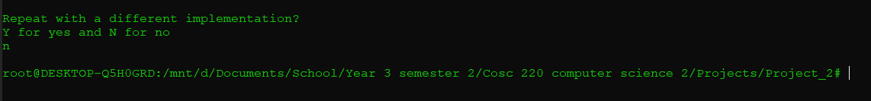

All possible cases tested no errors occurred!

😊