Jeremy Scheuerman

COSC 220

Dr. Wang

30 April 2021

Lab 13 writeup

Compile and Build in linux environment



Working Menu interface

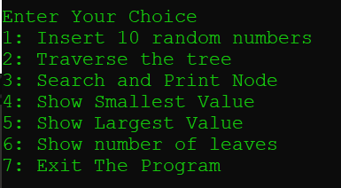

Insert 10 numbers

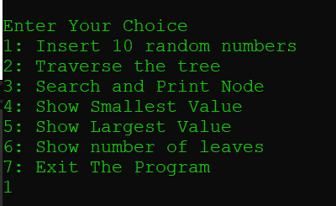

Tree Traversals

PreOrder  
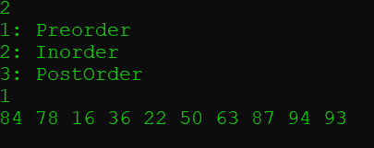

InOrder

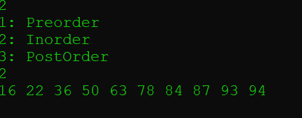

PostOrder

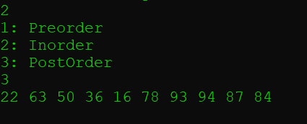

Search and Print e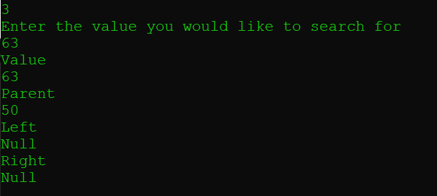

Lets try it with a value that isn’t there

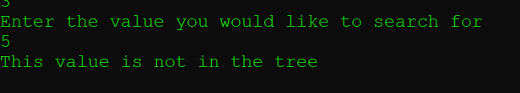

Show the smallest value

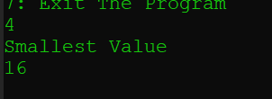

Show Largest Value

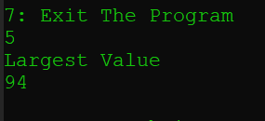

Show Leaves

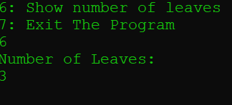

Exit the program

