Jeremy Scheuerman

Computer Science 2

Lab 1

Task 0:

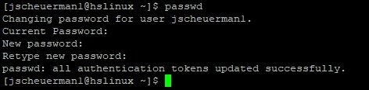

Cmd

Task 1:

/usr/include

Task 2:

..usr/bin

Task 3:

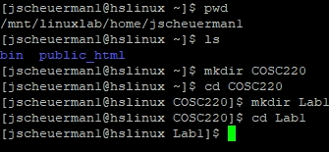

Task 4:

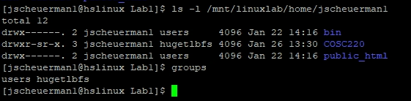

1. Jscheuerman1 owns this directory
2. Read write execute
3. Users group is associated with this directory
4. They can read write and execute
5. Yes
6. None

Task 5:

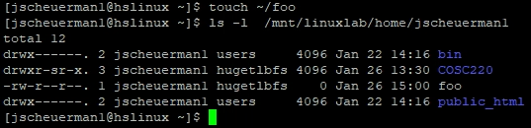

2.

a. regular file, read write

b.jscheuerman1

c.huglbfs



d.yes I am in that group

e.users, hugelbfs

3.



Task 6:

2. a-all,l-use long listing format,R- recurssive lists all subdirectories recursively

3. 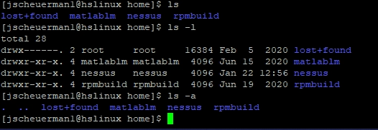

Ls simply lists all the files in the directory, ls – l gives more detailed output about the file and the permissions of them, ls -a simply lists the files all in one long format

4. man time-a simple command or give resource usage

5. man -an interface to the on-line reference model

Time- time to get in seconds

Task # 7

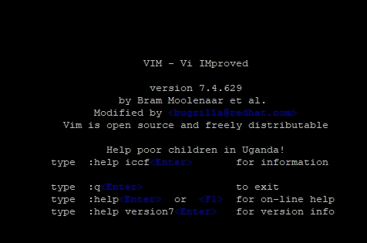

Task #8

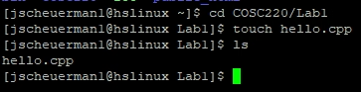

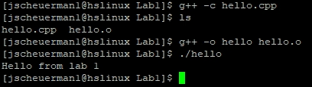

Task #9



Source Code

Hello

//hello.cpp

//Jeremy Scheuerman

//Created 1/28/2021

#include <iostream>

int main(){

std::cout<<"Hello from lab 1"<<std::endl;

return 0;

}

File 1

//file1.cpp

//COntains the main function

//Created:1/28/21

//Current:1/28/21

#include <iostream>

#include "file2.h"

int main()

{

using namespace std;

int i=3;

int sq;

sq=SquareIt(i);

cout<<"Square of "<<i<<" is "<<sq<<endl;

return 0;

}

File2.cpp

//file2.cpp

//Def of squareIT function

//Demo for Lab 1,Cosc-220

//

//Jeremy Scheuerman

//Created 1/28/21

//Current 1/28/21

//

#include "file2.h"

int SquareIt(int x)

{

return x*x;

}

File2.h

//file2.h

//Declaration of SquareIt function

//Demo for Lab 1, Cosc-220

//

//Jeremy Scheuerman

//Created:1/28/21

//Current:1/28/21

#ifndef FILE2_H

#define FILE2_H

int SquareIt(int);

#endif