Jeremy Scheuerman

COSC 220

Dr. Wang

6 April 2021

Lab 10 writeup

1. The advantage of a linear search is that it is simple
2. The disadvantage of a linear search is that it is slow/time consuming
3. The advantage of a binary search over a linear search us that a binary search is that it is faster/more efficient
4. An advantage of a linear search over a binary search is that the data must be ordered for a binary search
5. After 3 passes of a binary search approximately what fraction of the original array still needs to be searched (assuming the desired data has not been found) ? 1/8
6. While the bubble sort algorithm is conceptually simple it can be inefficient for large arrays because data values only move one at at time.
7. An advantage of the ­selection sort is that ,for an array of size n, at most n-1 moves are required.
8. Use the bubble sort on the array below and construct the first 3 steps that actually make changes, (Assume the sort is from smallest to largest).

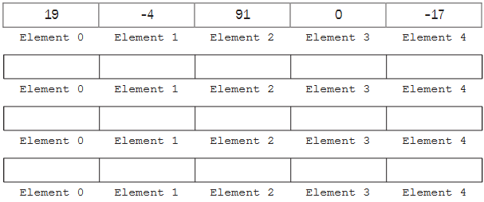

-4 , 19 , 91, 0 -17

-4, 19, 0, 91 -17

-4, 19, 0, -17 , 91

(now it would repeat the process from the beginning switching the elements)

1. Use the selection sort on the array below and construct the first 3 steps that actually make changes (Assume the sort if from smallest to largest)

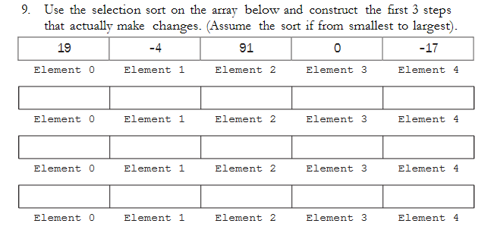

-17, -4, 91, 0, 19

-17 ,-4, 0, 91,19

-17, -4, 0, 19, 91

8.1

8.2

Ex 1

The right side is an integer because if it is run by itself it will round off and stay as an integer

-The middle value is determined by the values of first and last , it is first plus the difference of last and first divided by 2, last will result as an integer (since integer div by integer) so the result will always be an integer

-It affects the program because it can determine where the middle of the array actually is dynamically

Ex 2



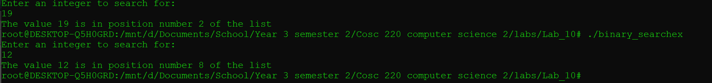

It finds the 1st occurrence of 19

It finds the 3rd occurrence of 12

Difference is that we are only looking at the middle point of an upper and lower bound so since the occurrence happened near the middle point that is the result you get

Ex 3



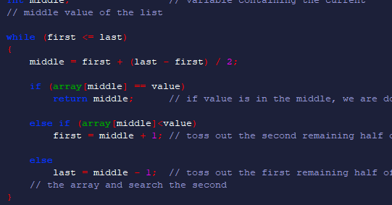



8.3 (with bubble sort)

Ex 1

Original

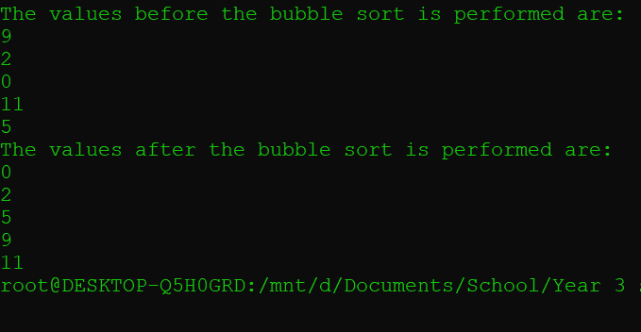

All you have to do is change the > to a <

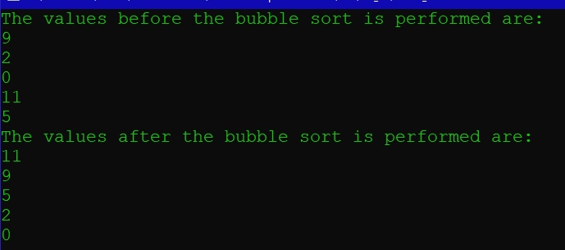

No

My Prediction (After the exercise earlier this makes more sense)

9,2,11,0,5

9,2,11,0,5

9,11,2,5,0

9,11,5,2,0

11,9,5,2,0

Actual array after each step

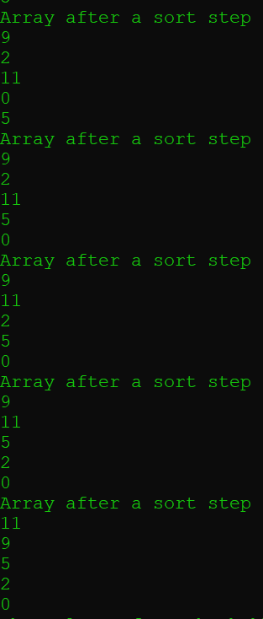

8.4

