Jeremy Scheuerman

COSC 220

Dr. Wang

16 April 2021

Lab 11 writeup

All times go to 6 decimal places (seconds)

Bubble Sort

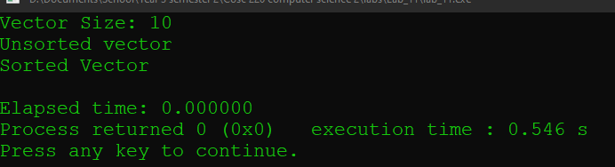

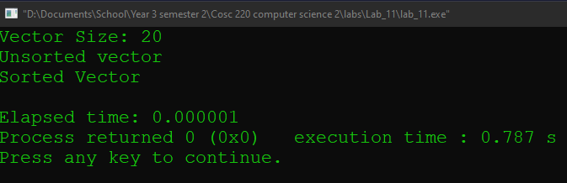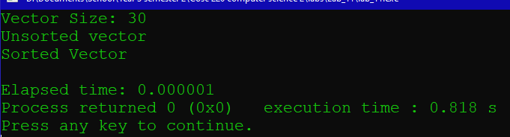

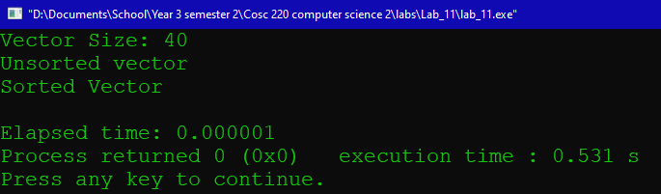

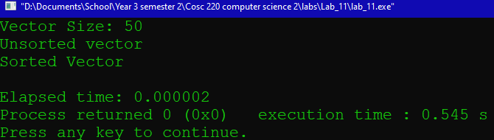

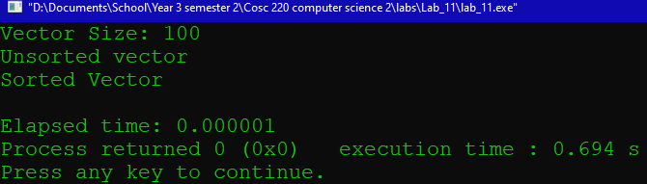

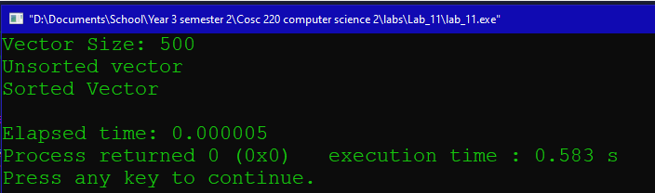

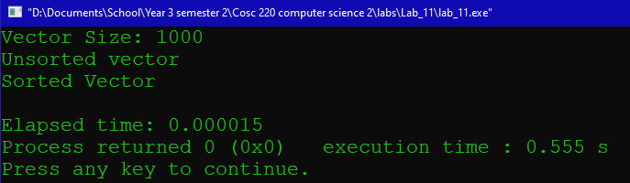

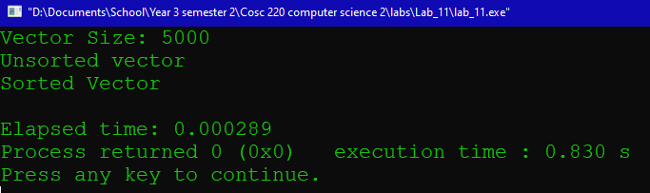

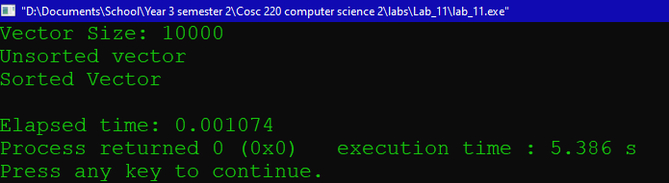

Removed divided by 1000 and running it 1000 times to cut back on time

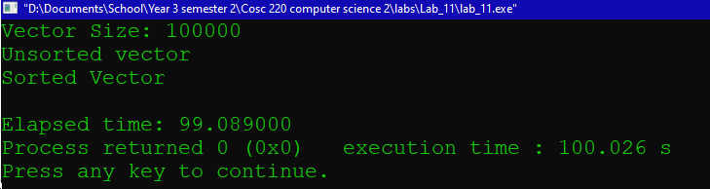

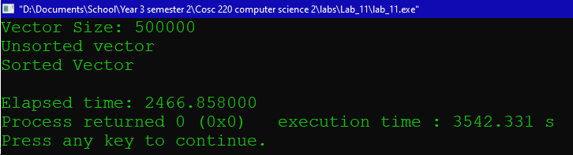

Insertion Sort

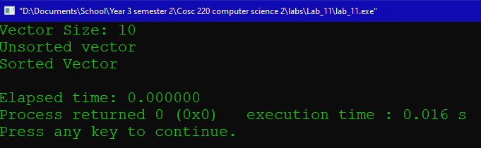

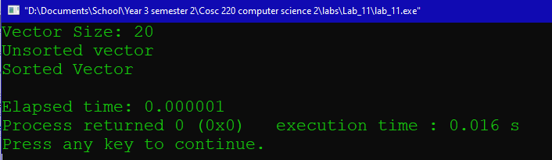

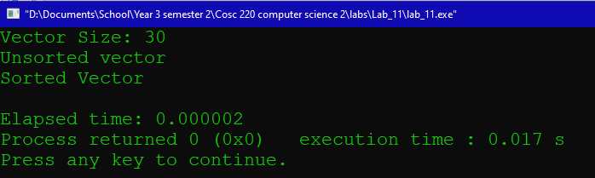

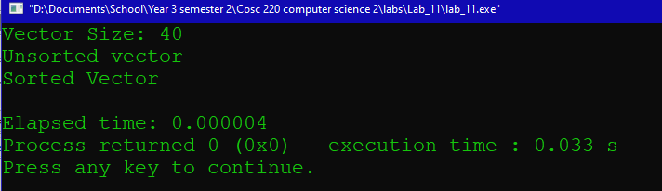

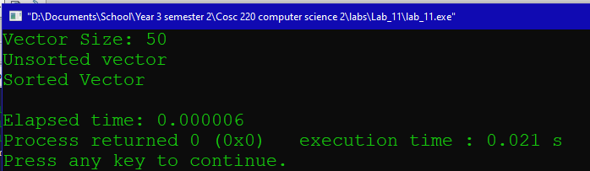

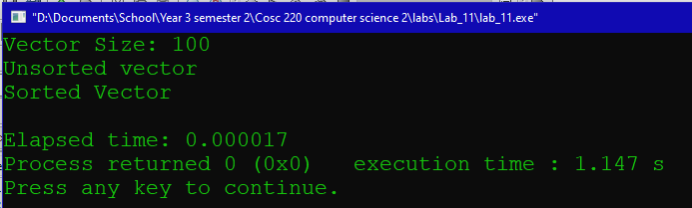

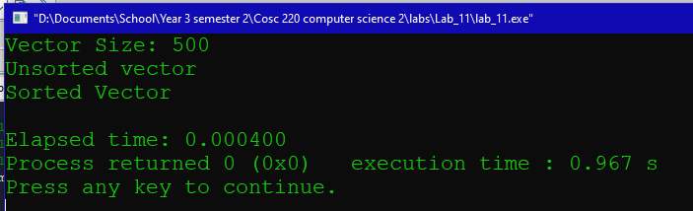

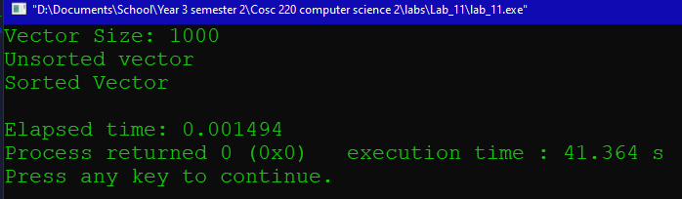

Stopped doing 1000 trials at this point

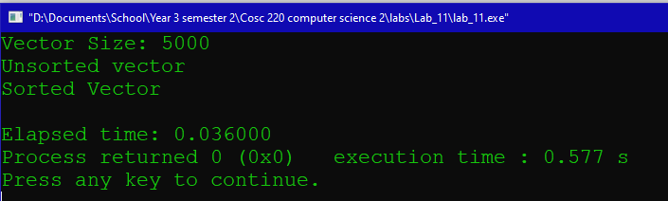

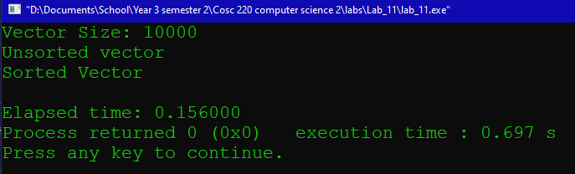

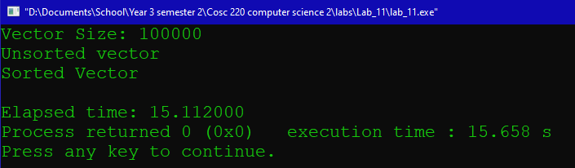

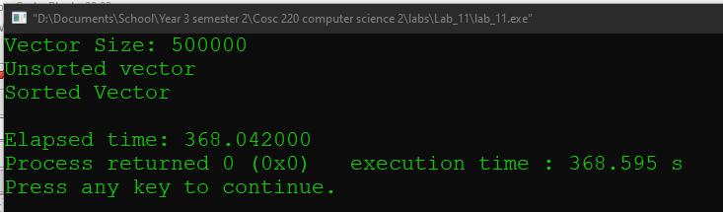

Merge Sort

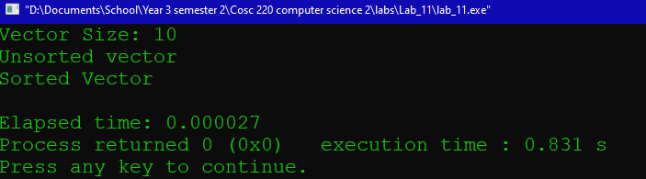

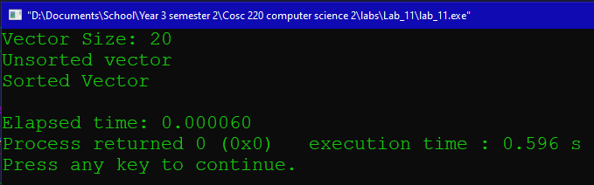

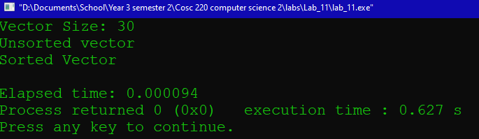

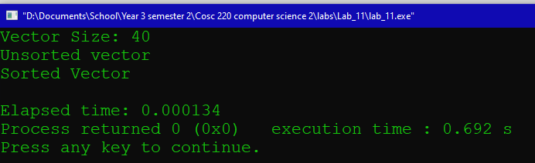

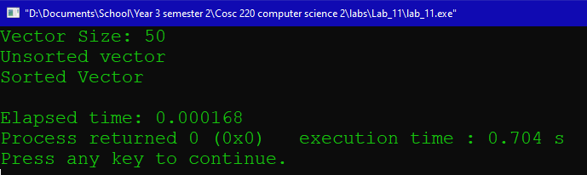

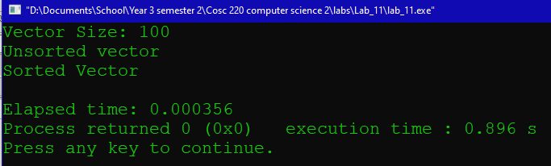

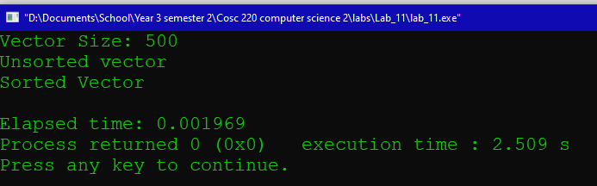

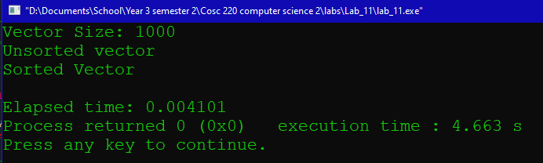

Stopped doing 1000 trials

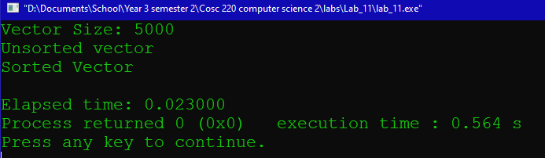

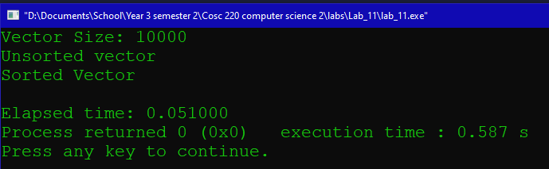

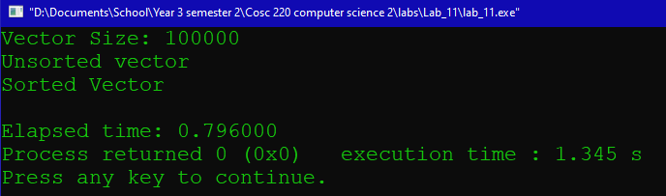

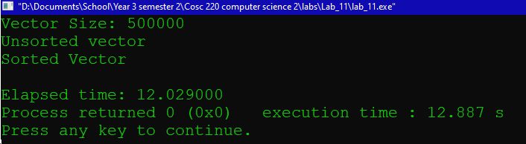

QuickSort

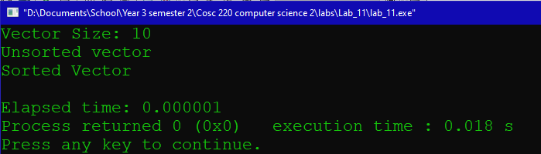

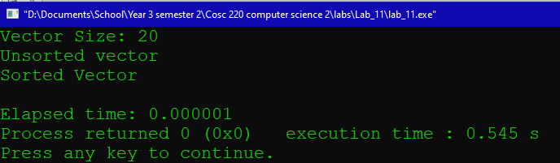

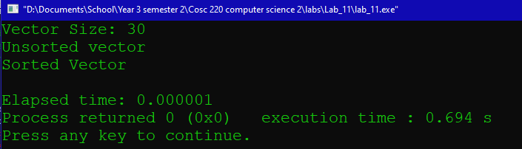

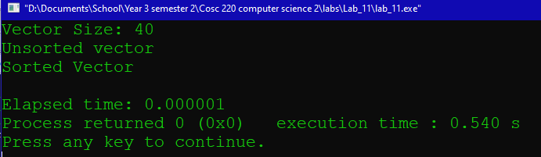

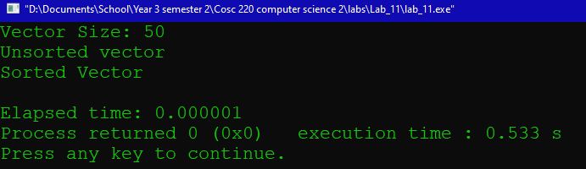

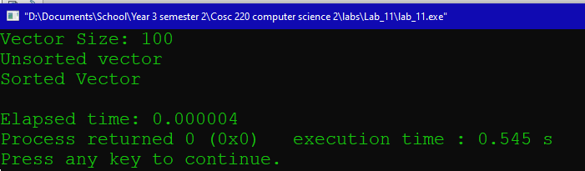

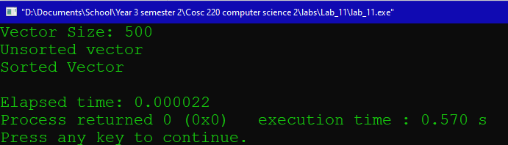

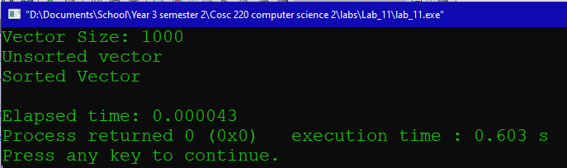

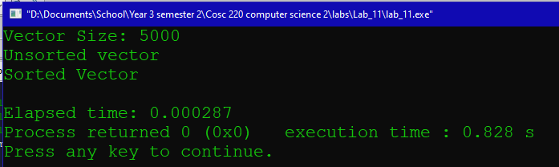

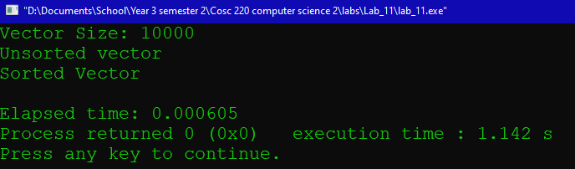

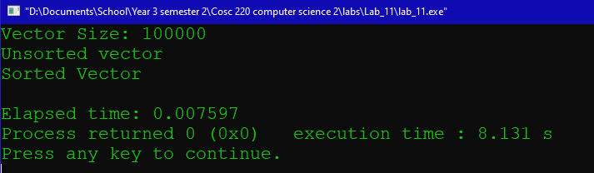

Stopped doing 1000 trials

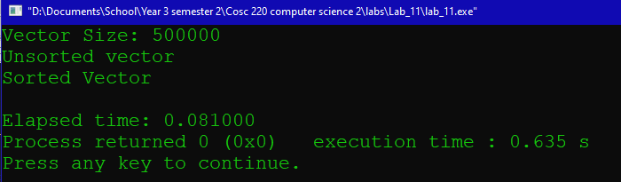

Note:Quick sort is very very fast

Selection Sort

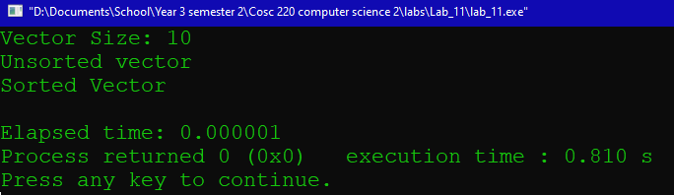

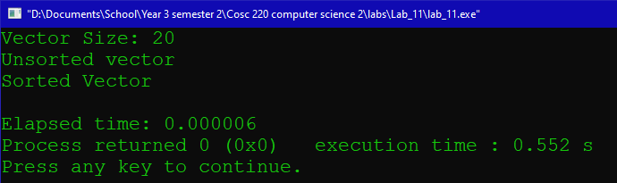

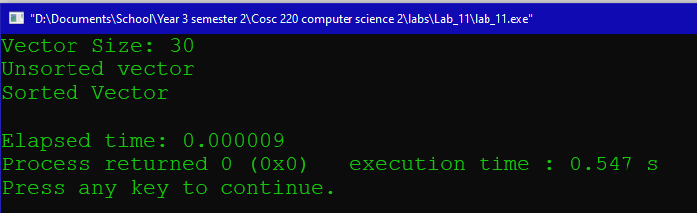

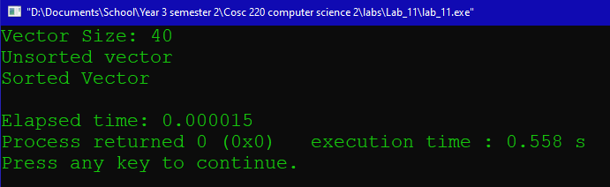

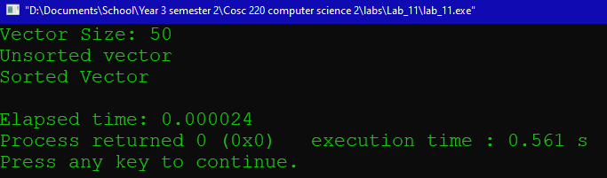

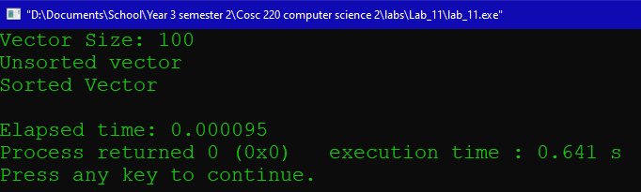

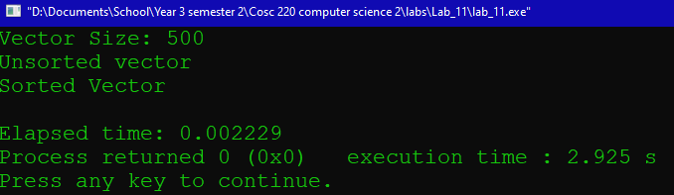

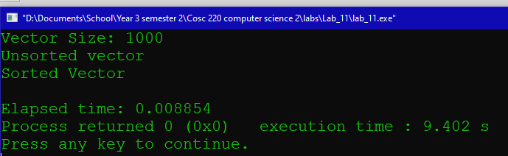

Stopped doing 1000 trials

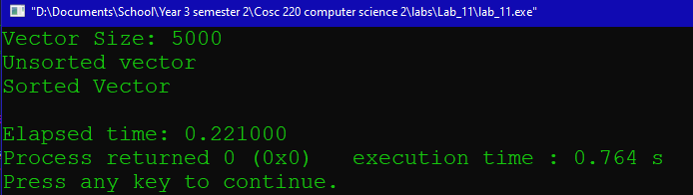

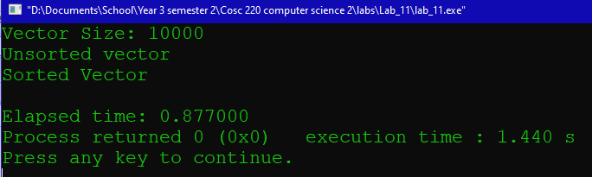

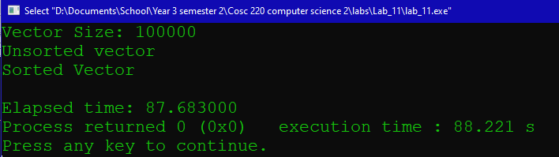

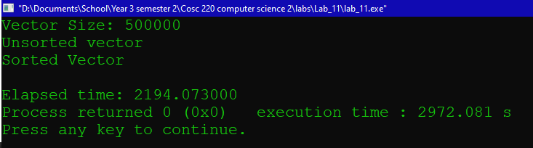

Radix Sort

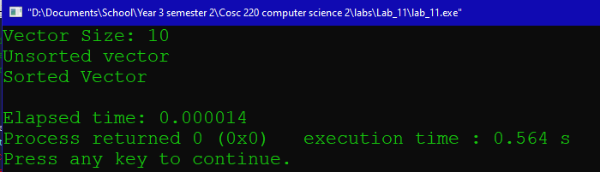

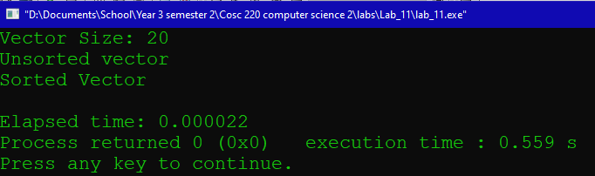

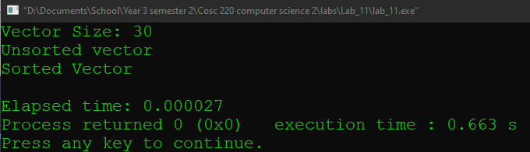

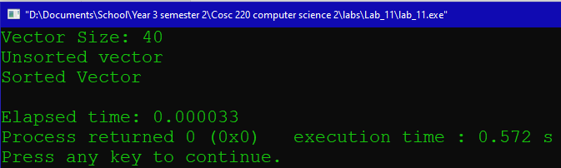

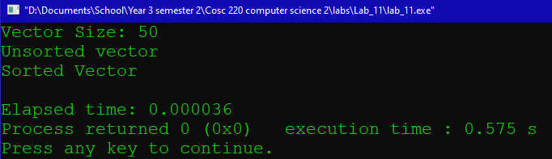

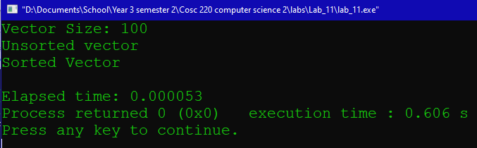

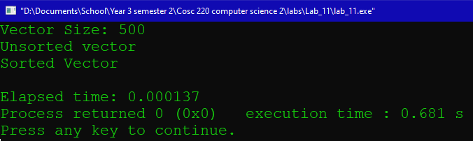

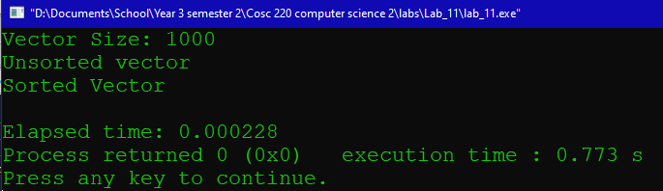

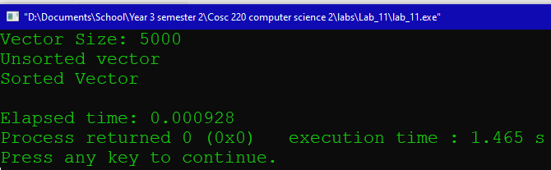

Stopped doing 1000 trials

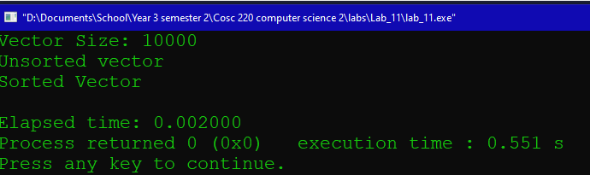

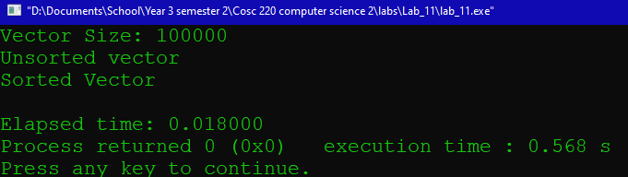

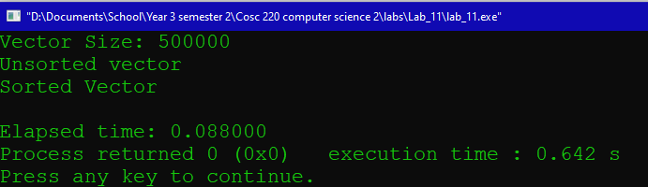

Heap Sort

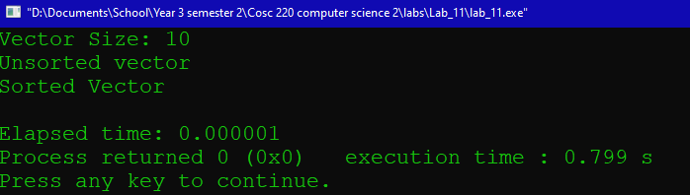

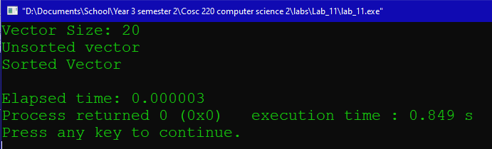

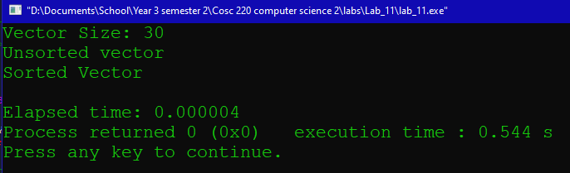

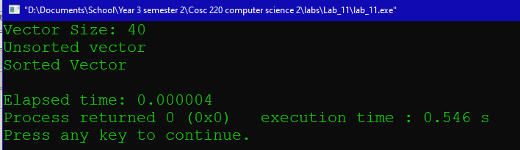

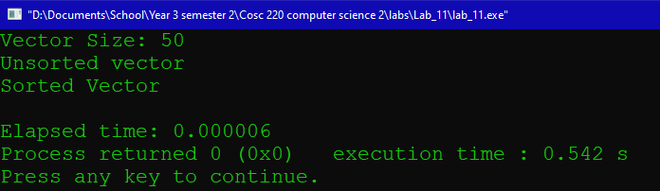

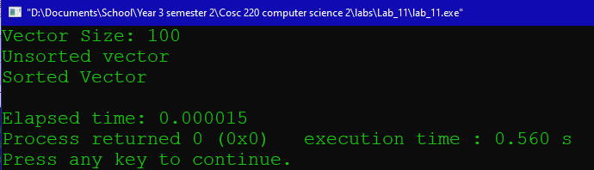

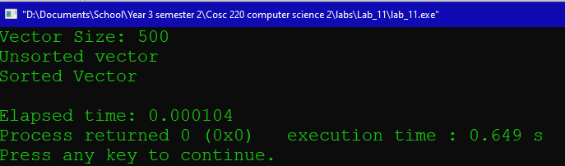

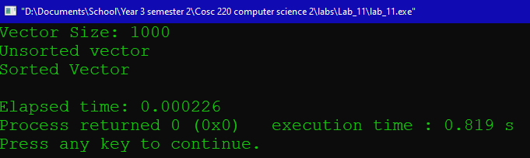

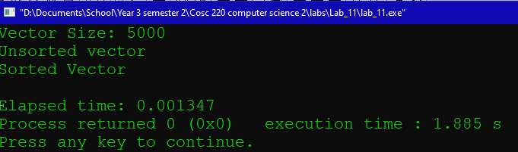

Stopped running 1000 trials

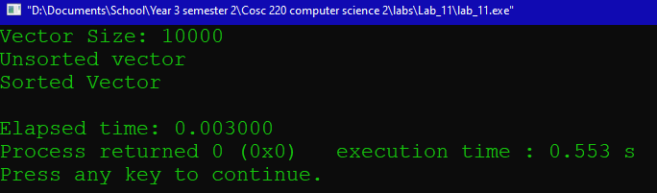

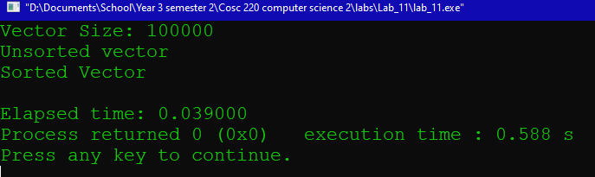

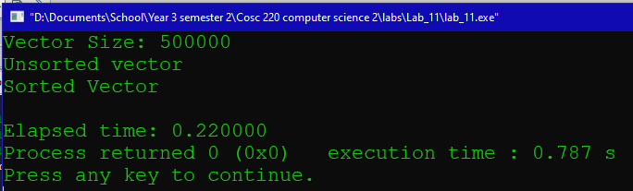

Table of Data measured in seconds (to 6 decimal places)

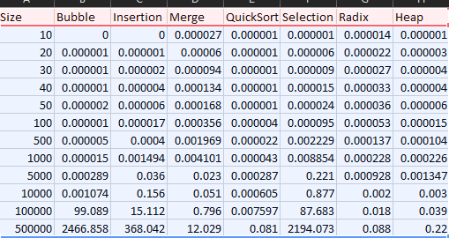

Vector Size

Time in Seconds