Jeremy Scheuerman

COSC 220

Dr. Wang

20-April-2021

Lab 12 writeup

Task 1 normal constructor initialization

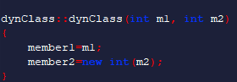

Task 2 Copy constructor init

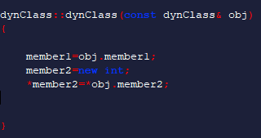

Task 3 destructor

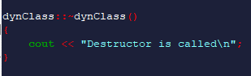

Task 4 operator overload

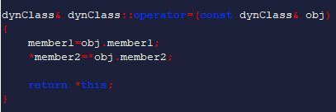

Task 5 main implementation

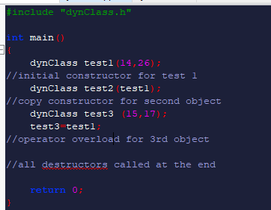

Test in linux environment

Build

****

Output



Built successful all destructors called