Jeremy Scheuerman

Lab 3 report

COSC 220

2/12/21

Task 1:



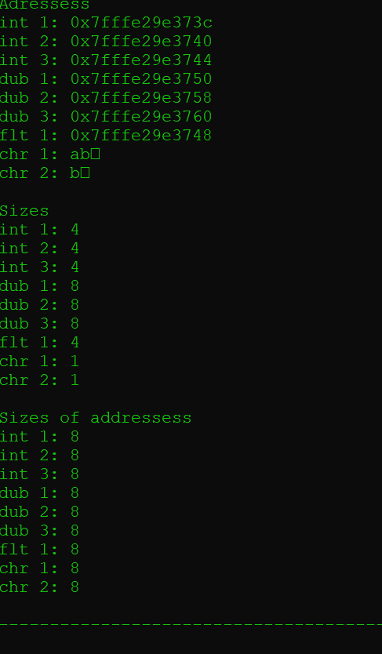

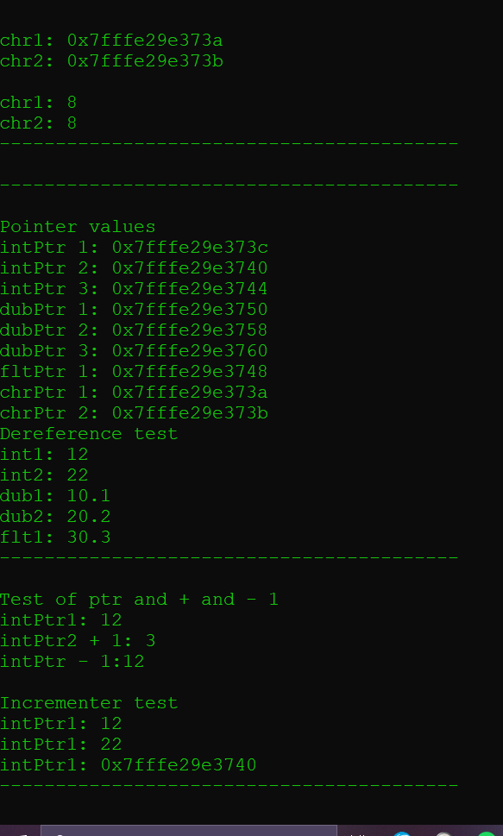

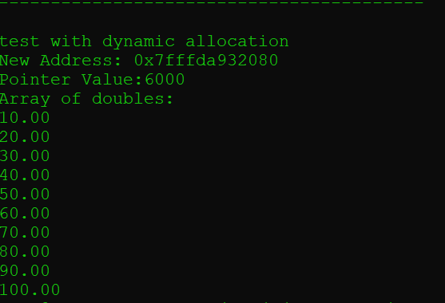

Task 2



Task 3

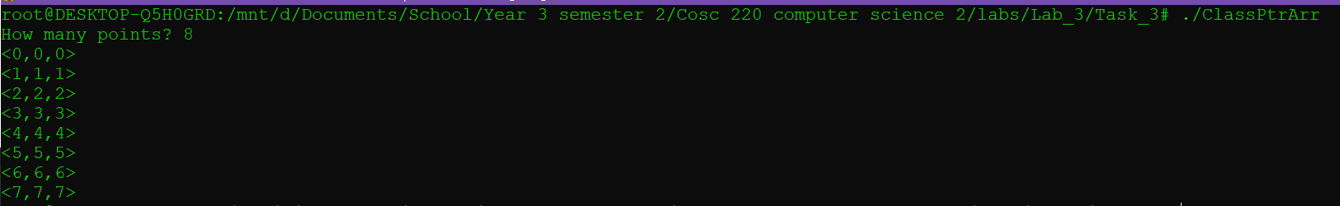

Task 4

