­­­Lab 5

Jeremy Scheuerman

COSC 220

Dr. Wang

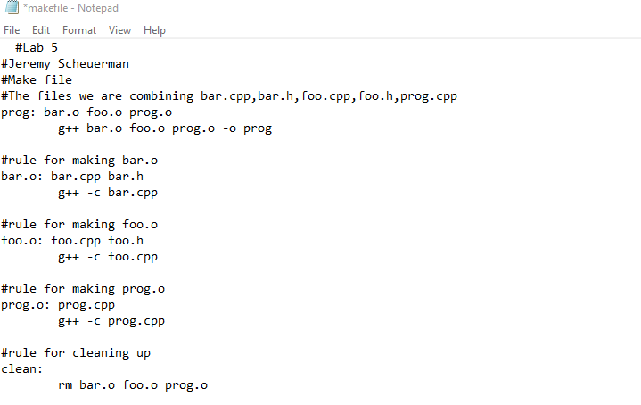

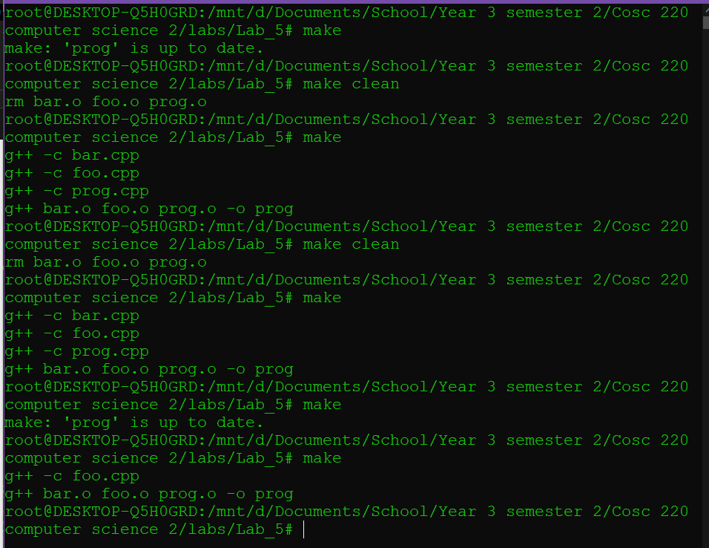

It only modified foo in the after that because that was the only file that was modified