Jeremy Scheuerman

COSC 220

Dr. Wang

Lab 6

Compilation and linking (without implementation)

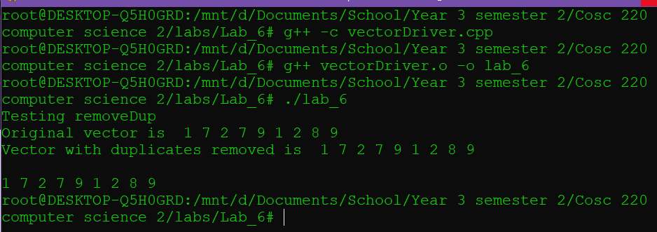

After Search function is written

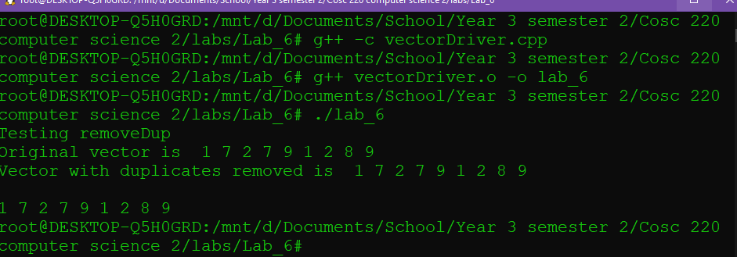

After both are written (I encountered a segfault error)

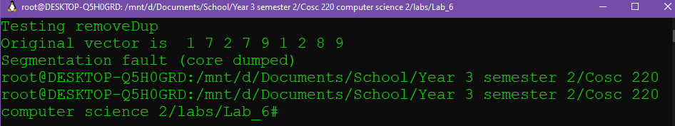

Fixed the function

