Jeremy Scheuerman

COSC 220

Dr. Wang

9 March 2021

Lab 7 Writeup

Compile debugme

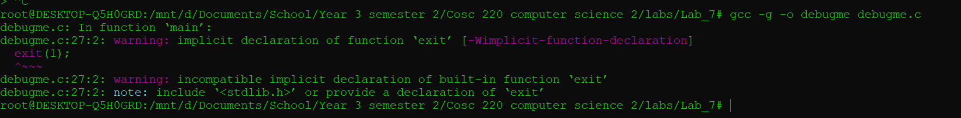

Hi there and Bye Bye



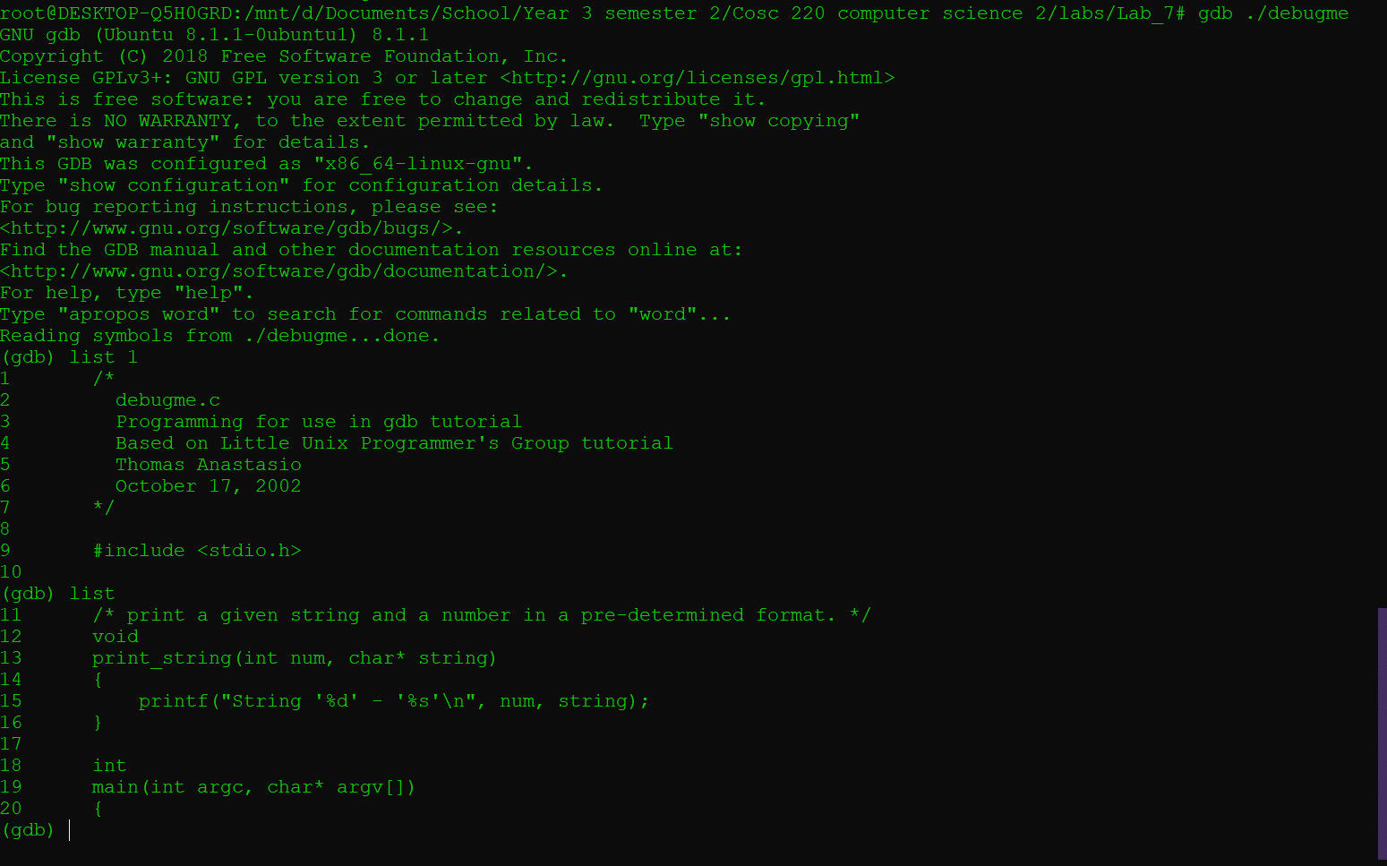

Run “Hi there” and “Bye Bye”

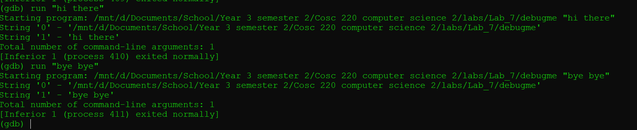

Breakpoint at print string

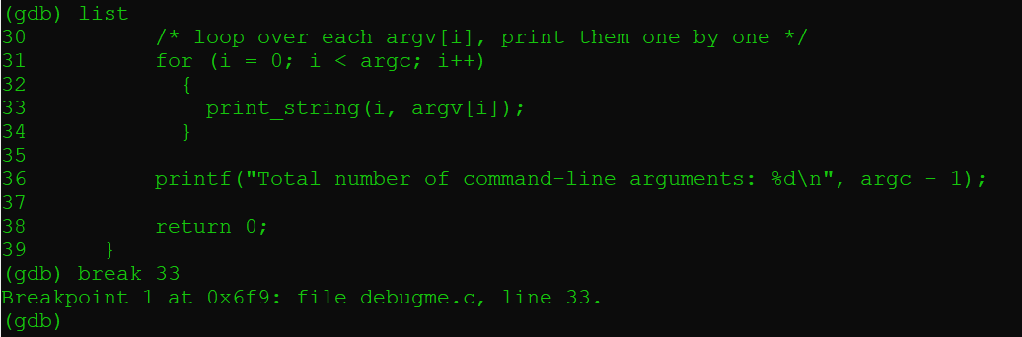

Step through for loop at breakpoint and print I and argv[i]

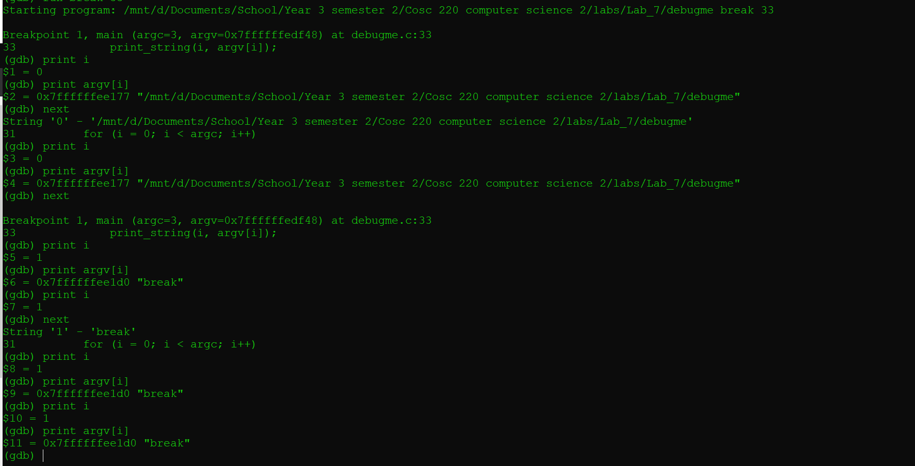

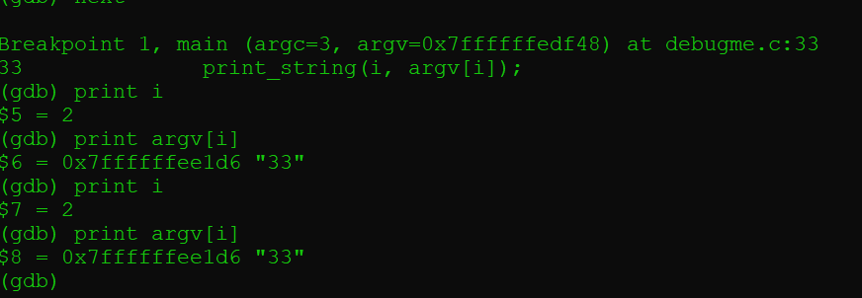

Breakpoint info

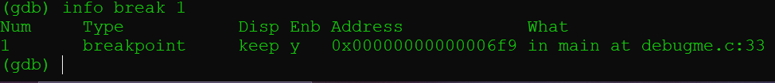

Delete breakpoint

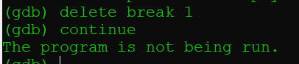

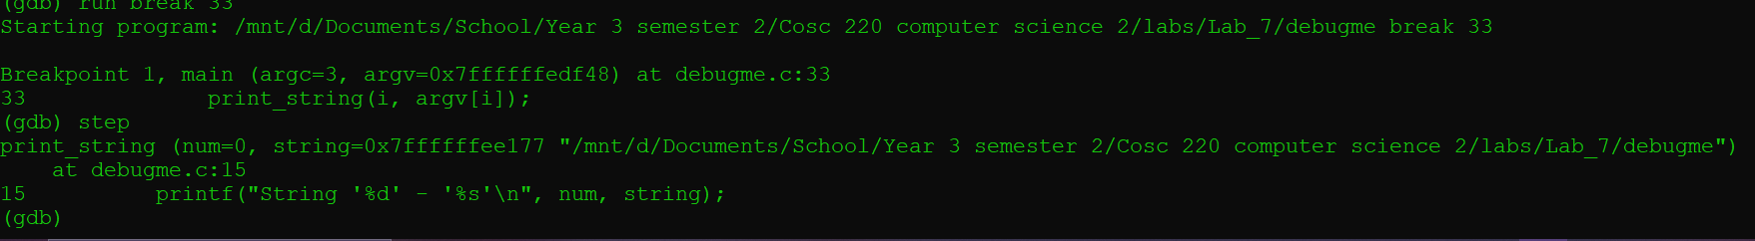

Step through at the breakpoint and print num and string

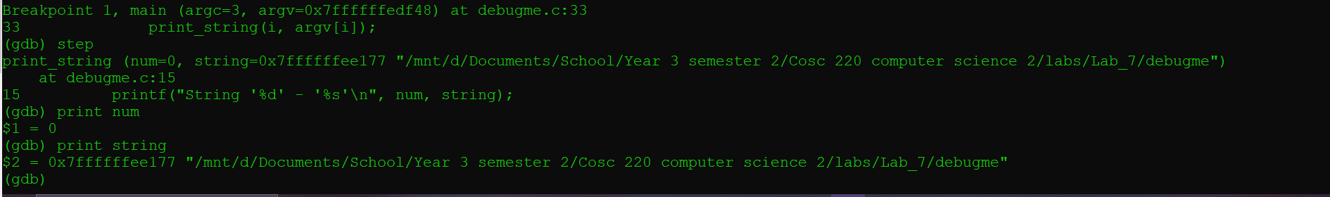

Print I and Print argv do not work

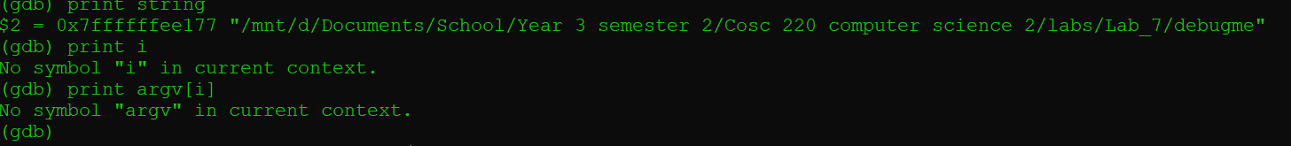

Compile with debug flag -ggdb and enter indexes until segfault

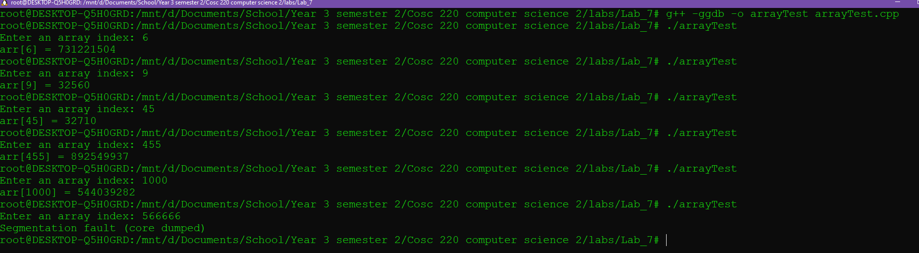

Compile and run the factorial



Breakpoint 23 and step through recursively

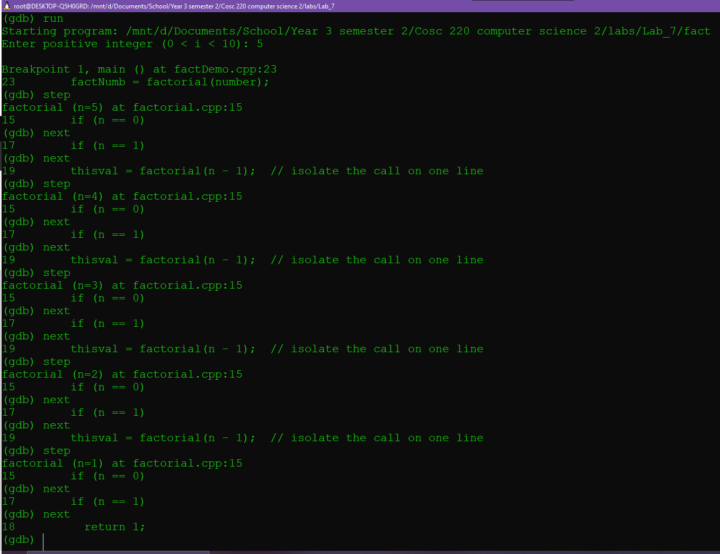  
Back trace through the function

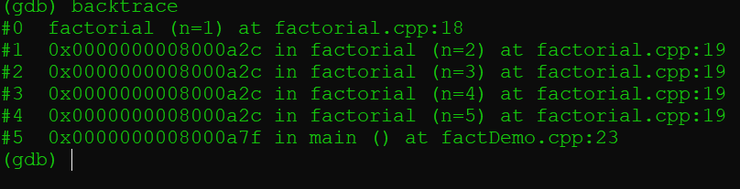

Step into main call print n the n set = to 5

