Jeremy Scheuerman

COSC 220

Dr. Wang

17-March-2021

Lab 8 writeup

Hierarchy Chart (Rough draft I before UML diagram)

*UML does not contain getters and setters due to repetitiveness it is unnecessary

|  |
| --- |
| **Employee** |
| -firstname:String  -lastname:String  -basesalary:double  -jobTitle:String |
| +CalculateSalary():double  +displaybaseSalary():void  +displayJobTitle():void  +displayInfo():void |

|  |
| --- |
| **Technical Staff** |
| -profitShare:double |
| +CalculateSalary():double  +displayProfitShare():void  +displayJobTitle():void  +displayInfo():void |

|  |
| --- |
| **Manager** |
| -bonus:double |
| +CalculateSalary():double  +displayBonus():void  +displayInfo():void |

|  |
| --- |
| **Software Engineer** |
| -Overtime:String |
| +CalculateSalary():double  +displayOvertime():void  +displayInfo():void |

|  |
| --- |
| **Executive** |
| -stockShare:float |
| +CalculateSalary():double  +displayStockOption():void  +displayInfo():void |

|  |
| --- |
| **Test Engineer** |
| +CalculateSalary():double  +displayInfo():void |

Output and Testing

Linking process

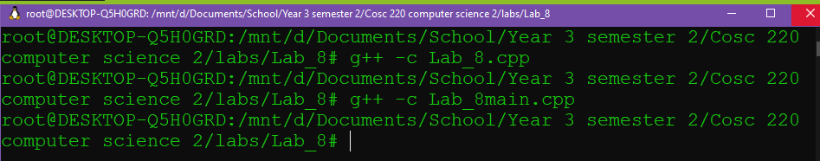

Make program file



The first set of output

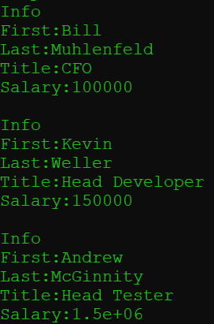

This displays only the base class print functions

Second set of output

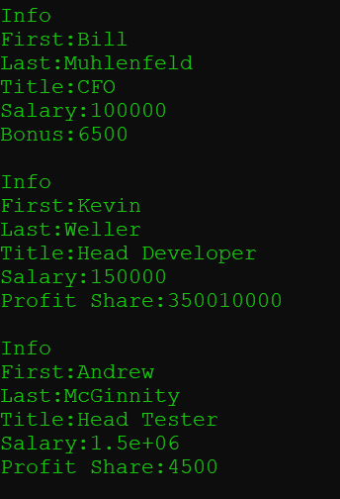

The second set of output is the print function from the derived class which includes bonus and profit share