SALISBURY UNIVERSITY

COMPUTER SCIENCE DEPARTMENT

**Assignment 1**

Student name: *.........................................*

Course: *Microcomputer Organization (COSC 250) –* Professor: *Dr. Giulia Franchi*

Due date: *September 9th, 2020*

*Jeremy Scheuerman*

# Question 1

What is the difference between hardware and software?

**Hardware is the physical component of the computer this includes micro architecture physical devices and even machine language embedded in the bios.**

**Software is all the digital components and programs, os ,drivers etc loaded onto the computer.**

**Question 2**

What are the important factors that influence buying a laptop and tablet computers in today’s technology? Scan the advertisements from vendors and vendor catalogs to list the characteristics and their importance.

**I would say they are**

**Price-important for obvious reasons**

**Ram (type and amount)-depends on the amount of programs being executed**

**Processor (Speed and cores)**

**Storage (hdd ssd M.2.)-amount of storage and the speed of it**

**Portability-for a laptop to be taken on the go**

**Battery life**

**Display**

# Question 3

Compilers translate the program into machine language so that it can be executed by hardware. Some systems use an “interpreter” rather than a compiler. How is this environment different?

**The compiler translates the whole program into machine language at one time. Making it much faster.**

**The interpreter must process each statement into machine language one at atime. This makes working with the source code easier for beginners however the interpreter must be installedo n the machine for it to work.**

**Question 4**

Does the main memory size in the system affect the speed of operation, that is, exe- cution of the programs, in a considerable way? How and why?

**Yes it does, this all depends on how much the system has to load and what the program is. Servers generally need large amount of ram especially if it is running lots of processes at once.**

**Question 5**

What evolutionary compulsion drove the invention of high-level languages? With the high-level languages available, what is the relevance of low-level languages to- day?

The reason for the invention of high level languages are to allow the programmer to ignore many low level hardware features of the computer. The first high level language was fortran, used primarily by scientists.

**Question 6**

There are several “apps” available now for use on tablet computers and smartphones. What is an “app”? Why does an app designed for one type of smartphone not work on another type of smartphone?

**An app is an executable application. An app designed for a certain type of phone ex an iphone, cannot work on an android or windows phone. This is because the phones run on different operating systems, additionally especially with a type of less flexible phone like iphone the OS is hardware specific to the phone so running an android system on iphone and vice versa would be near impossible to do (without professional help)**

**Question 7**

How many units does Von Neumann Architecture has? describe in details

**A Vonneuman is typically a uniprocessor computer system, consisting of the MU, the ALU ,the CU and the IOU. The MU consists of the Memory address register and the memory buffer register.**

**Question 8**

What is the full form of the ALU?

**The Alu is the Arithmetic Logic Unit**

**Can add subtract multiply and divide**

**Logic operators include NOT, AND,OR and XOR**

The Structure consists of local memory cells a CCR (condition code register, that stores the result of <,=,> operations)

Contains an array of circuits to do mathematical/logic operations

Bus: Data path interconnecting the registers to the ALU circuitry

**Question 9**

Which unit is responsible for recording the information provided by the user and sending it to the CPU?

**The input devices are responsible for this usually a keyboard.**

**Question 10**

Computer memory consists of. ?Please describe in details.

**It consists of man number of storage locations /cells all with unique memory addresses which are usually written in hexadecimal.**

**Question 11**

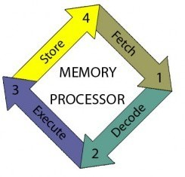

Describe the following image.

This image is known as the CPU cycle

**Question 12**

Where is RAM located? Which are the RAM specific features?

**In the 2 ram slots on the mother board**

**Usually in the bottom left**

**Question 13**

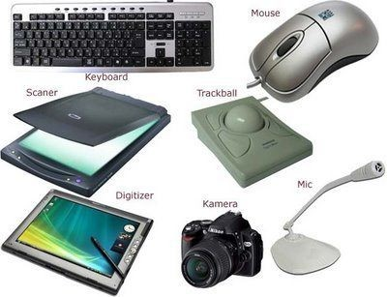

Which among following is not an input device?

**The Camera**

**Question 14**

Describe the Program Counter

**The program counter is a register in a computer processor that contains the address (location) of the instruction being executed at the current time. As each instruction is fetched the porgam counter increases its stored value by 1**

**Question 15**

My hand writing is quite bad so here is an image

The basic Von Neumann architecture is defined as one composed of.... Draw the scheme to describe better.

