SALISBURY UNIVERSITY

COMPUTER SCIENCE DEPARTMENT

__________________________________________________________________________________________________

Assignment 2

Student name: Jeremy Scheuerman

__________________________________________________________________

__________________________________________________________________________________________________

*Course: Microcomputer Organization (COSC 250) – Professor: Dr.Giulia Franchi*

*Due date: September 16th, 2020*

1. What is the decimal equivalent of (1101011)

**107**

1. What is the next binary number following 10111 in the counting sequence?

**11000**

1. What is the largest decimal value that can be represented using 12 bits?

**1S**

1. Which of the following are analog quantities and which are digital?

* number of atoms in a sample of material -**digita**l
* altitude of an aircraft -**analog**
* pressure in a bicycle tire -**analog**
* current through a speaker **Digital**
* timer setting on a microwave oven **-Digital**
* width of a piece of lumber -**analog**
* the amount of time before the over buzzer goes off **Digital**
* the time of day displayed on a quartz watch **Analog**
* altitude above sea level measured on a staircase **Analog**
* altitude above sea level measured on a ramp **Digital**

1. Convert the following binary numbers to their equivalent decimal values

* 11001

**25**

* 10011001

**153**

* 1001110101

**629**

* 10011

**19**

* 1111111

**127**

1. How many bits are needed to count up to a maximum of 511

**9 bits**

1. Convert the following decimal numbers to binary

* 566

**1000110110**

* 114

**1110010**

* 19288

**100101101011000**

* 29373

**111001010111101**

* 3333

**110100000101**

1. Convert the following decimal numbers to binary, octal and Hexadecimal numbers:

* 35

B **100011**

O **43**

H **23**

* 67

B **1000011**

O **103**

H **43**

* 83

B **1010011**

O **123**

H **53**

* 90

B **1011010**

O **132**

H **5A**

* 45

B **101101**

O **55**

H **2D**

* 113
* B **1110001**
* O **161**
* H **71**

1. Convert the following binary numbers to decimal, octal and Hexadecimal numbers:

* 101101

D **45**

O **55**

H **2D**

* 11111111

D **255**

O **377**

H **FF**

* 101010110

D **342**

O **526**

H **156**

* 101

D **5**

O **526**

H **5**

* 1111100

D **124**

O **174**

H **7C**

* 1000011

D **67**

O **103**

H **43**

* 10110011

D **179**

O **263**

H **B3**

1. Convert the following octal numbers to binary numbers:

* 73222254

**111011010010010010101100**

* 6444

**110100100100**

* 7222

**110100100100**

1. Convert the following hexadecimal numbers to binary numbers:

* ABC10

**B 10101011110000010000**

* FFAA10

**B 111111111010101000010000**

* 3882927382

**B 11100010000010100100100111001110000010**

* B10

**B 101100010000**

1. Please find the correct representation for the following decimal numbers into Sign and Magnitude, One’Complement and Two’s Complement Format (in a 8 bit memory location)

* +45

S/M **00101101**

1C **010010**

2C **0000000000101101**

-223

S/M **-11011111**

1C **-00100000**

2C **1111111100100001**

+99

S/M **1100011**

1C **0011100**

2C **0000000001100011**

* -200

S/M **-11001000**

1C **-00110111**

2C **1111111100111000**

-34

S/M**-100010**

1C -**011101**

2C **1111111111011110**

* -17

S/M **-10001**

1C **-01110**

2C **1111111111101111**

* -456

S/M **-111001000**

1C **-000110111**

2C **1111111000111000**

* -78

S/M **-1001110**

1C **-0110001**

2C **1111111110110010**

1. Decode the following number (Two’s Complement Format) into Decimal

* 10010101

**107**

* 11111111

**-1**

* 00000101

**5**

* 11100000

**32**

1. Decode the following number (Sign and Magnitude Format) into Decimal

* 10010101

**-21**

* 11111111

**-127**

* 00000101

**5**

* 11100000

**-96**

1. Decode the following number (One’s Complement Format) into Decimal

* 10010101

**01101010**

**106**

* 11111111

**00000000**

**0**

* 00000101

**11111010**

**5**

* 11100000

**00011111**

**31**

1. Do the following operation as a computer with 16 bit memory space would, using the two’s complement format.

* -46 +13

**1111111111011111**

* +57-2

**0000000000110111**

* -102-87

**1111111101000011**

* +8-3

**0000000000000101**

* -11-24

**1111111111011101**

* +567-134
* **0000000110110001**
* -900-1200

**0000000110110001**

* +333-45

**0000000110110001**

For each of the exercises below please do not write only the result but even the process, I want to see your work!!

For the following exercises you are required to work with Logisim and upload a .circ file.

1. The 2-Input AND gate can be extended to a 4 input AND gate. How will you do it using only AND gates? After you design the circuit in Logisim, generates the output and fill the following Truth Table.

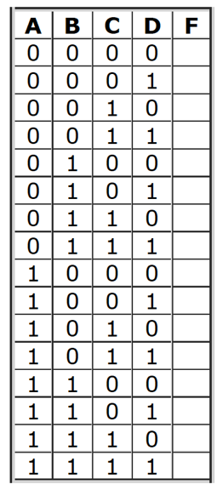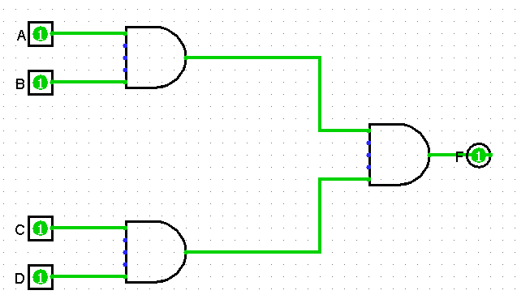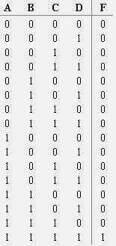

do

1. Design a 3-Input AND gate that is composed of different 2-input AND gates

Measure the output and generate the Truth Table.

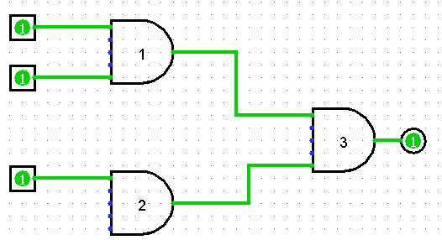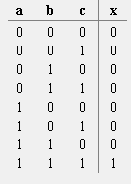

1. How would you create a 5-Input AND gate?

By using 4 total and gates

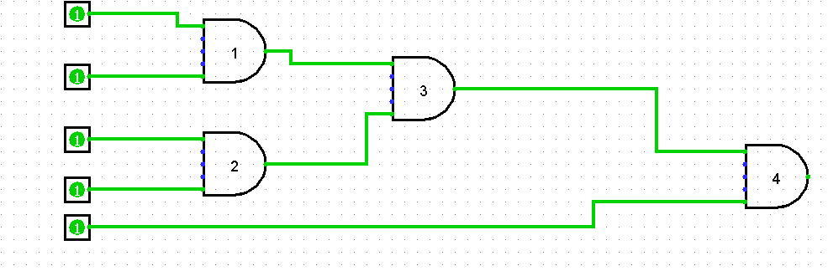

1. The 2-Input OR gate can be extended to a 4 input OR gate. How will you do it using only OR gates? After you design the circuit in Logisim, generates the output and fill the following Truth Table.

By linking multiple or gates together

