Review Sheet­

Definitions

Say what it does…

ALU-Arithmetic and logic unit,performs arithmetic and logic such as add subtract and multiply

Ram-Random access memory, stores datacurrently in use, is wiped on power off

Registers-fast temporary storage

Data Registers (R1, R2, R3 ...) –hold variable data which are frequently used for calculation.

Instruction Register –The CPU is responsible for fetching instructions, one by one, from the memory, storing them in the instruction register, interpreting them and executing them

Program Counter(PC) –keeps track of the instruction currently being executed.

Control Unit–controls the operation of each part of body (Memory, ALU) in CPU and Input/output subsystems.

Define it

Device Driver-drivers for each input/output devices must be installed. Device drivers are interface between hardware and operating system

Micro-architecture–physical devices are grouped together to form a functional units

Input device-a device that sends data to the machine, this includes keyboards, microphones, midi devices, mouse, disk readers etc

Analog representation-real worl mostly in analog, takes longer, less accurate, harder to design

Discrete quantity- things are represented by variable quantities, used by discrete computers

Conversion rates

Integers:

Unsigned integer-an integer without a sign

Signed- integer with a sign , these next 3 formats are this

Sign and magnitude- the most significant bit is used to represent the sign so a zero is positive and a 1 is negative

One’s complement-convert to binary, change all zeros to ones and ones to zeroes

Two’s complement-convert to binary, add as many zeroes as you get to get to 8 bit, then add 1 to it

This link shows work

<https://ncalculators.com/digital-computation/hex-decimal-converter.html>

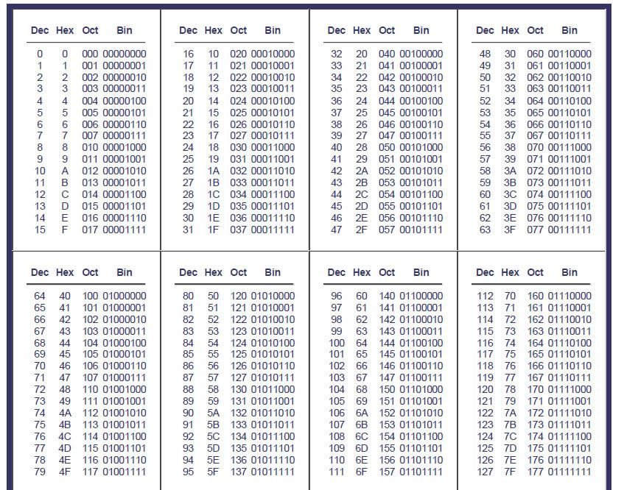

Logic Gates

