COSC 250 MICROCOMPUTER ORGANIZATION

**MIDTERM I**

02/24/2021

Name Jeremy Scheuerman

1. Briefly describe the following:

* ALU

Arithmetic and logic unit

* Micro-Architecture

Physical devices grouped together to form functional units

* Digital System

System designed to store process and communicate information

* Circuit

A loop through which electrical current can flow through designed by logic gates and Boolean algebra

* Memory in Von Neumann Architecture

The key thing to know about memory in the von nuemann architecture is that data and instructions are both treated the same and are addressable

1. Convert the following decimal numbers to Binary, Octal and Hexadecimal numbers.

* 23 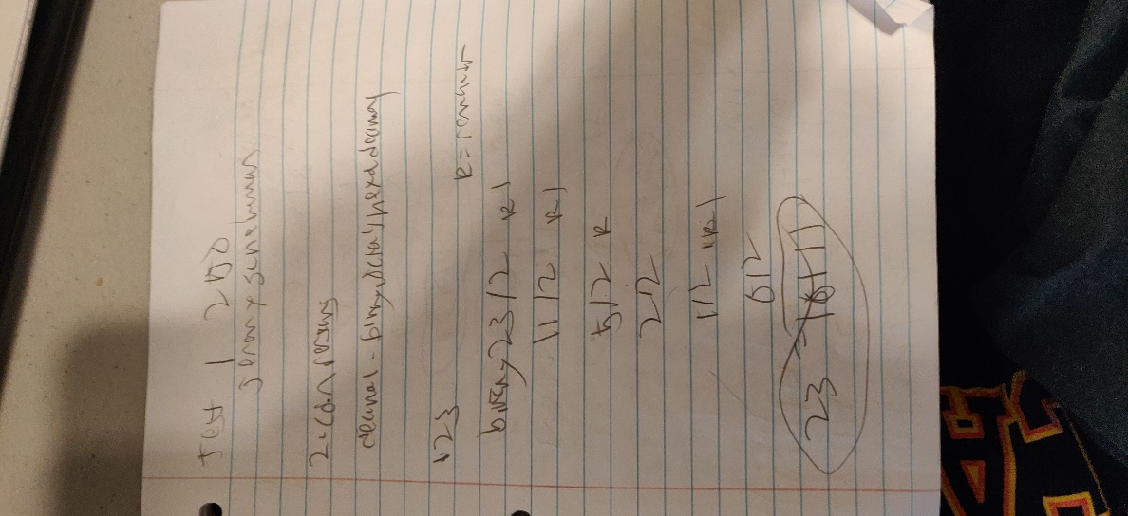 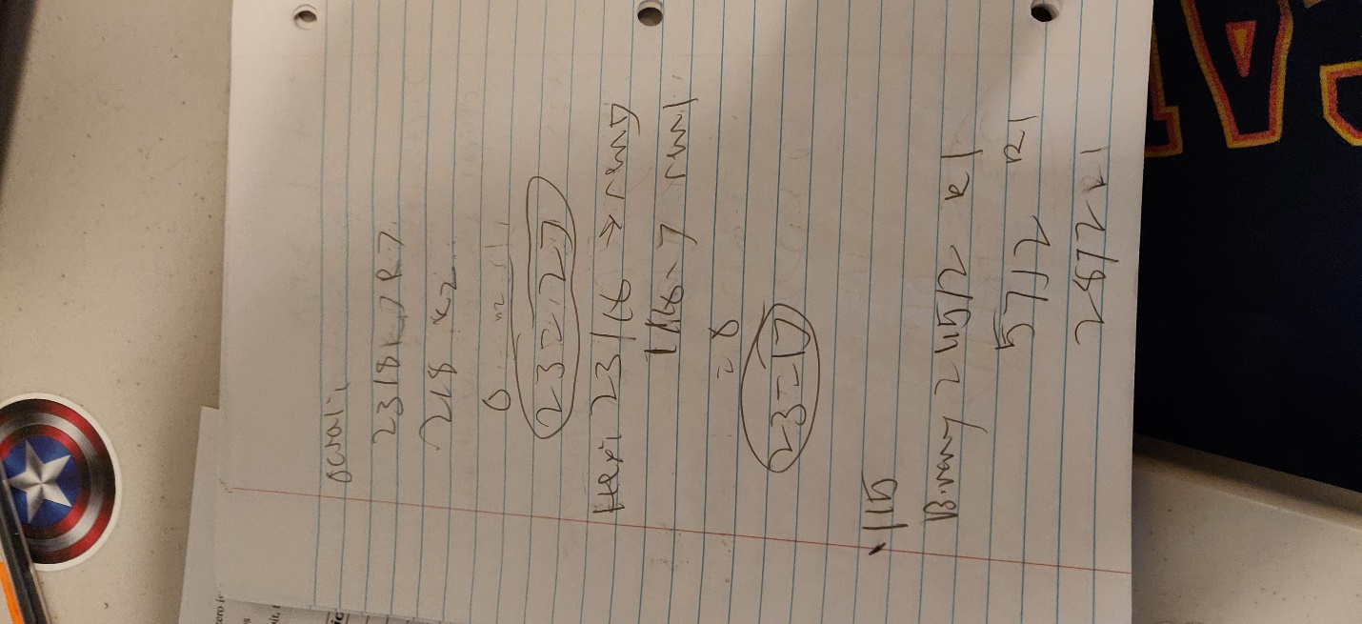
* 115 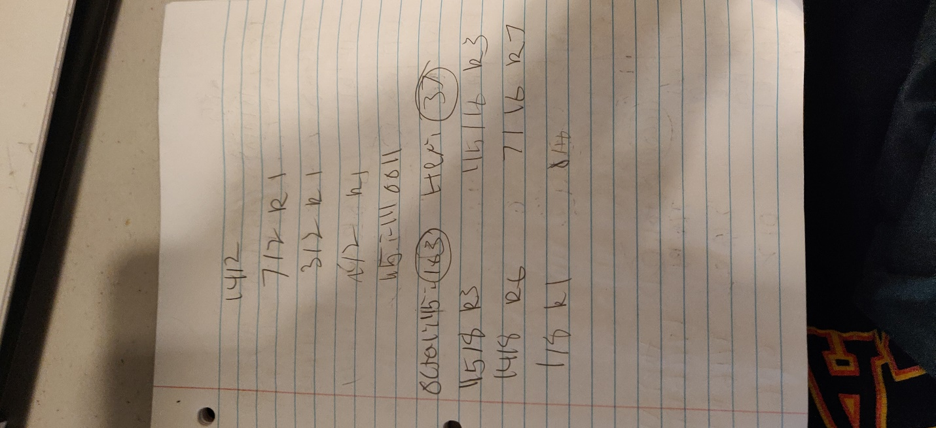
* 85 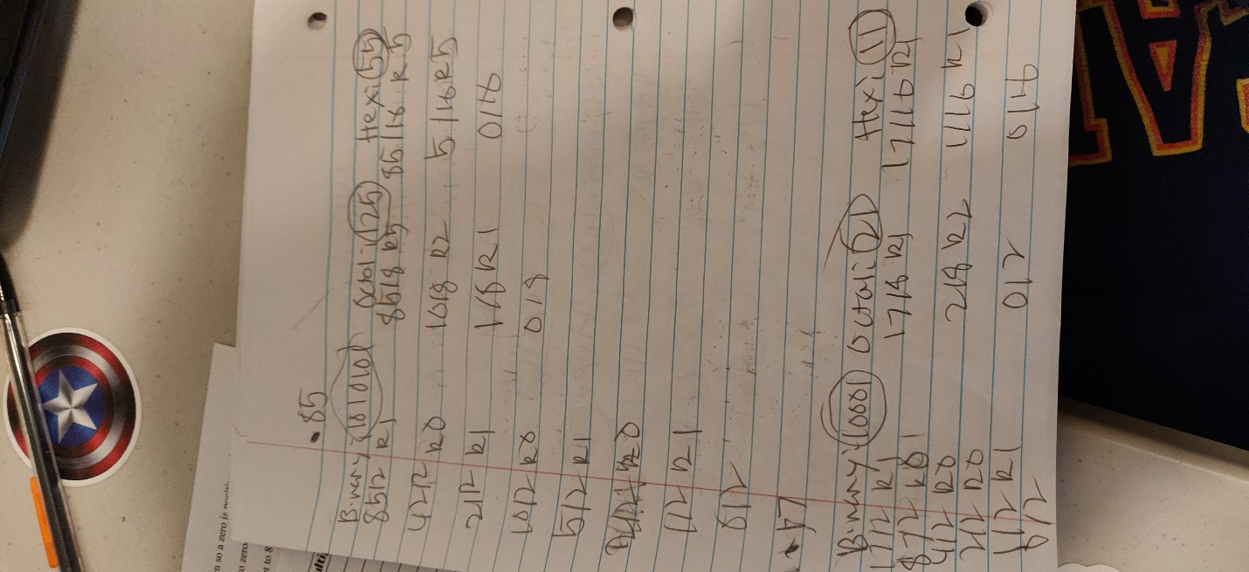
* 17

1. Convert the following Binary numbers to Octal and Hexadecimal

* 100101010010100111
* 11111111111001111 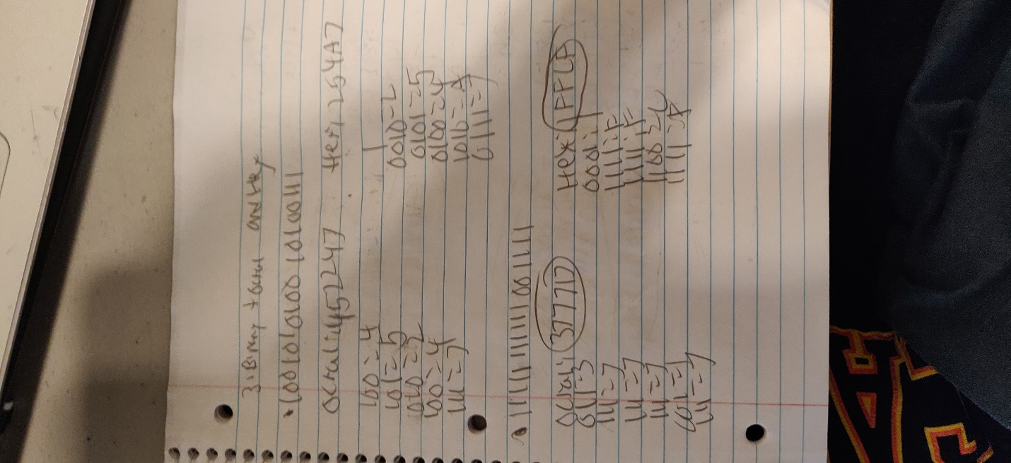

1. Two’s complement format is used for encoding an integer in a modern computer system.

Let’s assume that 16 bits are used to save an integer in the computer system. How the followings decimal numbers are saved in the memory?

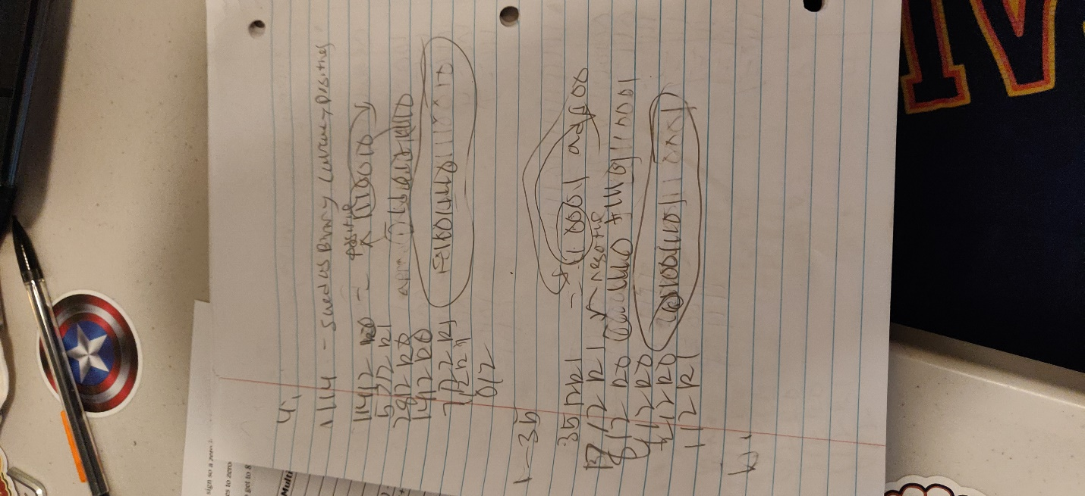

* 114
* -35

1. Two’s complement format is used for encoding an integer in a modern computer system. Let’s assume that 16 bits are used for saving an integer in the system. What is the decoded value for the following binary codes?
   1. 1100010101011000
   2. 0010101010111001
   3. 1111000000000000
   4. 1011111111111111

Out of time

1. Using the Two’s Complement Format in a 8 bits memory location, which is the result of the following arithmetic operation:

* -71 + 4
* -18 -11

Out of time

1. Simplify following Boolean expression by using algebraic manipulation.

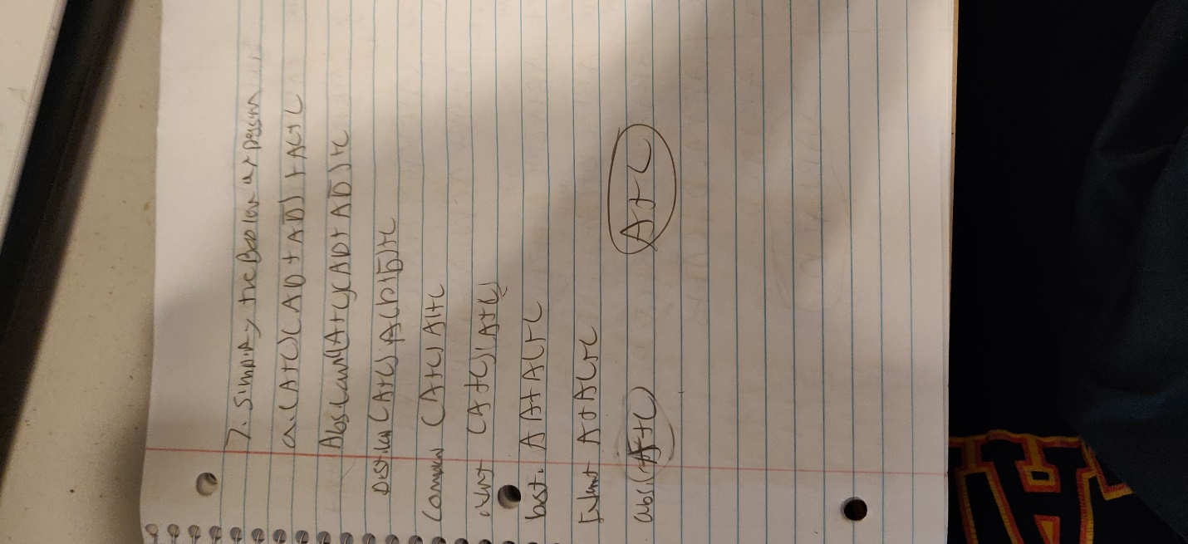

* 1. 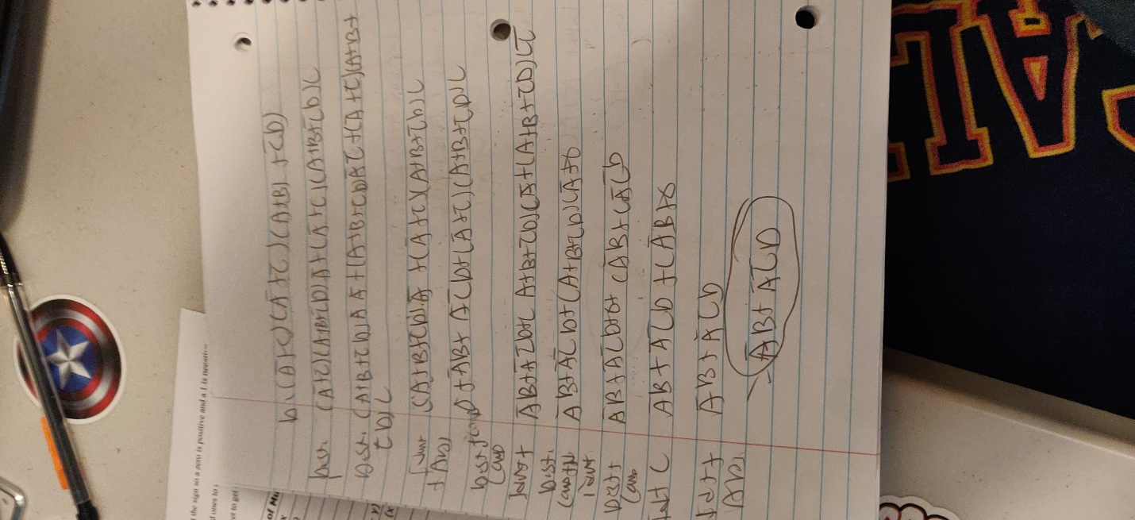

1. Prove the identity of each of the following Boolean equations using algebraic theorems.

a) 

b) 

c) 

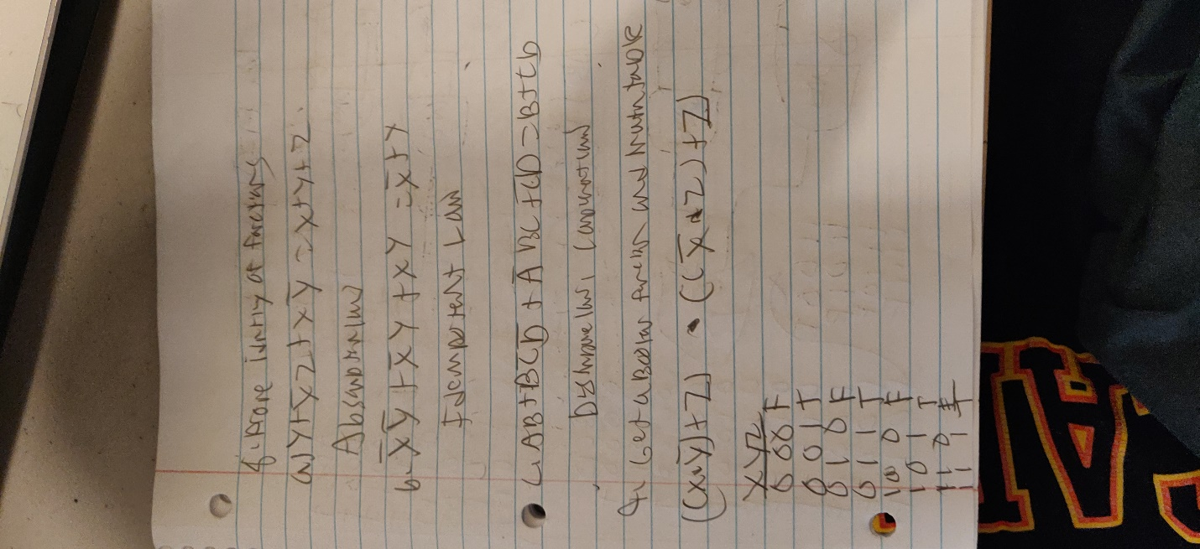

1. Get a Boolean function F for the following logic diagram and build a truth table.

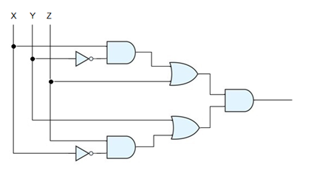

10. Derive the truth table and draw the logic circuit corresponding to the following Boolean expressions:

|  |
| --- |
|  |
|  |

11. From the following truth table, get a Boolean function F. Then, using Boolean algebra, simplify F to obtain the simplified form. Draw the logic diagram of the simplified function.

|  |  |
| --- | --- |
| X Y Z | F |
| 0 0 0 | 0 |
| 0 0 1 | 0 |
| 0 1 0 | 1 |
| 0 1 1 | 1 |
| 1 0 0 | 1 |
| 1 0 1 | 1 |
| 1 1 0 | 0 |
| 1 1 1 | 0 |
|  |  |

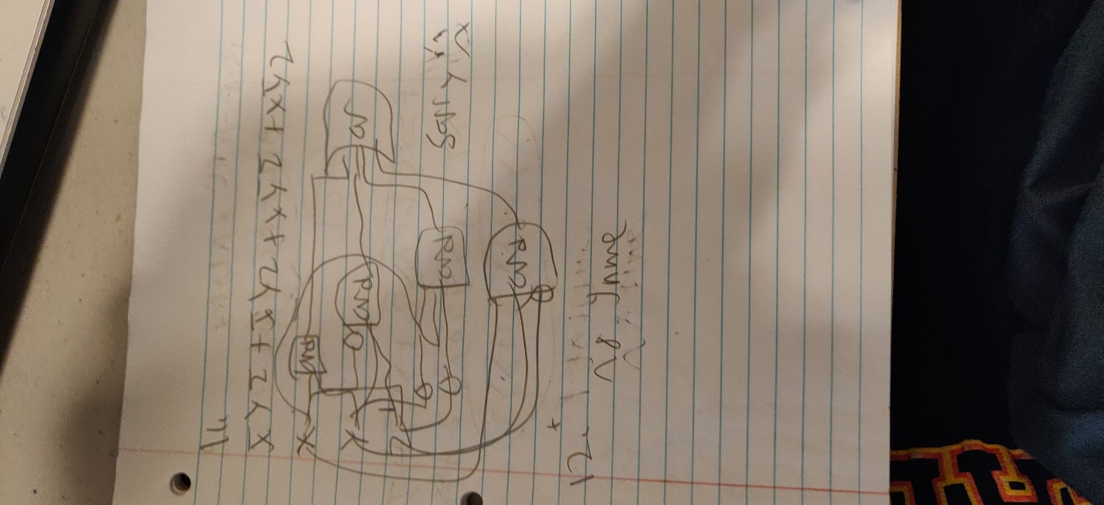

12. From the following Truth Table, get the simplified Boolean function in sum of product form

|  |  |
| --- | --- |
| **A B C D** | **F** |
| 0 0 0 0 | 1 |
| 0 0 0 1 | 0 |
| 0 0 1 0 | 1 |
| 0 0 1 1 | 1 |
| 0 1 0 0 | 1 |
| 0 1 0 1 | 1 |
| 0 1 1 0 | 0 |
| 0 1 1 1 | 0 |
| 1 0 0 0 | 0 |
| 1 0 0 1 | 0 |
| 1 0 1 0 | 1 |
| 1 0 1 1 | 1 |
| 1 1 0 0 | 0 |
| 1 1 0 1 | 1 |
| 1 1 1 0 | 1 |
| 1 1 1 1 | 0 |

OUT OF TIME

13. Calculate the Complement of the following functions:

* F = A’B’C’ + A’C + ABC
* F = X’Y’Z’+X’YZ’+XY’Z’+XYZ

