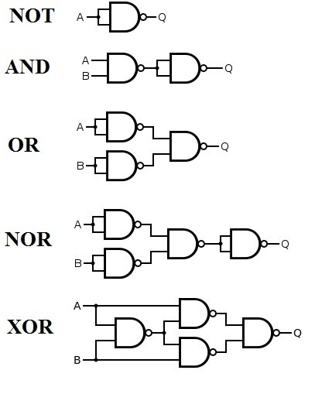  **NAND**

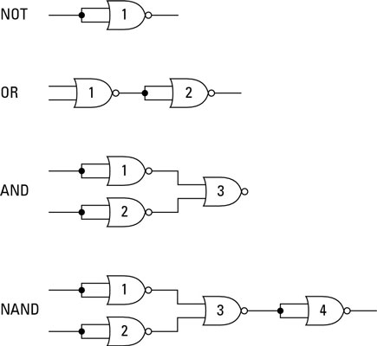 **NOR**

**Topics:**

NAND/NOR only^ guide up there

ODD/EVEN functions

<http://www.cburch.com/logisim/docs/2.1.0/libs/gates/xor.html>

Multiplexer

<http://www.cburch.com/logisim/docs/2.1.0/libs/plexers/mux.html>

Demultiplexer

<http://electronics-course.com/demux>

Adders

<https://www.electronics-tutorials.ws/combination/comb_7.html>

Full Adder

<https://www.geeksforgeeks.org/full-adder-in-digital-logic/>

Latches

<https://www.geeksforgeeks.org/latches-in-digital-logic/>

Flip Flops

<https://www.electronics-tutorials.ws/sequential/seq_1.html>

1. 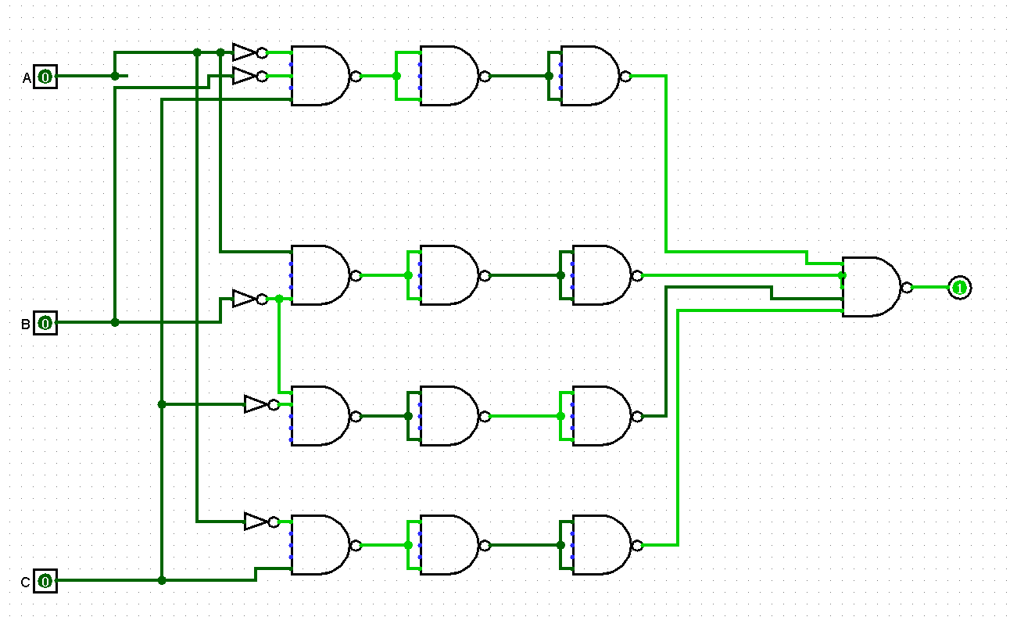
2. Use Boolean algebra simplifier to help solve
3. 2
4. 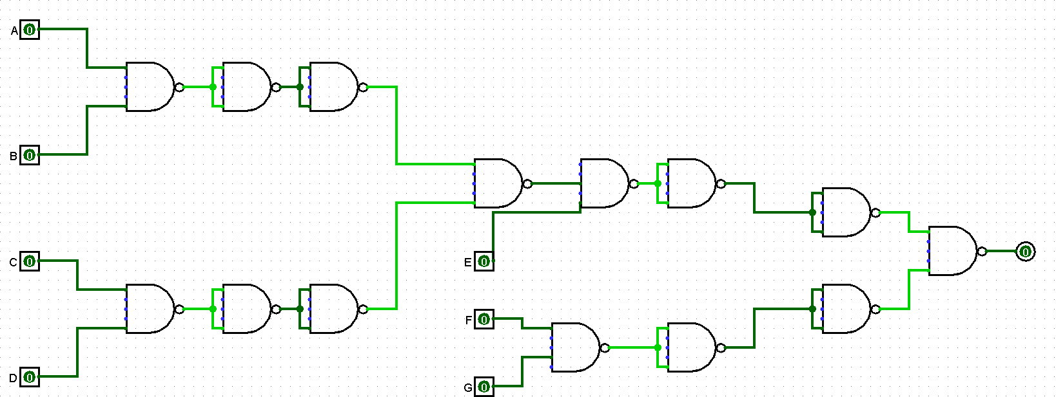
5. 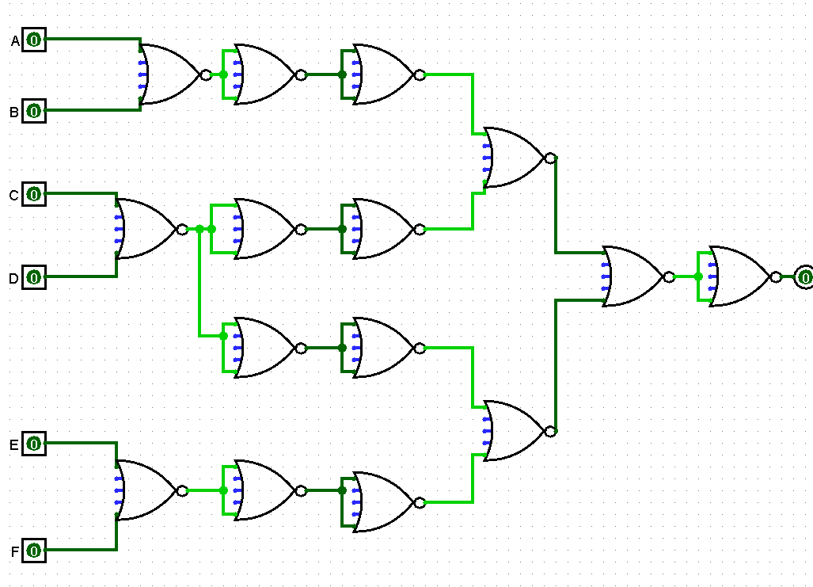
6. 45
7. 4
8. Hardware Description languages-Hardware description languages allow you to describe a circuit using words and symbols, and then development software can convert that textual description into configuration data that is loaded into the FPGA in order to implement the desired functionality

Computer Aided Design-(autocad) -Computer-aided design (CAD) refers to computers being used to assist the design process in all sorts of industries. With CAD software, it’s possible to build an entire model in an imaginary space, letting you visualize properties like height, width, distance, material, or color before the model is used for a particular application.

Top-Down Design-the decomposition of a system into smaller parys in order to comprehend its compositional subsystem

Hierarchical Design-**Hierarchical architecture** views the whole system as a **hierarchy** structure, in which the software system is decomposed into logical modules or subsystems at different levels in the **hierarchy**.

Divide and Conquer approach-**Divide and Conquer** is a recursive problem-solving **approach** which break a problem into smaller subproblems, recursively solve the subproblems, and finally combines the solutions to the subproblems to solve the original problem. This **method** usually allows us to reduce the time complexity to a large extent

Sequential circuit

-unlocked-clock is not present

Latch

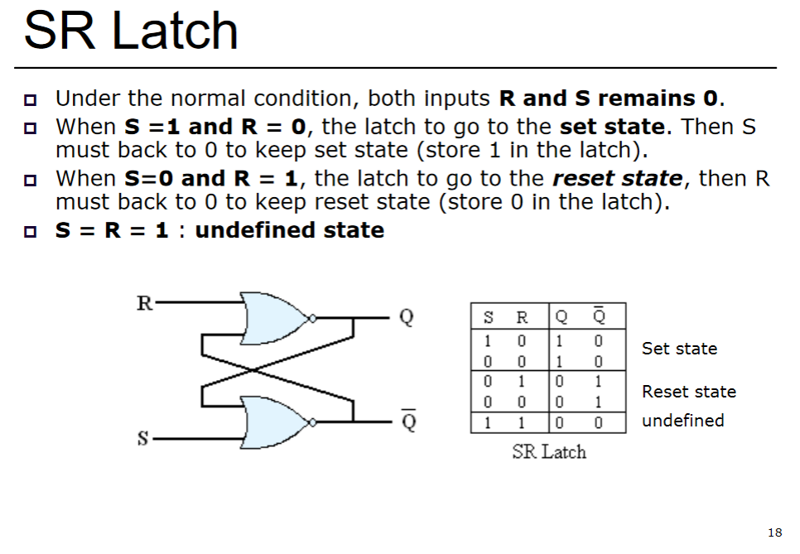

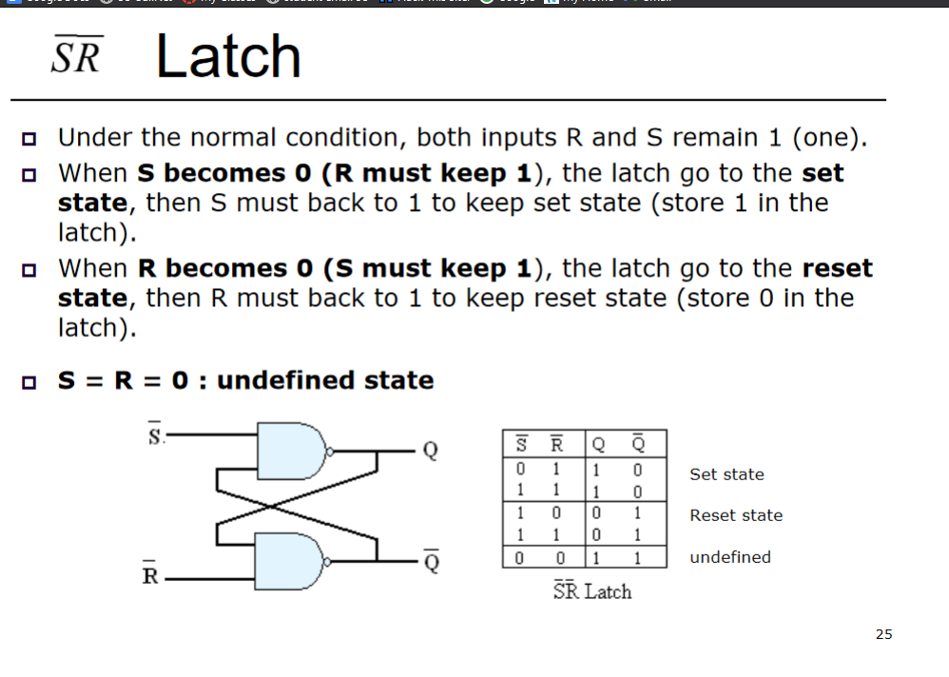

Flip Flop-eliminates undesirable condition that leads to undefined outputs and indeterminate behavior

1. Y
2. E
3. 1
4. E
5. E
6. A **priority encoder** is a circuit or algorithm that compresses multiple binary inputs into a smaller number of outputs.
7. T
8. Y
9. R
10. E
11. Y
12. R
13. E
14. W
15. T
16. Carry look ahead adder

<https://www.geeksforgeeks.org/carry-look-ahead-adder/>

Ripple carry adder

<https://www.circuitstoday.com/ripple-carry-adder>

1. e