1. Create stack using the following S3 URL:

<https://webapp-theresa.s3-ap-southeast-2.amazonaws.com/main.yaml>

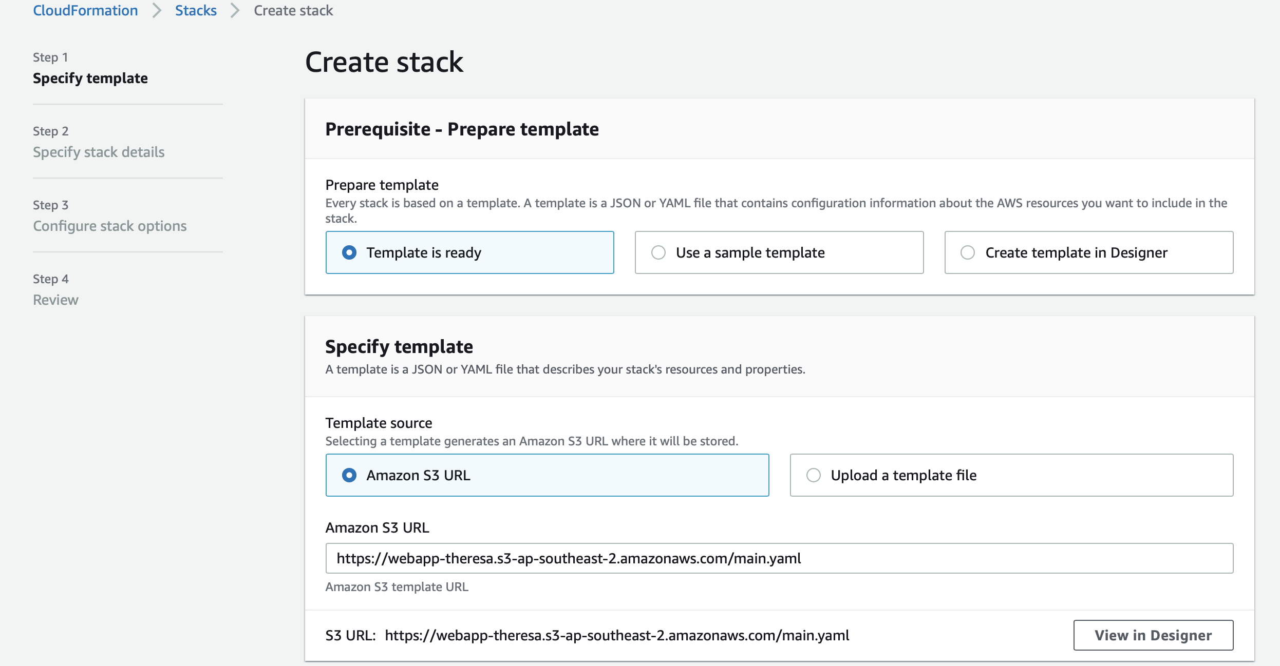

1. Specify stack name

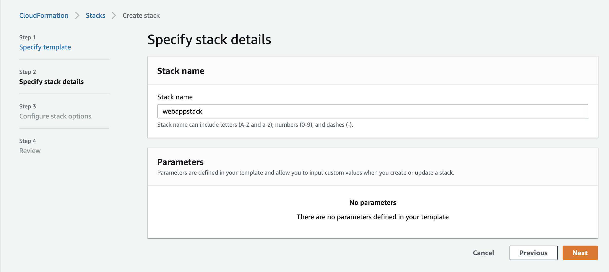

1. Specify the role created using rolepolicy.json

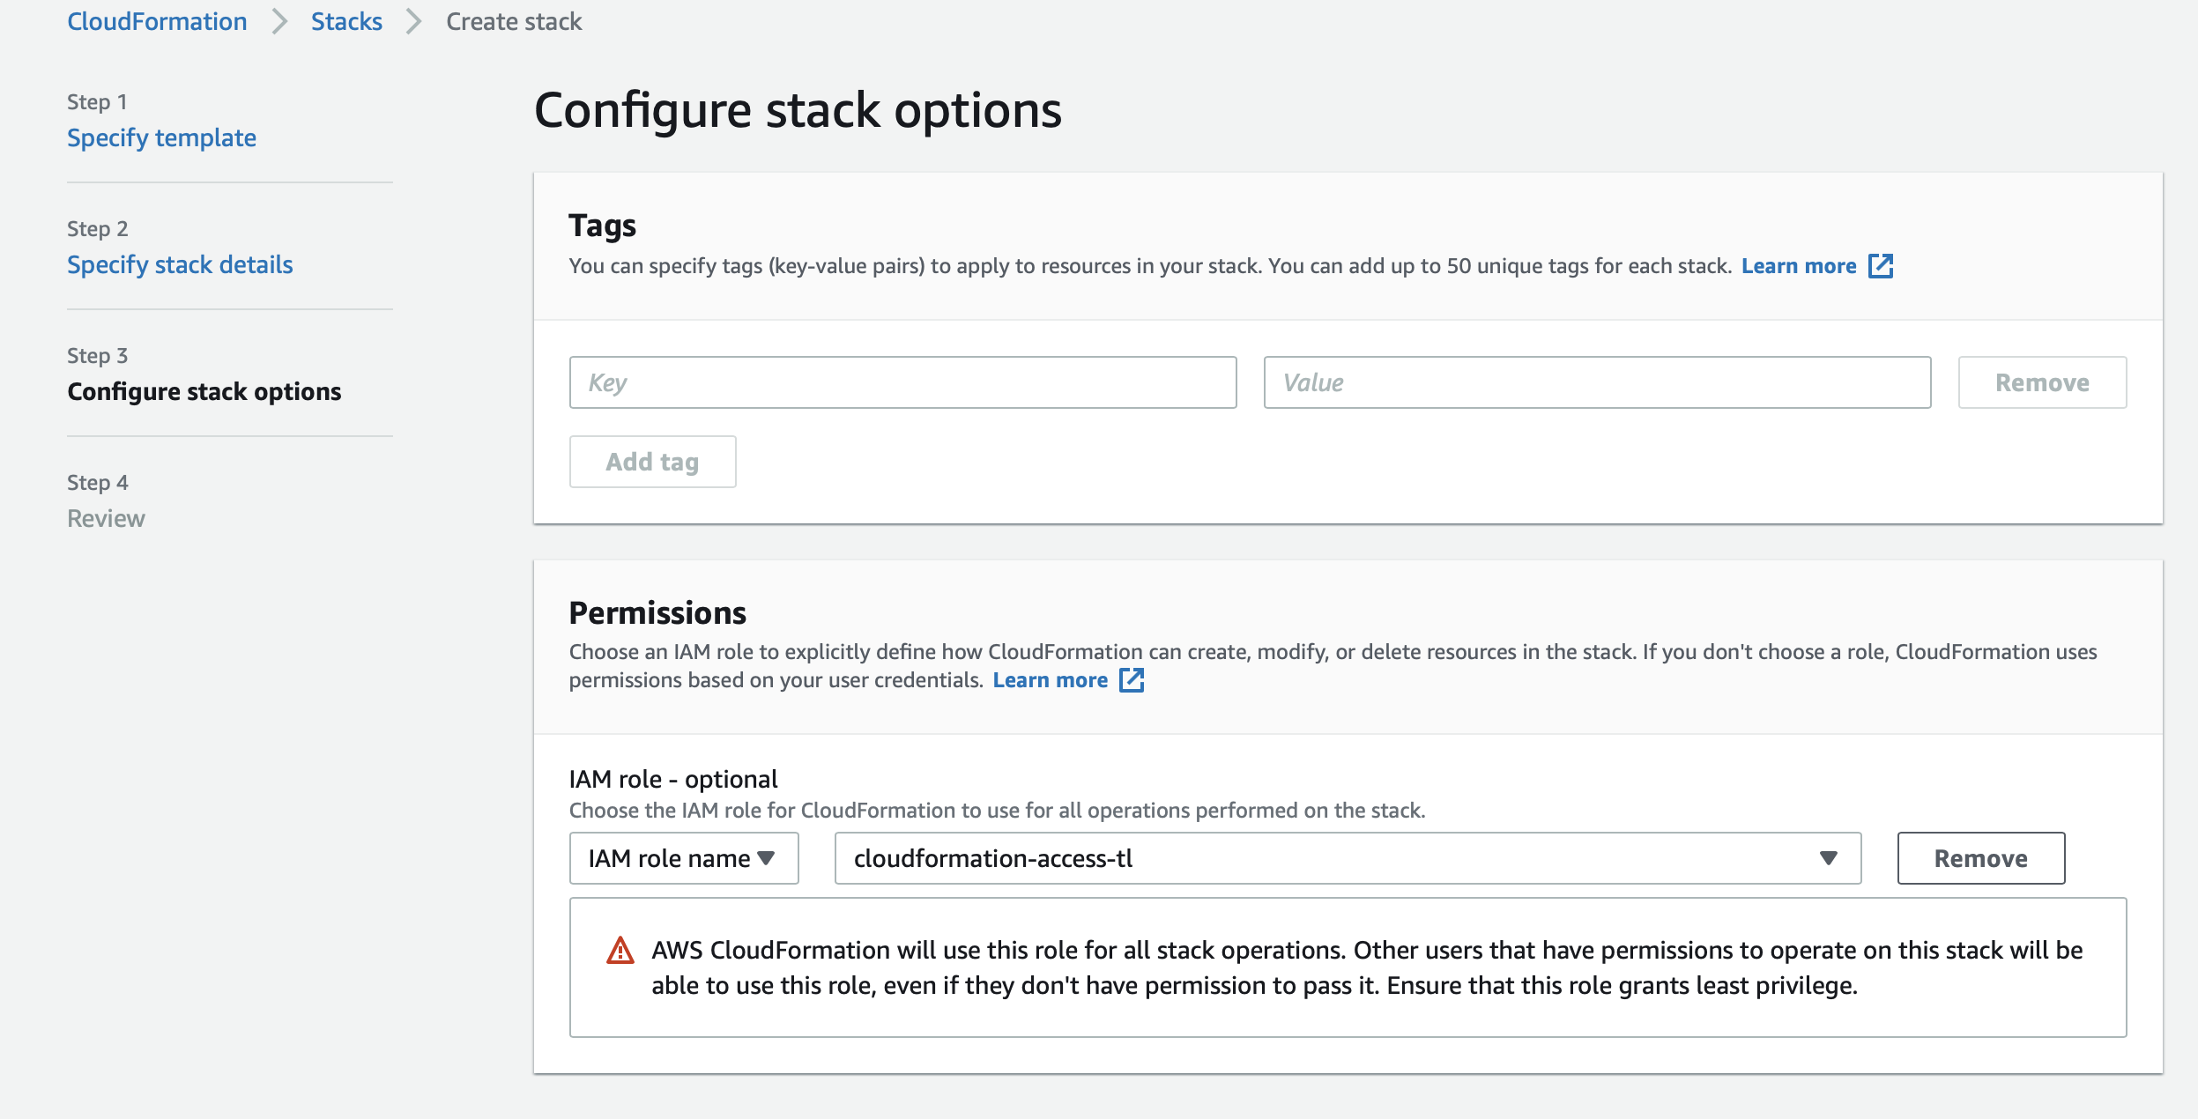

1. Click Next, and then Create Stack.

This kicks off the stack provision.

1. When the stack creation finishes, click on the CDN nested stack and check the output

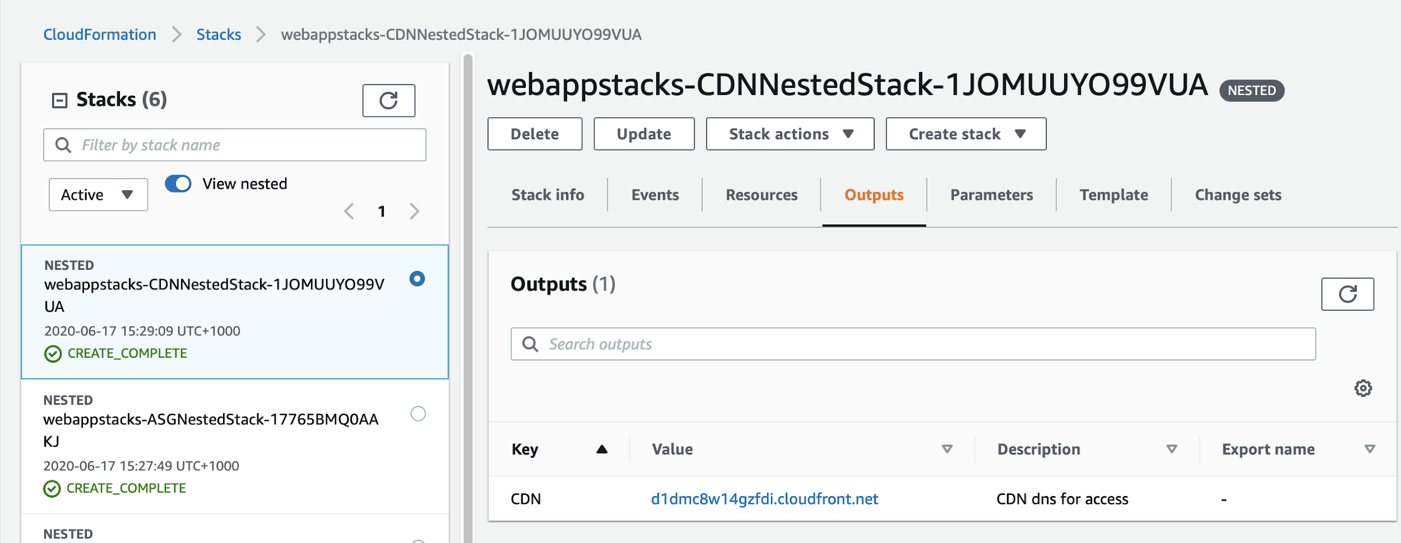

1. Click the URL and you should be able to see the “Hello World” web page using HTTPS.

