- Create stack using the following S3 URL:
https://webapp-theresa.s3-ap-southeast-2.amazonaws.com/main.yaml
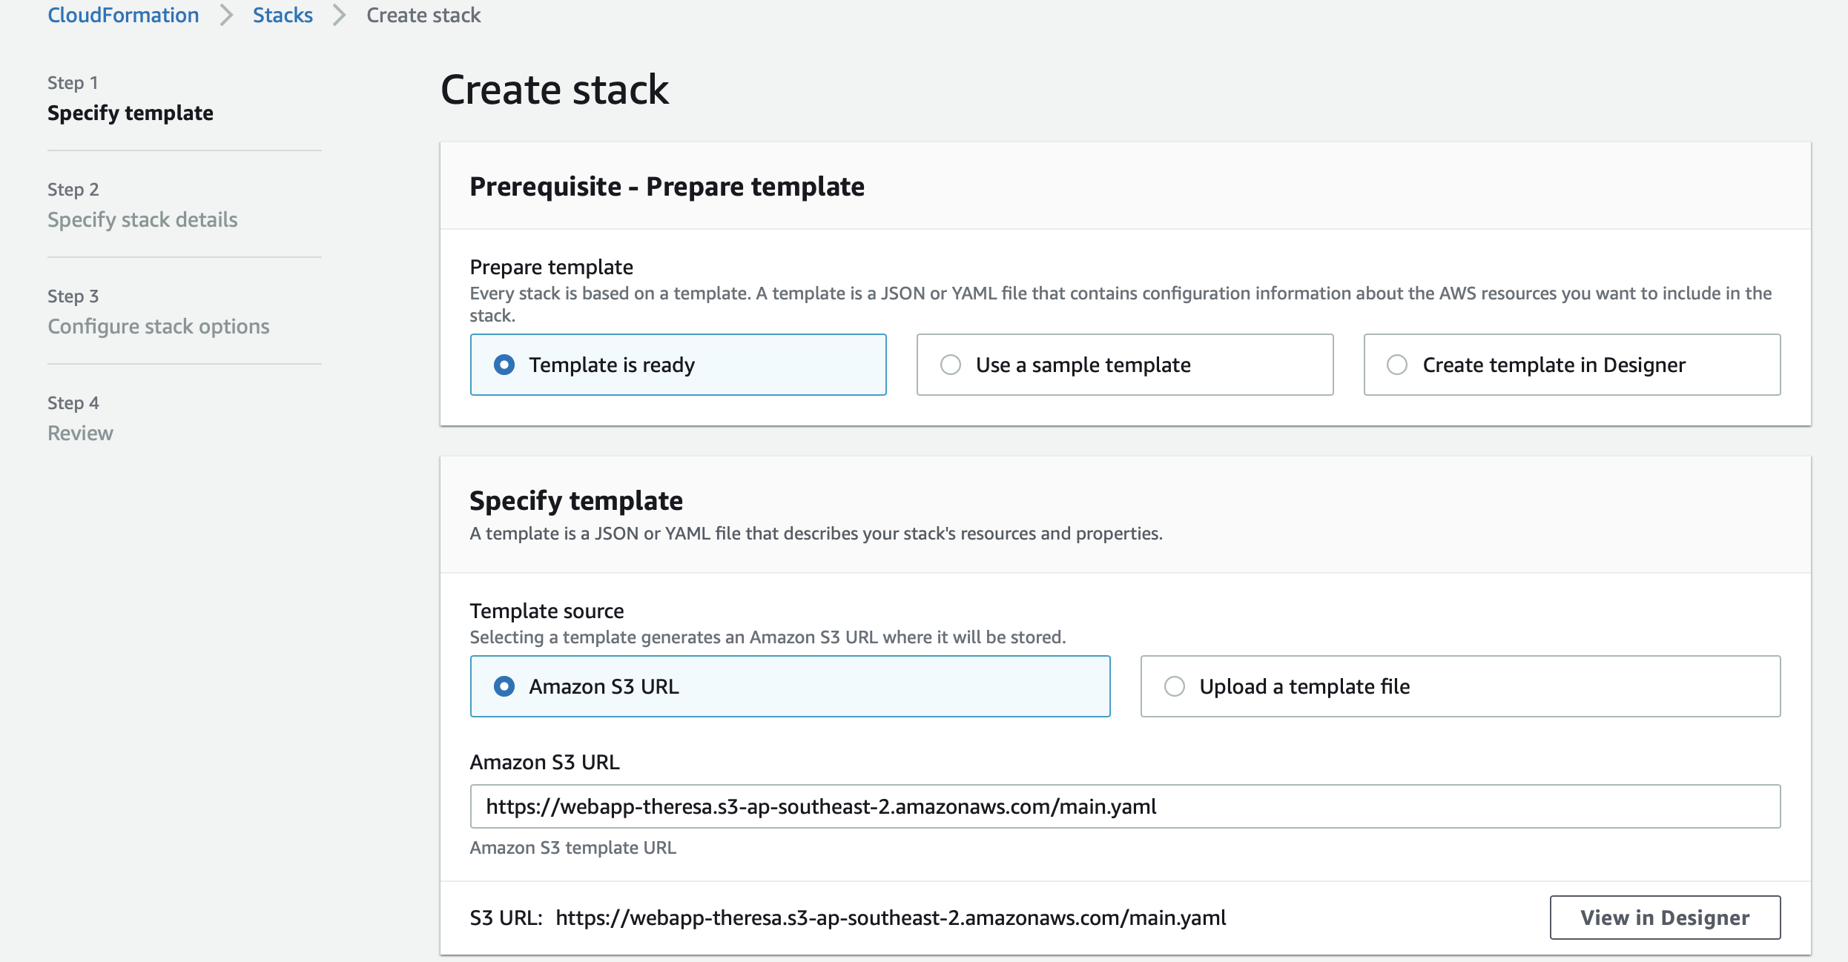

- Specify stack name
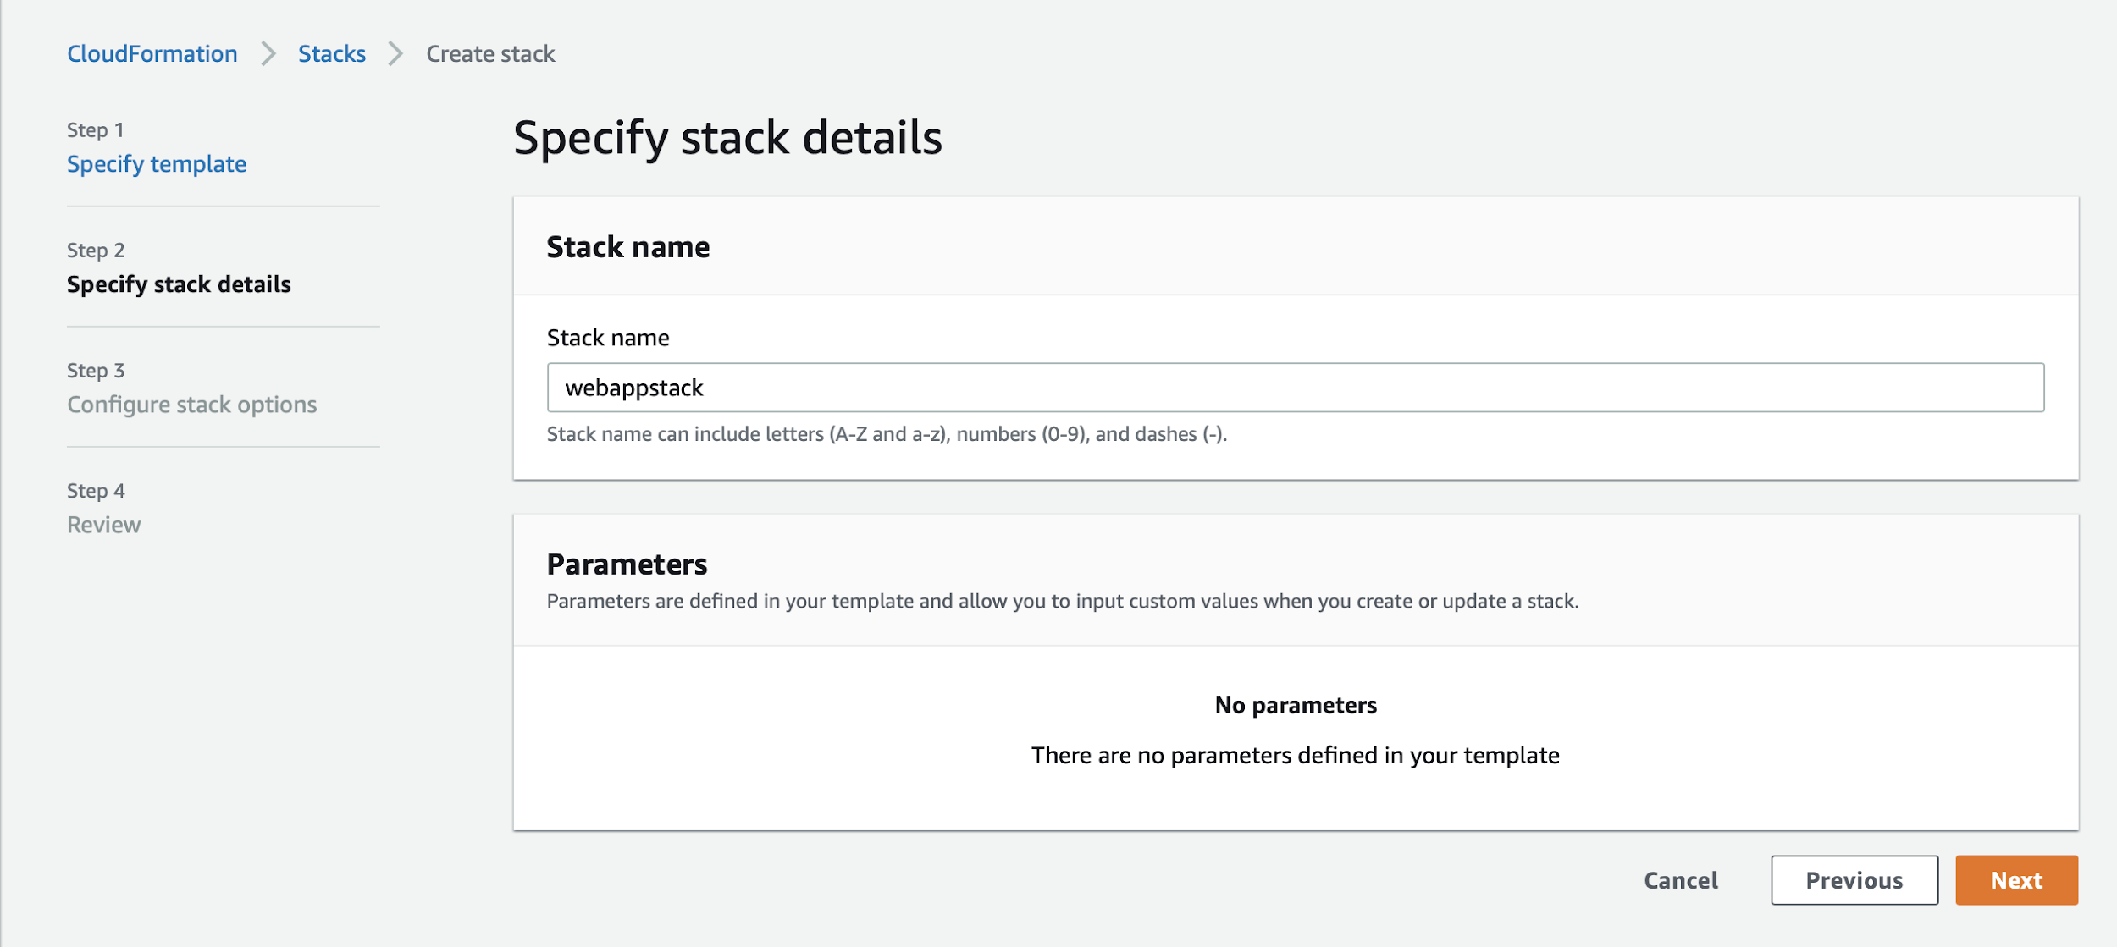

- Specify the role created using rolepolicy.json
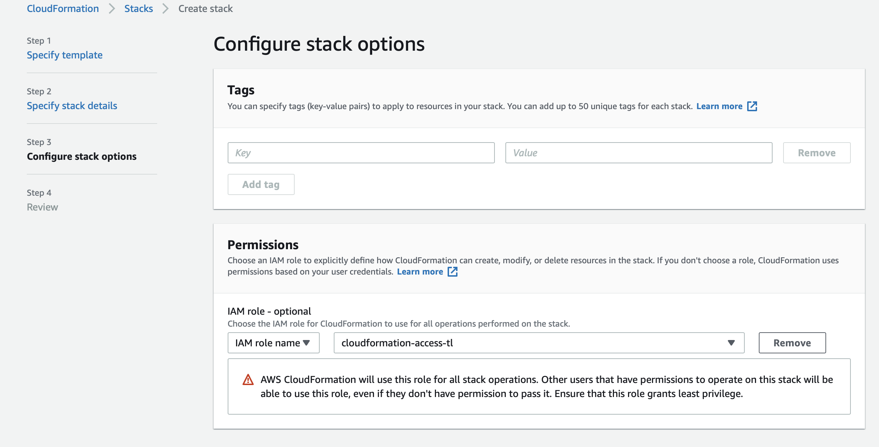

- Click Next, and then Create Stack.
This kicks off the stack provision.

- When the stack creation finishes, click on the CDN nested stack and check the output
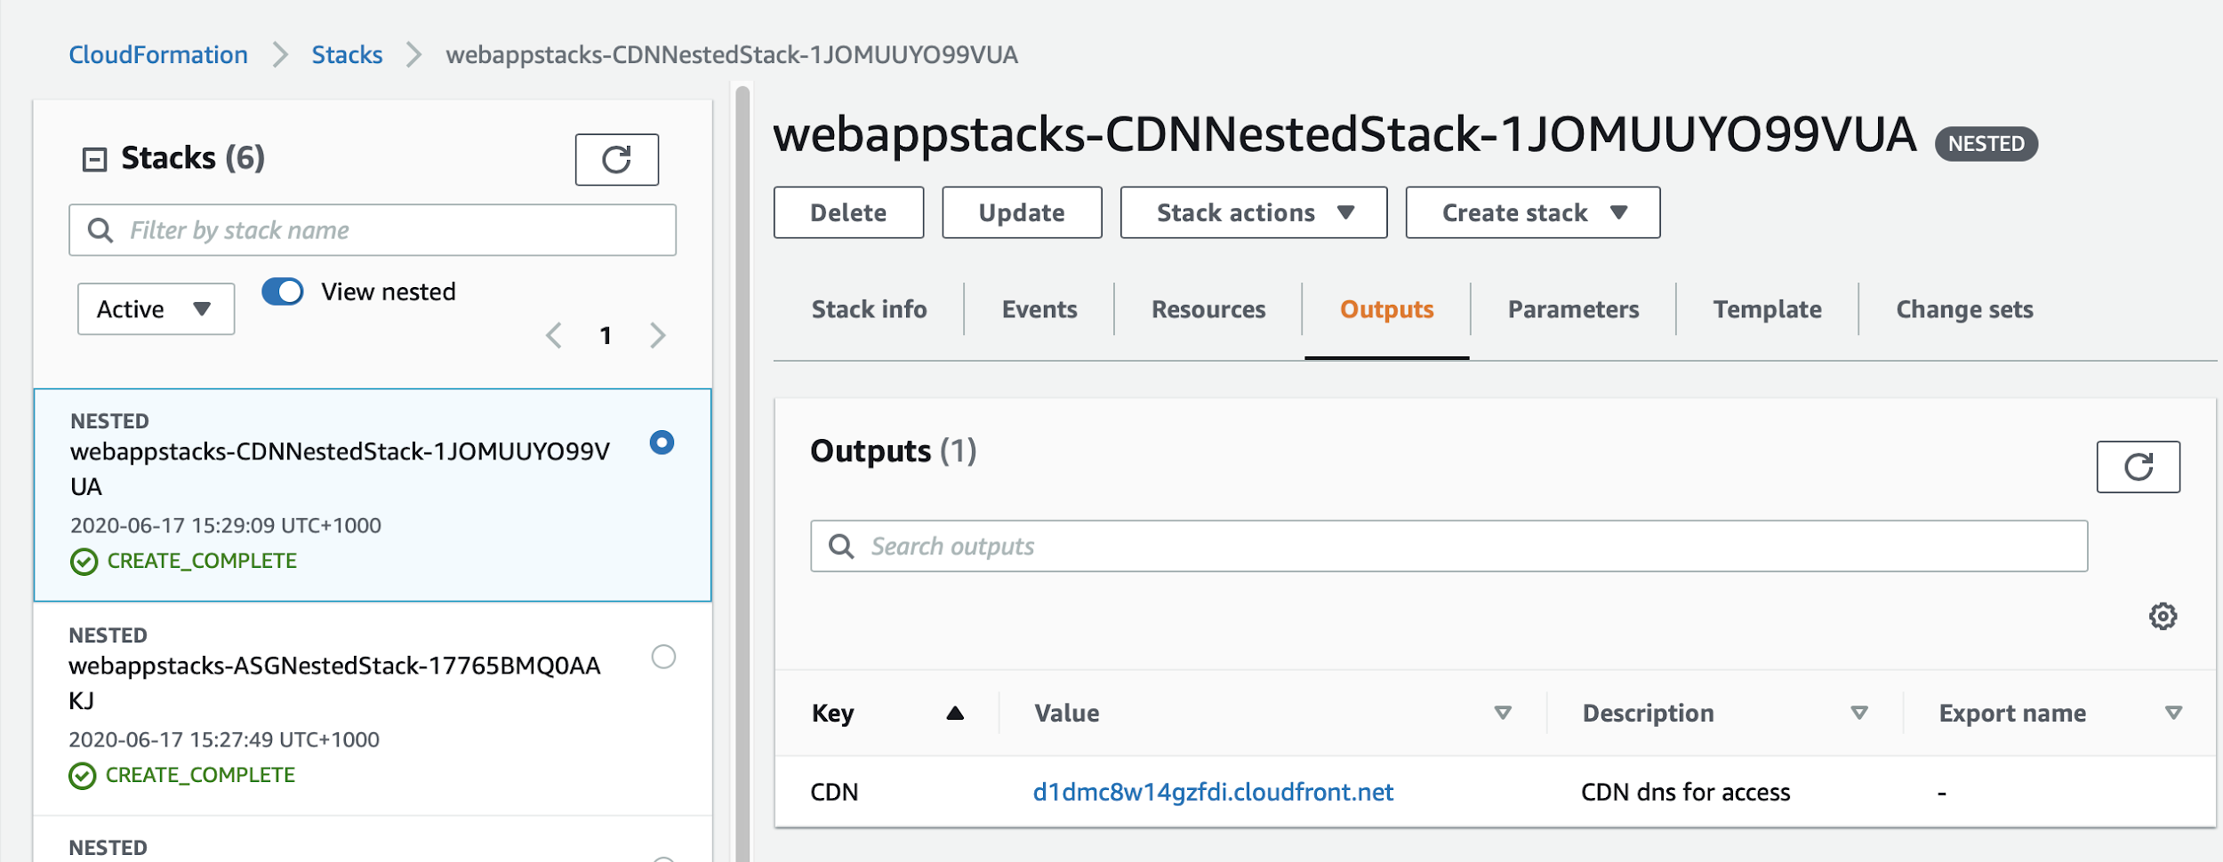

- Click the URL and you should be able to see the “Hello World” web page using HTTPS.
