**README**

**=====**

Since I had IIS, i made the virtual directory against IIS, but IIS Express should work as well.

**backend** :

- is written with 3 action methods in the books api

- tested inside postman for

a) <http://localhost/Library/api/books>

b) <http://localhost/Library/api/books/2>

c) <http://localhost/Library/api/books/2/the>

**front end :**

- vanilla javascript with fetch() api is used to invoke the apis

-run the code either a) using vs code (Live server) , use : http://127.0.0.1:5500/index.html, we can see the ui is showing data

or using Visual Studio ( <http://localhost/Library/index.html>)

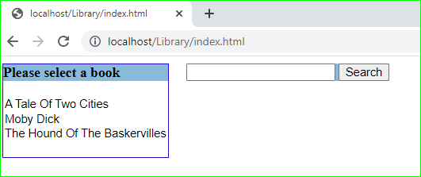

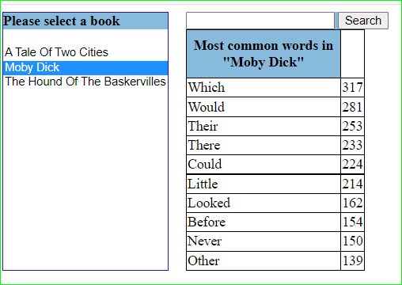

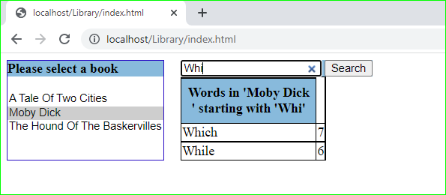

Ps : The nunit project is not complete.