Project Repo : <https://github.com/theresaport/MAssist-.git>

* Asp.net Web AP 2,
* Angular 12
* VS Code
* EF Code First
* EF 6 – code first is used to setup the database and schema

Angular ag grid is used to showing the titles

**Tools used :**

1. VS Code
2. Visual Studio 2017
3. Postman
4. SQL Server Management Studio

**Folder structure :**

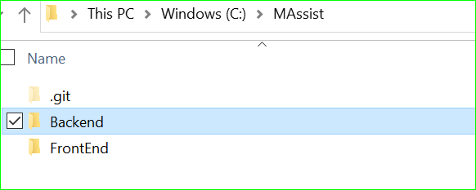

To compile .net web api :

Open Visual Studio in admin mode ( I used VS 2017) and follow step1 and build.

To run :

**Step1 :** Backend API ( Code first) Go to Tools🡪Nuget Packagemanager console ( discard any warnings)

PM> Enable-migrations //You don't need this as you have already done it

PM> Add-migration Give_it_a_name

PM> Update-database

**Step2 : To launch angular 12**

ng serve --open --port=4300

