Predicting Cannabis Use Using Canadian Health Survey Data

Jonathan Steen
MSDS, Bellevue University
Instructor: Frank Neugebauer
DSC630 – Predictive Analytics (T301)
June 1, 2025

Introduction

Substance use remains a critical public health issue due to its impact on individual well-being and societal costs. This project focuses specifically on cannabis use, using data from the 2019-2020 Canadian Community Health Survey (CCHS). The goal is to identify key demographic, lifestyle, and mental health predictors of cannabis use and develop predictive models that can inform targeted public health interventions. Though based in Canada, the findings can potentially generalize to similar populations globally.

Overview of Data Used

The CCHS dataset contains over 108,000 anonymized records with detailed information on respondents' health, lifestyle, and socioeconomic conditions. For this project, I focused on variables relevant to cannabis use and eliminated features that introduced noise, excessive missing values, or target leakage. After cleaning, decoding, and filtering, I worked with a refined dataset of over 7,000 complete records and 30 predictive features.

Methods of Analysis

I used two interpretable classification algorithms:
- Logistic Regression (with regularization and scaling)
- Decision Tree Classifier (baseline non-linear model)

Data Preparation Steps:
- Standardized and corrected column names
- Decoded categorical variables using a mapping dictionary
- Removed sparse or high-leakage columns
- Created a binary target variable (Cannabis_user) from original multi-class values

Addressing Class Imbalance:

The data showed a strong imbalance (~85% non-users). To correct this, we applied random oversampling to the training set, creating a balanced class distribution without affecting the test data.

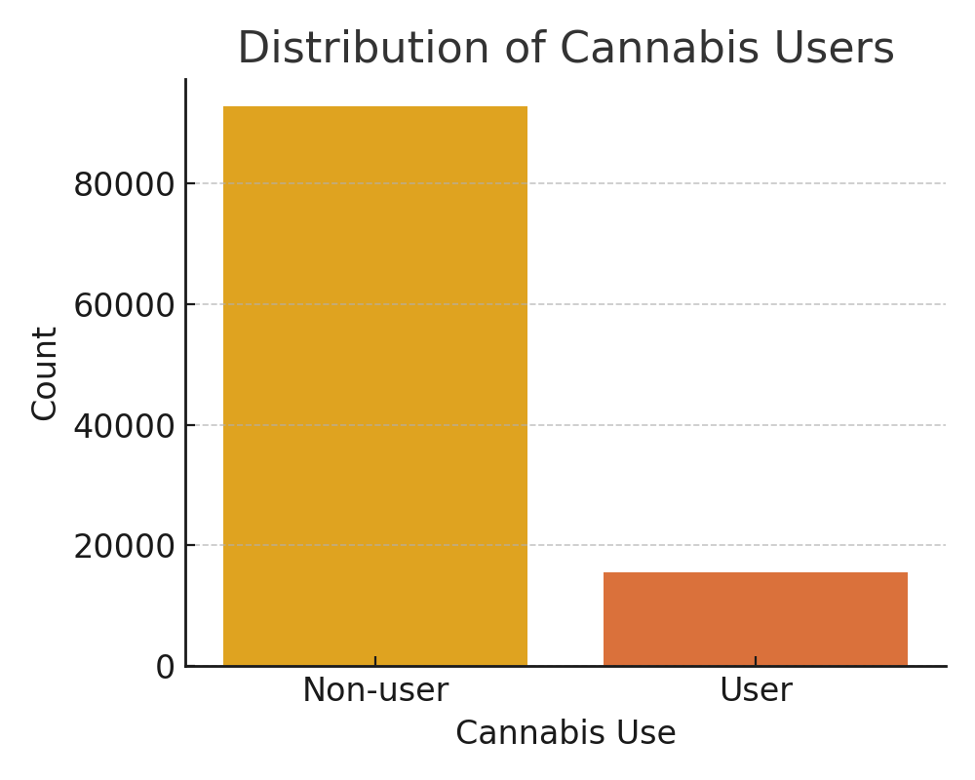

Model Evaluation Metrics:
- Accuracy
- Precision, Recall, F1-score
- ROC-AUC
- Feature Importance (coefficients and impurity-based ranking)

Results & Findings Explained

Baseline Results (Before Balancing):
- Logistic Regression had 81% accuracy, but only 17% recall for cannabis users.
- The Decision Tree performed slightly better with a 34% recall for users.
- Both models heavily favored predicting non-users due to class imbalance.
Model | Accuracy | Recall (User) | Recall (Non-user) | ROC AUC
Logistic Regression | 81% | 17% | 96% | 0.56
Decision Tree | 72% | 34% | 81% | 0.57

Post-Oversampling Results:
- Logistic Regression improved to 64% recall for users with 69% accuracy.
- The Decision Tree improved to 62% recall with 59% accuracy.
- ROC curve analysis showed Logistic Regression as the better-performing model.
Model | Accuracy | Recall (User) | Recall (Non-user) | ROC AUC
Logistic Regression | 69% | 64% | 71% | 0.67
Decision Tree | 59% | 62% | 58% | 0.60

Feature Importance:

The top predictors from both models included:
- Tobacco use
- Age group
- Gender
- Life satisfaction
- Mental health state
- Food security
- Sense of belonging

These results reinforce the multifaceted nature of cannabis use, linking it to behavioral, demographic, and psychosocial factors.

Conclusion

After addressing class imbalance and improving feature engineering, logistic regression emerged as the most balanced and interpretable model. The project revealed that cannabis use is best predicted by a combination of demographic, mental health, and lifestyle indicators. These insights can help health professionals better target interventions and screening.

Possible next steps include testing ensemble models like Random Forest, exploring imputation to reduce data loss, and refining feature engineering for deeper behavioral insights.

References

Canadian Community Health Survey Dataset (2019-2020), Kaggle: https://www.kaggle.com/datasets/aradhanahirapara/healthcare-survey/data

Scikit-learn Documentation: https://scikit-learn.org/

Abbott, D. (2014). Applied Predictive Analytics: Principles and Techniques for the Professional Data Analyst. Wiley.

Siegel, E. (2016). Predictive Analytics: The Power to Predict Who Will Click, Buy, Lie, or Die. Wiley.

